Additional File 5 Relation between visible and total root length.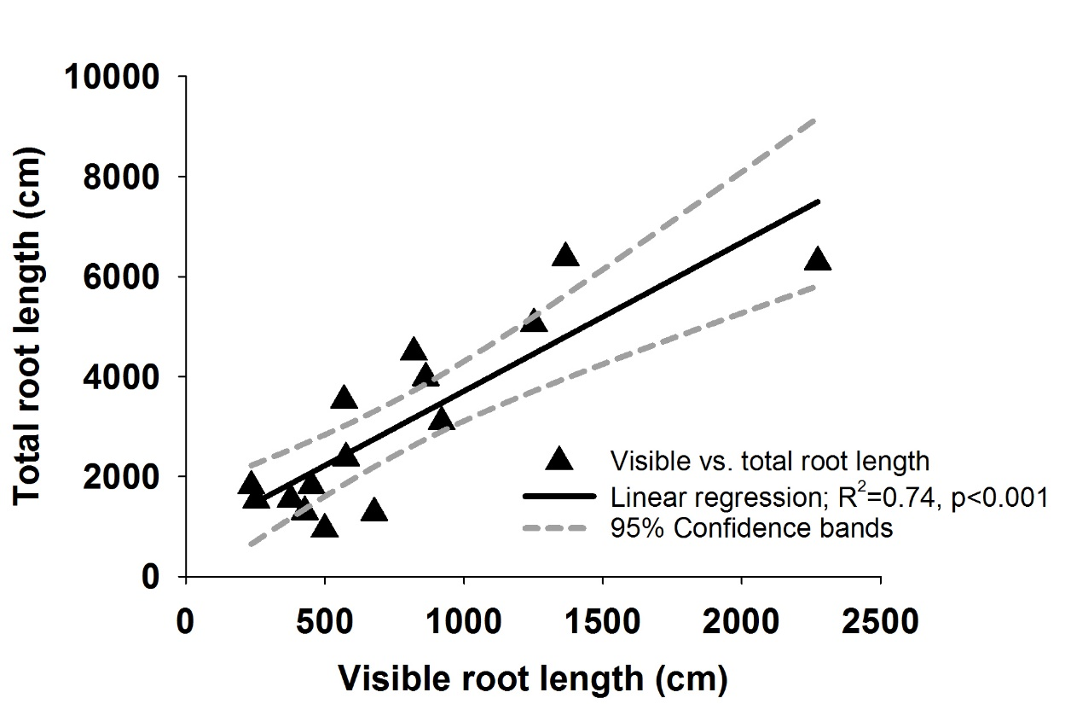
Additional File 5 Relation between visible root length on the observation window (accessible to imaging) and total root length obtained after opening the rhizoboxes and separating roots from soil.

