Additional File 6 Raw spectra of root pixels from centre to border region.
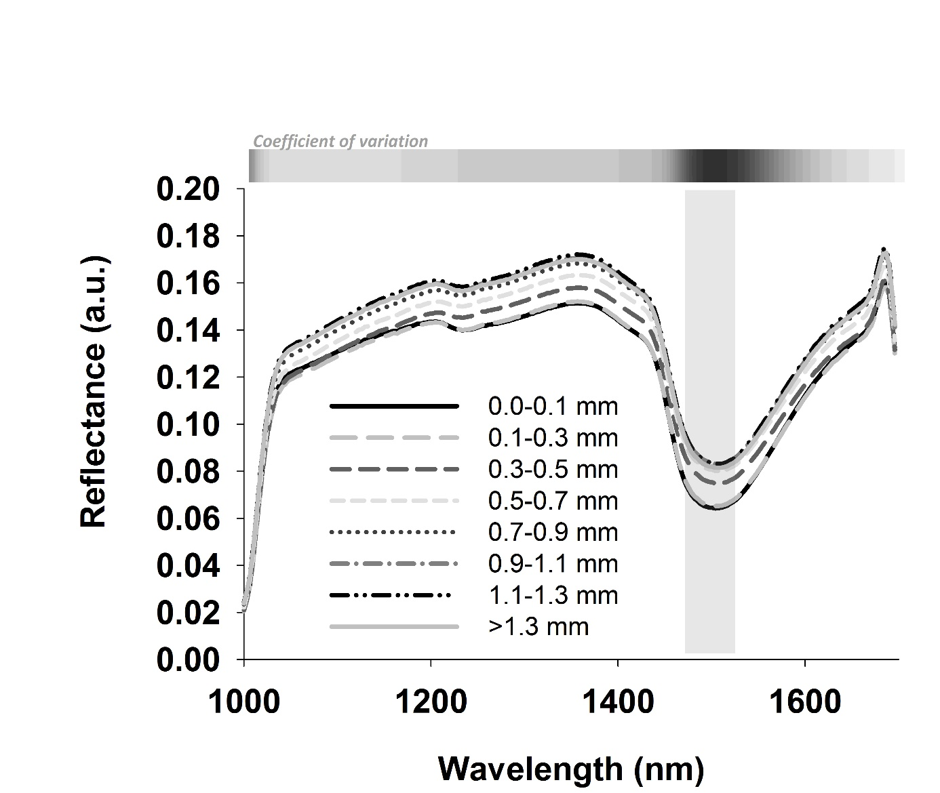

Additional File 6 Raw spectra of root pixels from centre (0-0.1 mm) to border region at 0.2 mm increment. Differentiation is indicated by the coefficient of variation (CV) over the measured wavelength region (horizontal bar; light grey low CV, black high CV). The vertical grey bar indicates the region with highest CV.

