Additional File 9 RGB image of sand grown root system with spectral segmentation and manual tracking.
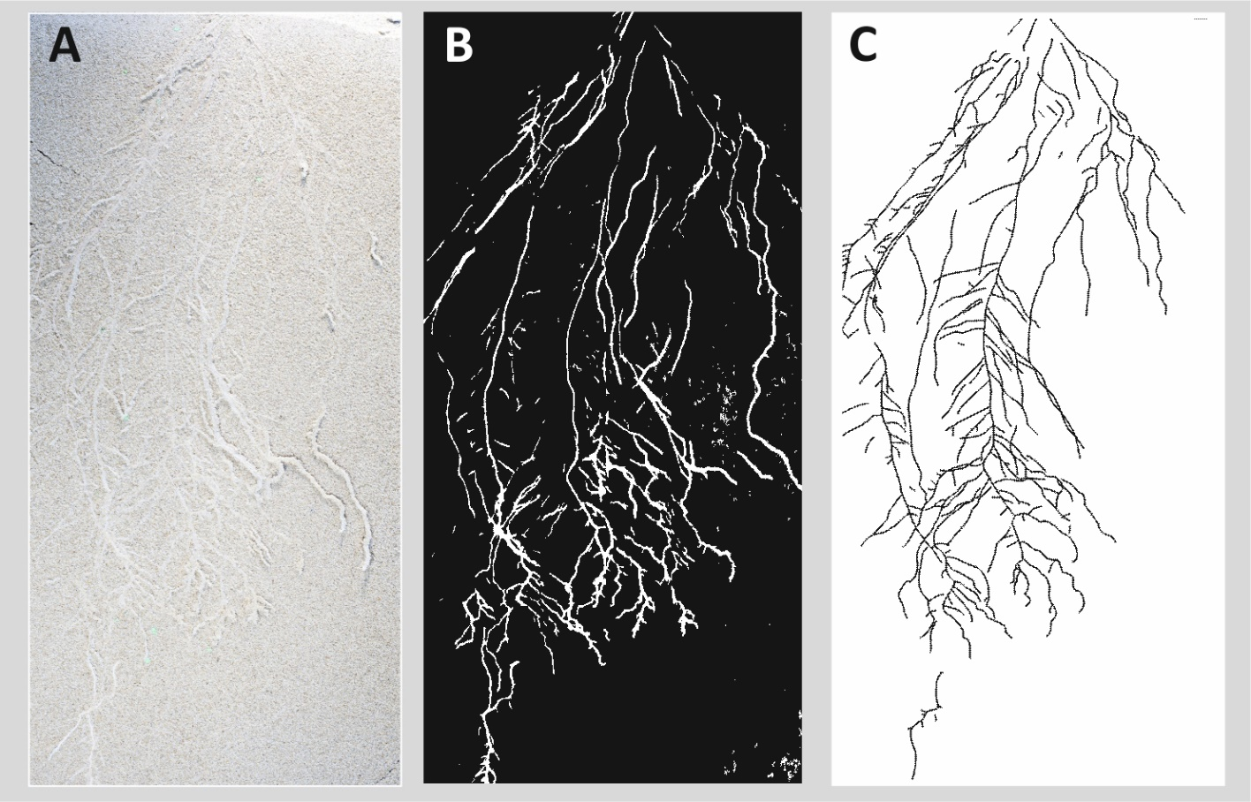
Additional File 9 Root grown in washed silica sand (0.1-0.3 mm particle diameter). The RGB image (A) reveals the low contrast between roots and soil background which makes colour based segmentation impossible. Spectral segmentation however is still feasible (B; obtained via fuzzy clustering). C shows the manually tracked reference root system.

