Figure S1

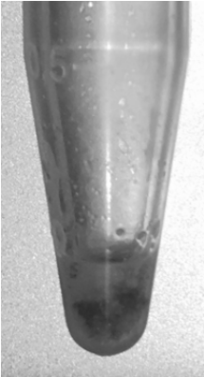
Figure S1 An example 1.5 ml Eppendorf tube (Harmondsworth Moor reference sample 1) showing the significant amount of biomass extracted from a single I. glandulifera seed in 100 µl of Solution 1.

Table S1
 |  | Reference samples
 |  | Harmondsworth Moor | Lampeter | Rhosmaen | Silwood Park
Test samples | Harmondsworth Moor | 2.224 | 1.361 | 1.485 | 1.477
 | Lampeter | 1.220 | 2.271 | 2.139 | 1.728
 | Rhosmaen | 1.389 | 2.120 | 2.331 | 1.834
 | Silwood Park | 1.356 | 1.662 | 1.830 | 2.364
Table S1 Average values, for each site-specific set of three unblinded test samples after Table 1, of the average Bruker scores against the site-specific triplicate reference spectra.

Table S2
 |  | Reference samples
 |  | Harmondsworth Moor | Lampeter | Rhosmaen | Silwood Park
Test samples | Harmondsworth Moor | 0.139 | 0.206 | 0.078 | 0.065
 | Lampeter | 0.271 | 0.081 | 0.045 | 0.180
 | Rhosmaen | 0.128 | 0.132 | 0.045 | 0.052
 | Silwood Park | 0.146 | 0.224 | 0.048 | 0.097
Table S2 Standard deviations, for each site-specific set of three unblinded test samples after Table 1, of the average Bruker scores against the site-specific triplicate reference spectra.

