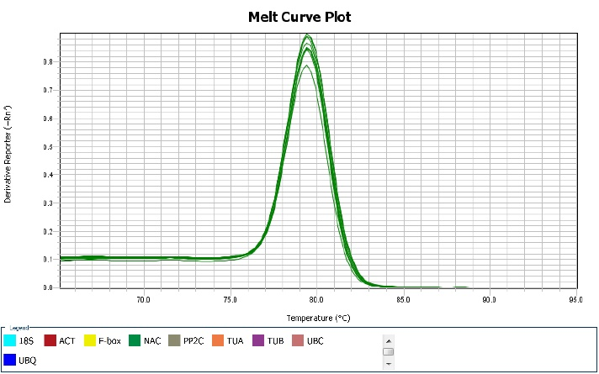
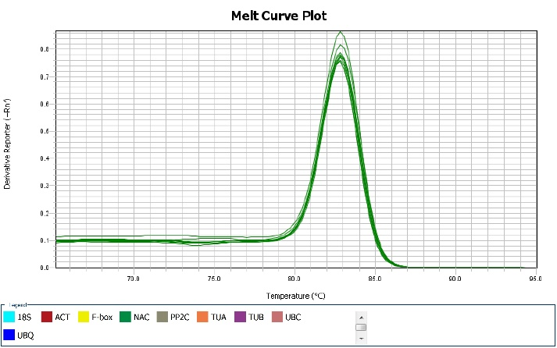
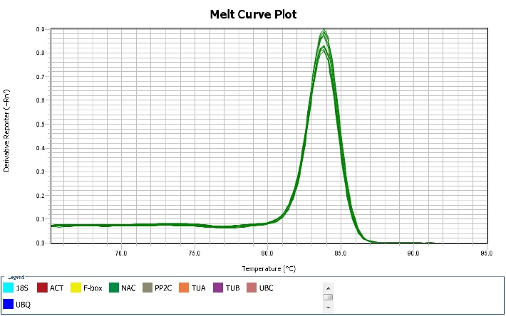
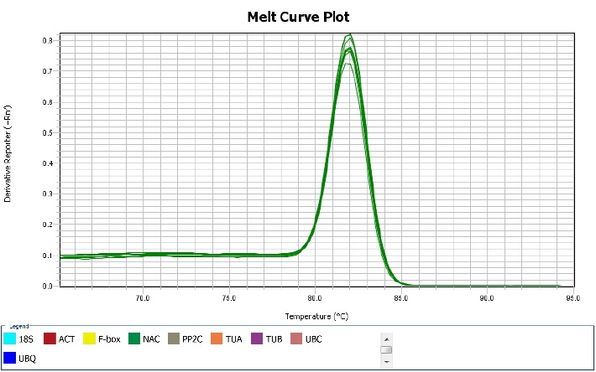
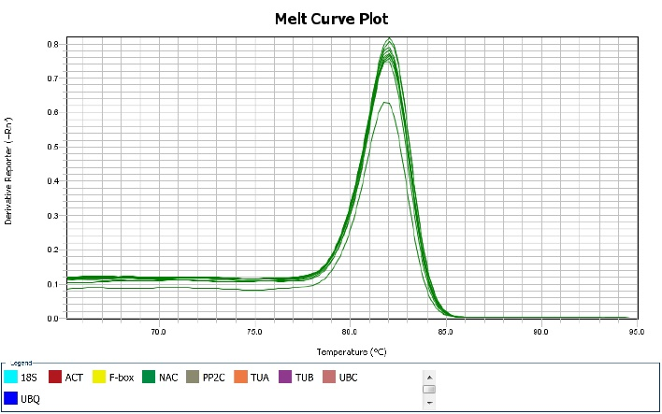
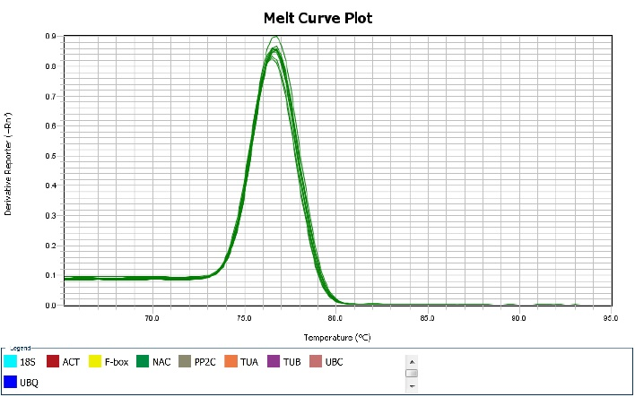
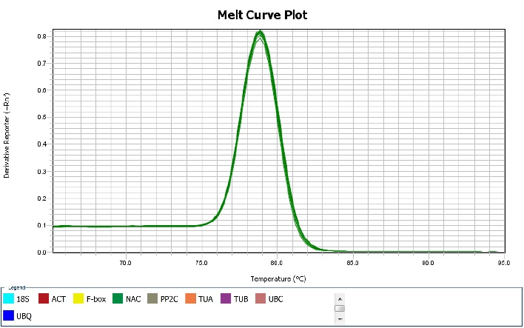
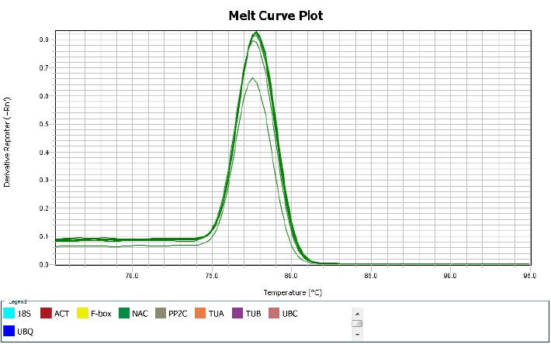
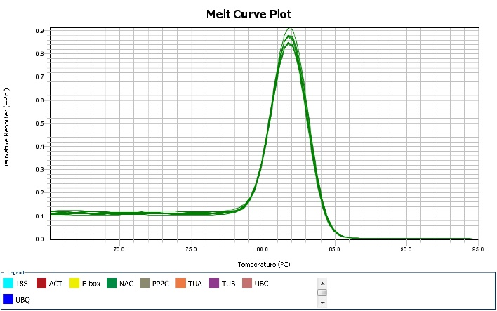
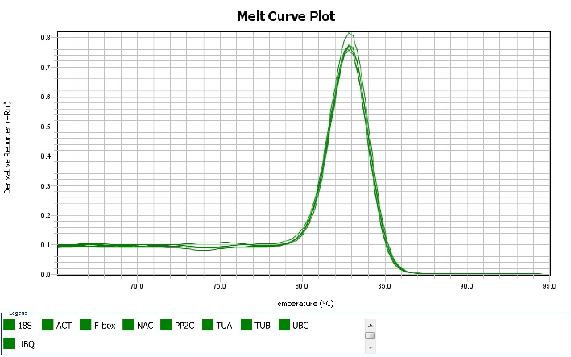
ACT
UBQ
NAC
F-box
PP2C
TUA
TUB
UBC
18S
ChNCS
A

ACT
UBQ
NAC
F-box
PP2C
TUA
TUB
UBC
18S
ChNCS
M
100bp
B
200bp

Additional file 1 Gene specificity and amplicon size. A: Melting curves of 9 reference genes and ChNCS showing single peaks; B: Agarose gel (2.0 %) electrophoresis showing amplification of a specific PCR product of the expected size for each gene.

