Explanation of statistics used to assess robustness
The tested variable with the most robust statistic is shown in bold in a grey highlighted box

% returned from FFTNLLS | Percentage of samples for which the algorithm could calculate a period estimate and define as ‘rhythmic’
RAE ratio average | Average ratio of amplitude error to amplitude. Represents amplitude robustness.
Period CV(%) | The coefficient of variation for all period estimates. Represents between sample period robustness.
Average of Period Err threshold | Average Period error-threshold for which the period estimate could vary and still give a good fit to the model (FFT-NLLS). Represents within sample period robustness.
Rhythm robustness testing

S1. Rhythm robustness table (wheat age Exp.1)

 | % returned from FFTNLLS | RAE ratio average | Period CV(%) | Average of Period Err threshold
18 days after sowing | 100 | 0.17 | 2.10 | 0.58
25 days after sowing | 100 | 0.16 | 1.52 | 0.51
32 days after sowing | 96.15 | 0.15 | 1.98 | 0.43
39 days after sowing | 82.61 | 0.22 | 3.23 | 0.67

 | % returned from FFTNLLS | RAE ratio average | Period CV(%) | Average of Period Err threshold
Leaf 1 | 100 | 0.22 | 3.16 | 0.65
Leaf 2 | 100 | 0.18 | 5.77 | 0.5
Leaf 3 | 100 | 0.23 | 5.25 | 0.66
Leaf 4 | 95.45 | 0.22 | 1.81 | 0.68
S2. Rhythm robustness table (wheat leaf Exp.1)

S3. Rhythm robustness table (Brassica leaf variation by plant age Exp.2)
 | % returned from FFTNLLS | RAE ratio average | Period CV(%) | Average of Period Err threshold
Age_20_Lea f_1 | 100.00 | 0.15 | 1.89 | 0.47
Age_20_Lea f_3 | 100.00 | 0.19 | 1.68 | 0.72
Age_20_Lea f_5 | 100.00 | 0.16 | 4.18 | 0.74
Age_25_Lea f_1 | 66.67 | 0.38 | 13.44 | 1.25
Age_25_Lea f_3 | 100.00 | 0.28 | 3.06 | 1.05
Age_25_Lea f_5 | 100.00 | 0.17 | 2.67 | 0.57
Age_30_Lea f_1 | 33.33 | 0.37 | 2.01 | 1.34
Age_30_Lea f_3 | 83.33 | 0.26 | 5.70 | 0.73
Age_30_Lea f_5 | 100.00 | 0.25 | 2.41 | 0.72
Age_35_Lea f_1 | 100.00 | 0.27 | 5.04 | 1.05
Age_35_Lea f_3 | 100.00 | 0.37 | 4.49 | 1.10
Age_35_Lea f_5 | 100.00 | 0.27 | 2.86 | 0.69

S4. Rhythm robustness table (wheat and Brassica cutting samples Exp.3)

 | % returned from FFTNLLS | RAE ratio average | Period CV(%) | Average of Period Err threshold
WHEAT
Whole | 100 | 0.16 | 1.99 | 0.47
10cm | 100 | 0.15 | 1.89 | 0.41
4cm top | 95.24 | 0.17 | 2.12 | 0.45
4cm bottom | 100 | 0.16 | 2.72 | 0.45
BRASSICA
Whole | 100 | 0.16 | 1.89 | 0.54
Square | 100 | 0.16 | 2.10 | 0.54
Quarter | 98.68 | 0.17 | 2.60 | 0.54

S5. Rhythm robustness table (D:D V L:L Exp.4)

 | % returned | RAE average | Period CV | Average of Period Err
Brassica DD | 66.67 | 0.53 | 11.80 | 1.62
Brassica LL | 100.00 | 0.13 | 1.34 | 0.41
Wheat DD | 100.00 | 0.20 | 2.25 | 0.55
Wheat LL | 95.83 | 0.38 | 13.53 | 1.17

S6. Rhythm robustness table (Temperature Exp.5)

 | % returned from FFTNLLS | RAE ratio average | Period CV(%) | Average of Period Err threshold
BRASSICA
12 | 100.00 | 0.14 | 2.72 | 0.55
17 | 100.00 | 0.16 | 3.61 | 0.50
22 | 100.00 | 0.16 | 2.24 | 0.52
WHEAT
17 | 73.91 | 0.64 | 13.63 | 2.69
22 | 100.00 | 0.19 | 5.01 | 0.57
27 | 100.00 | 0.15 | 2.78 | 0.48
32 | 100.00 | 0.23 | 1.38 | 0.74

S7. Calculation of Q10 temperature coefficient values

$Q_{10}={\left(\frac{R2}{R1}\right)}^{10/(T2-T1)}$

Where:

R=Period as a rate: 1 oscillation/time (hours). E.g: 1/24=0.042 oscillations/hour
T=Temperature °C
R1 is the rate at T1. R2 is the rate at T2.

S8. Wheat cultivar Genome Resource Unit information:

Line | Collection | Origin Country | Sowing Season | Type
Norin-61 | BBSRC_Wheat | Japan | Winter | Breeders line
Robigus | BBSRC_Wheat | UK | Winter | Advanced/improved cultivar
Claire | BBSRC_Wheat | UK | Winter | Advanced/improved cultivar
Paragon | BBSRC_Wheat | UK | Spring | Advanced/improved cultivar
Cadenza | BBSRC_Wheat | UK | Spring | Founder stock/base population
Weebil | WBCDB | Mexico | Spring | Founder stock/base population
Chinese Spring L42 | WBCDB | China | Spring | Founder stock/base population

S9. Spectral readings of light inside entrainment and imaging cabinets:

S10. Set up of equipment for delayed fluorescence:

An Arduino USB 2.0 cable connects the computer (1) to an Arduino board (2) controlled by a uManager BSH script. The Arduino sends a signal to a mains relay through two jumper wires (3) which converts power to 12V to turn the LED rig on and off.
The Lumo Reteiga CCD camera is mounted within a temperature regulated Sanyo MIR-553 growth cabinet. A Xenon 0.95/25mm lens is attached to the camera which is focused on a stage carrying the plate to be imaged. The lens fits through a customized hole in the LED rig.
The cabinet and camera are contained within a dark room sprayed matt black and the LEDs used have no afterglow so that total darkness can be created (grey box). The computer and controllers are positioned in the lab for ease of access (yellow box). Data from images taken by the camera are displayed post acquisition and are also automatically saved in a drive specified by the BSH script.
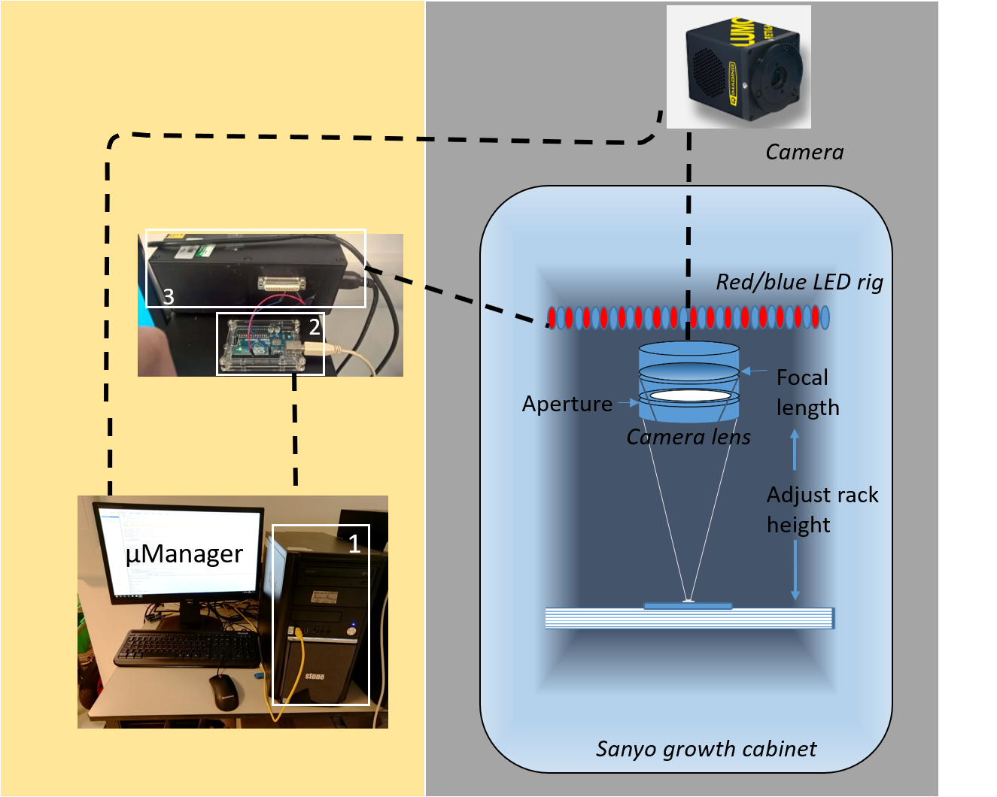

Additional Experiments
Independent experiments to those shown in the main figures. Any method differences have been highlighted.

S11. Additional experiments showing rhythms in wheat under D:D or L:L scripts:

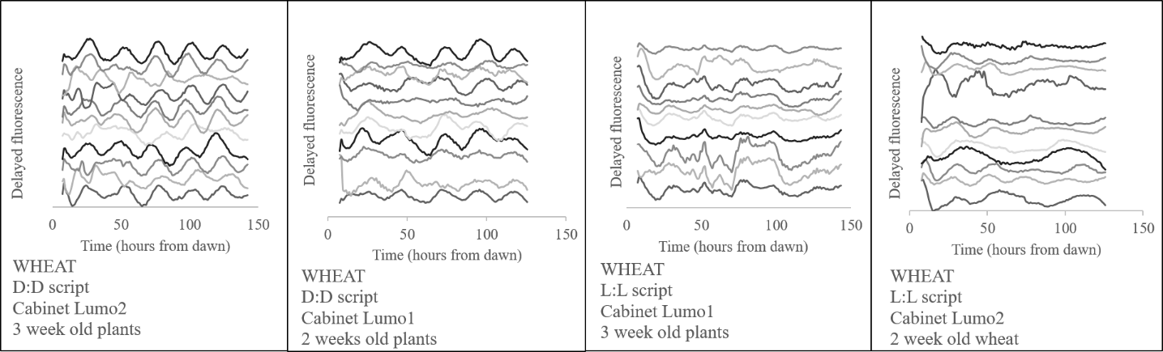
Delayed fluorescence between D:D v L:L scripts in wheat. 2 experiments- 2 week old and 3 week old wheat plants with two Lumo cameras with reciprocal tests of LL or DD script in each cabinet. Data is cubic de-trended, normalized to the mean intensity and then spread to show rhythmicity of each sample.

S12. Additional experiments showing rhythms in Brassica oleracia under D:D or L:L scripts:

Delayed fluorescence between D:D v L:L scripts in 6 different Brassica oleracia species. 2 experiments- 2 week old and 3 week old plants with two cameras with a L:L script used for the 2 week old experiments and the D:D script used for the 3 week old experiments. Data is cubic de-trended, normalized to the mean intensity and then spread to show rhythmicity of each sample.

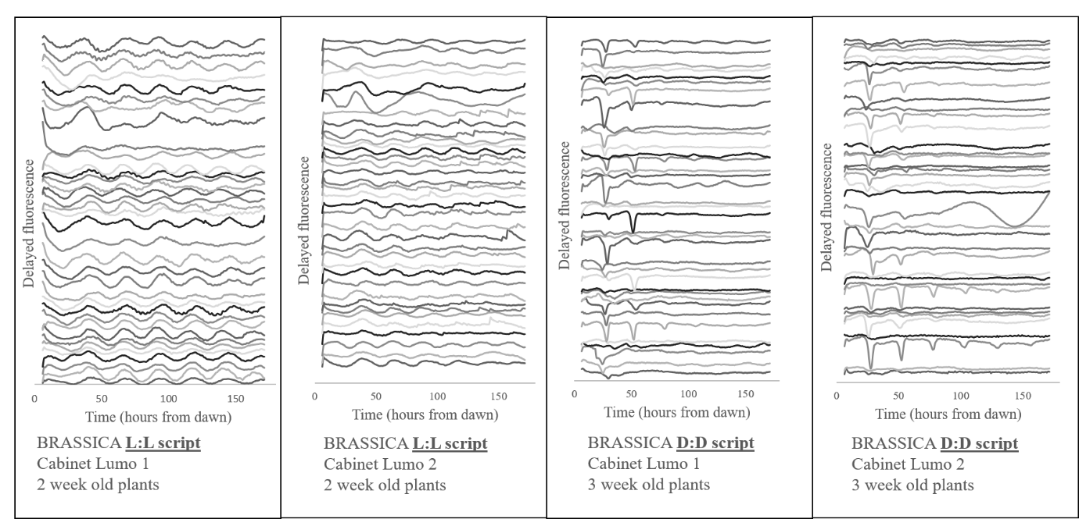

S13. Additional experiments showing rhythms in Wheat under 17°C or 22°C:

Delayed fluorescence in wheat under 17C or 22C temperature entrainment and imaging conditions. Temperatures were tested over 2 separate experiments using two Lumo cameras with a D:D script. Plants were either 18 or 25 days old and whole leaves were used. Data is cubic de-trended, normalized to the mean intensity and then spread to show rhythmicity of each sample.
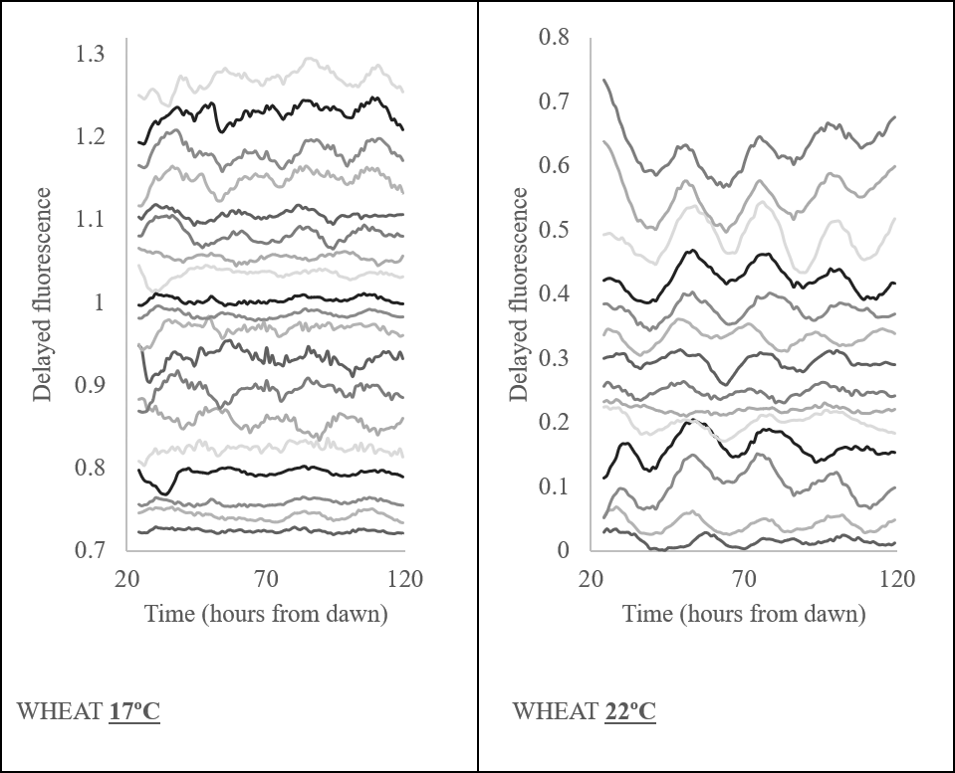
S14: Additional experiments of the three brassica cultivars from Figure 6

Periods detected from delayed fluorescence rhythms under L:L conditions at 22C from three independent technical replicates. Data is BAMP dtr. Cabriolet N=9/9, Chuanyou II N=7/9 and Norin N=9/9.

