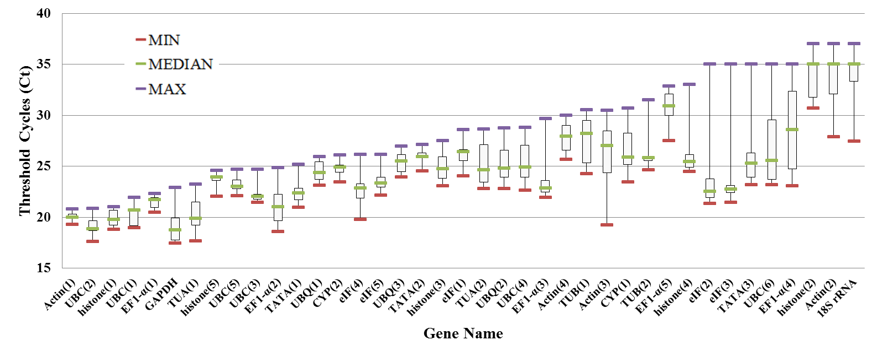
Additional file 5: Fig. S3. Boxplot analyses of 39 reference genes from eight different tissues (including roots, stems, flowers and fruits) of Hylocereus. The whisker caps show the distribution of the highest and lowest Ct values. The boxes indicate the first and third quartile, while the middle line marks the median.

