Additional file 10: Balloon plot nutrient solutions
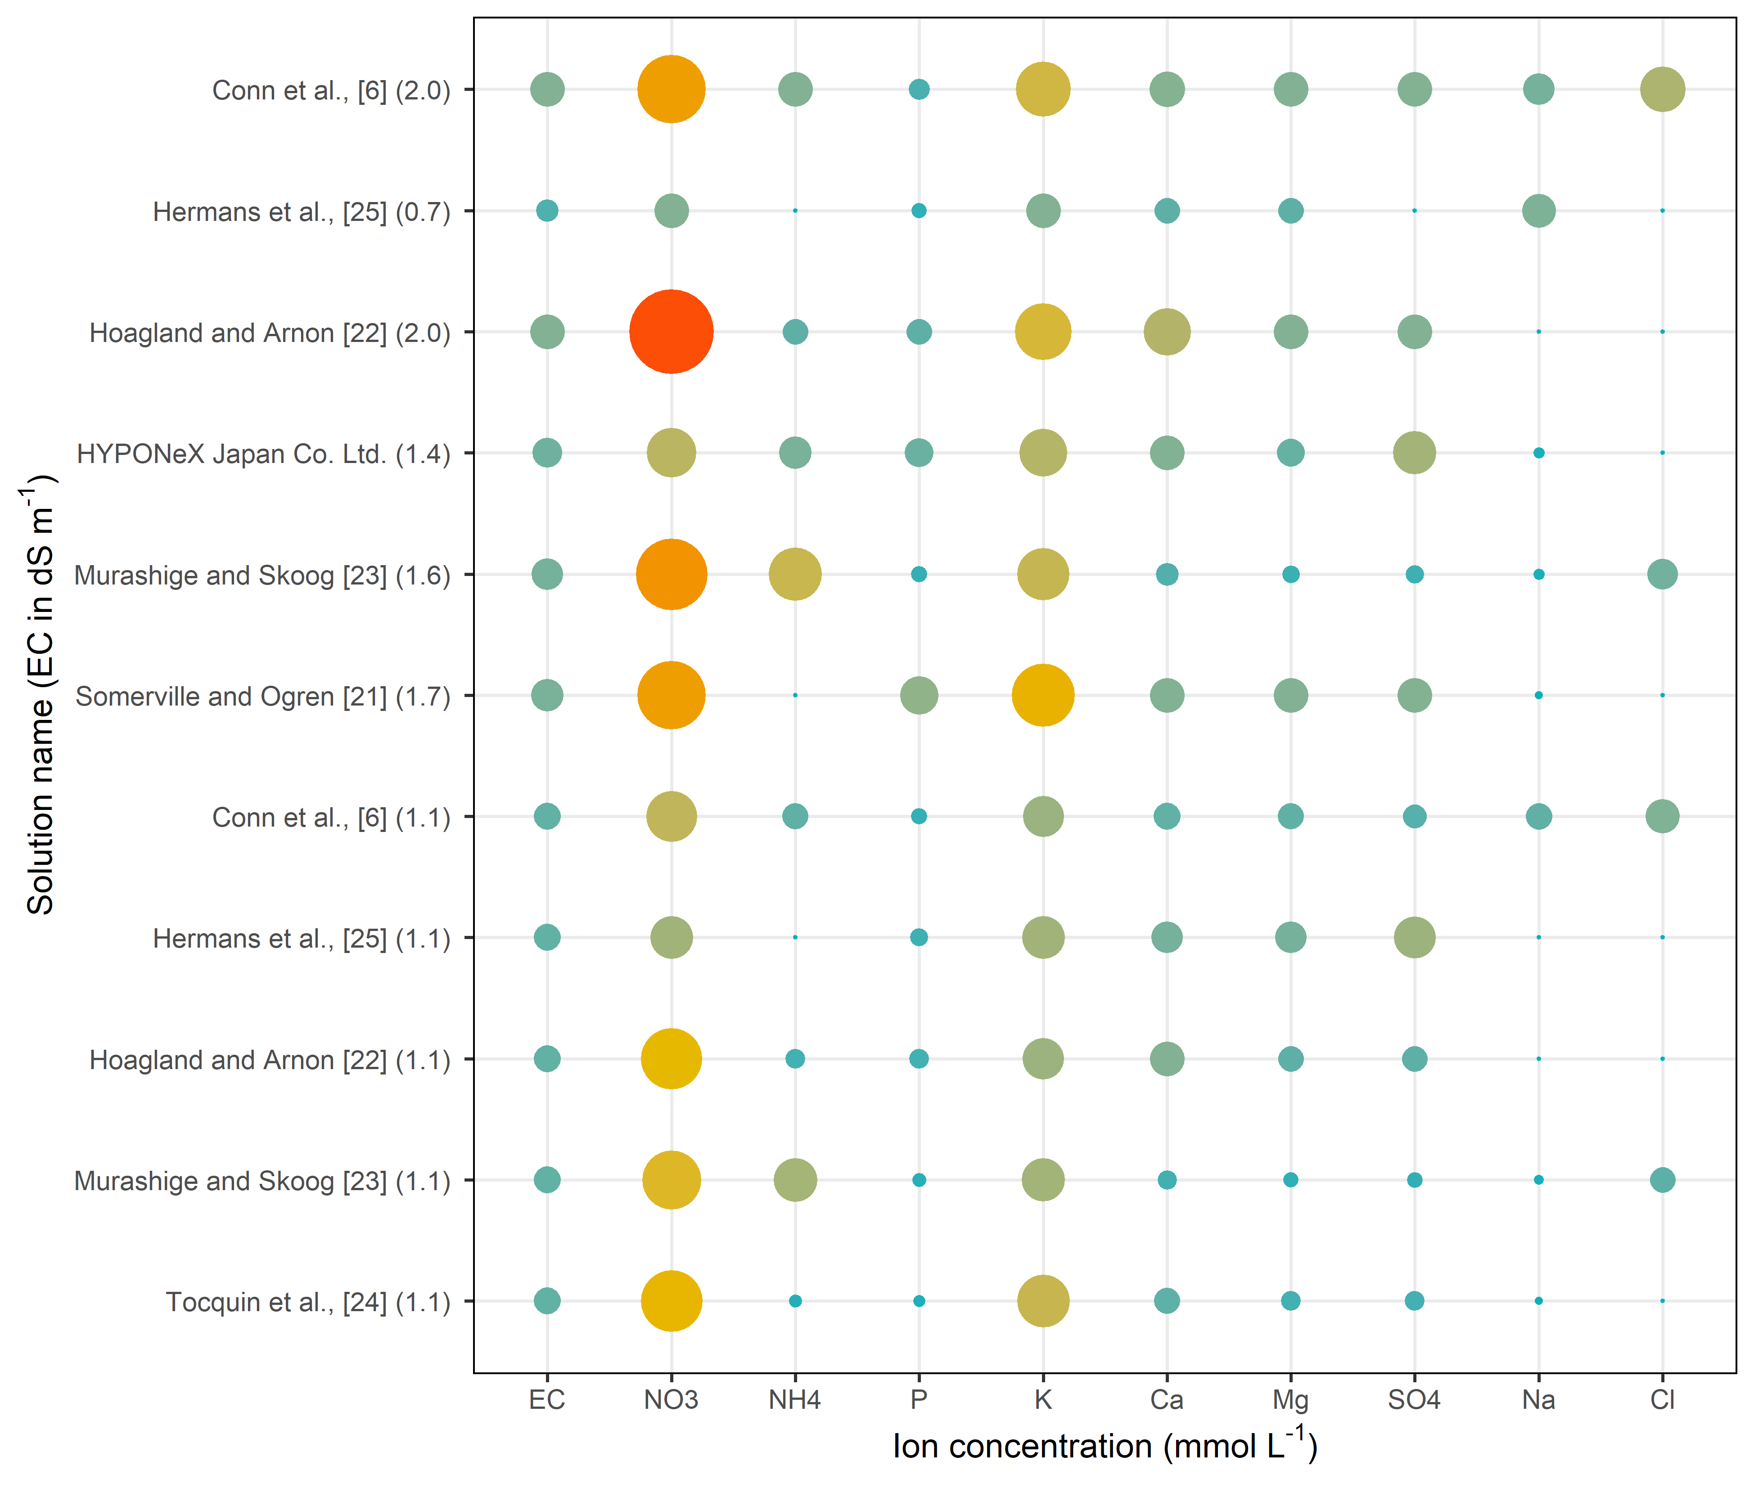
Fig. S10. Balloon plot of nutrient solution composition for intuitive visible comparison, nutrient solution names are followed by their (EC) in dS m⁻¹. Balloon sizes are normalized on the maximal value (14).

