Additional file 12: Germination and seedling system
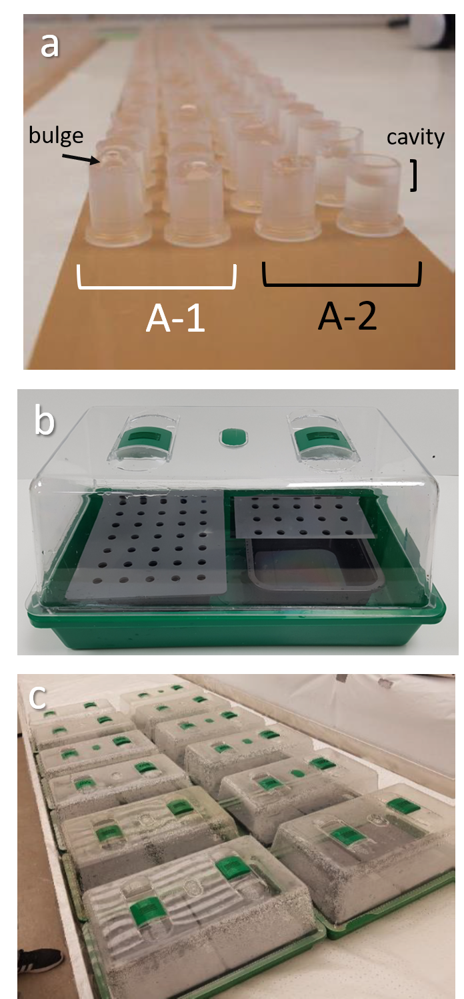
Fig. S12. Photos of germination system. (a) Microtubes filled with germination medium placed upside down on brown scotch adhesive tape. (b) A mini greenhouse with two 0.7 L PP (food grade) nutrient solution tanks (18.2 x 13.5 x 4.5 cm) covered by two BPA-free PVC lids (20 x 15 cm) containing 35 holes for microtubes. (c) Overview of germination phase in several mini greenhouses.

