Additional file 1: Somerville and Ogren (1982) solution from Arteca and Arteca (2000)

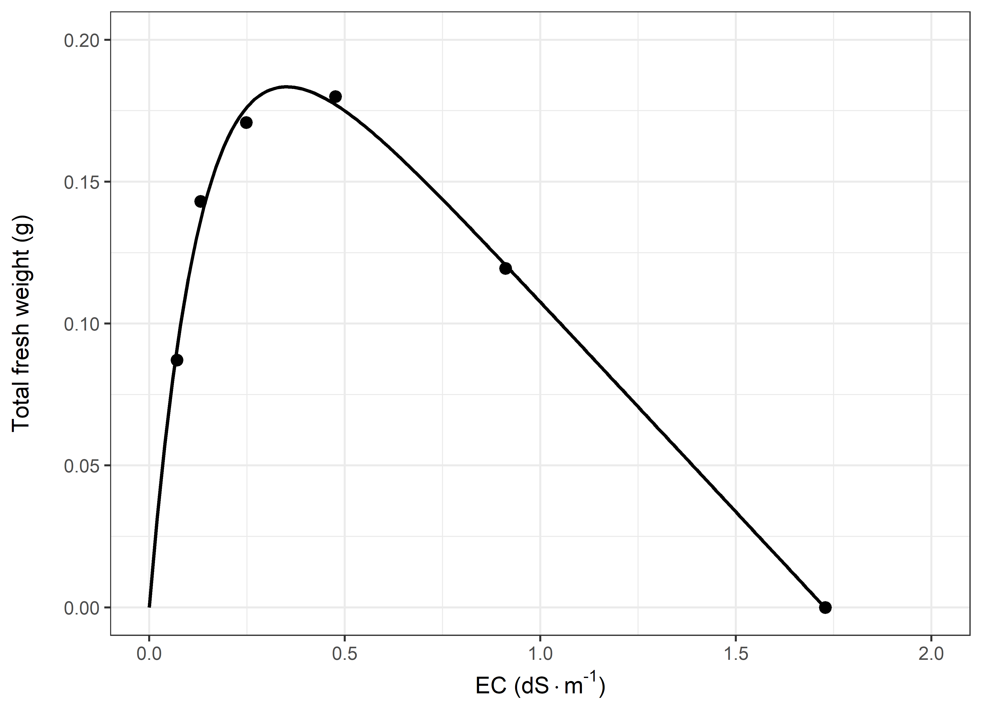
Fig. S1. Redrawing of the bar graphs that showed fresh weight in response to Somerville nutrient solution concentration (Arteca and Arteca [9]) to a dose response curve of nutrient solution concentration expressed in EC (dS m⁻¹ ) versus fresh weight (g). Fitted with an optimum curve $W(EC)=a∙\left(1-e^{-b∙EC}\right)∙\left(-EC+{EC}_{max}\right)$ were W is plant weight in grams, $a$ and $b$ determine the slope and optimum of the curve and ${EC}_{max}$is the EC at which the solution is lethal.

