Additional file 6: Plants on Murashige and Skoog (MS) solution
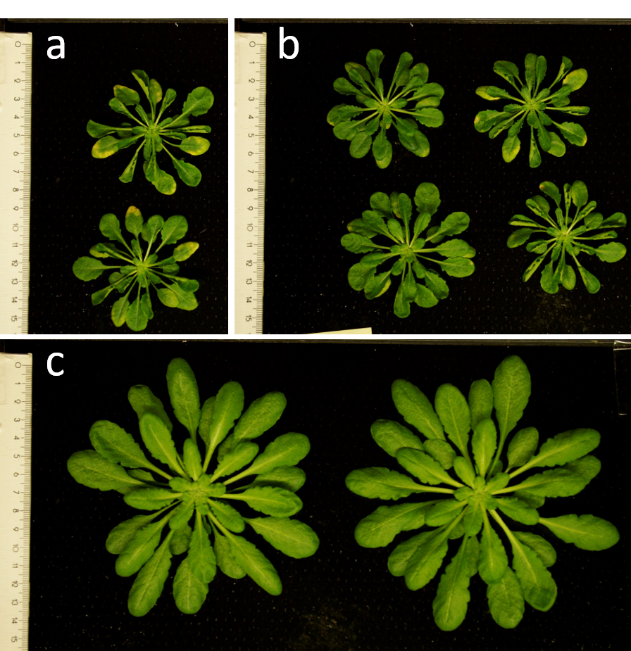
Fig S6. Arabidopsis plants 45 DAS grown on (a) Murashige and Skoog [23] 1.1 dS m⁻¹ , (b) ¼ x Murashige and Skoog [23] 1.6 dS m⁻¹ and (c) full concentration Tocquin et al., [24] solution 1.1 dS m⁻¹.

