Additional file 1
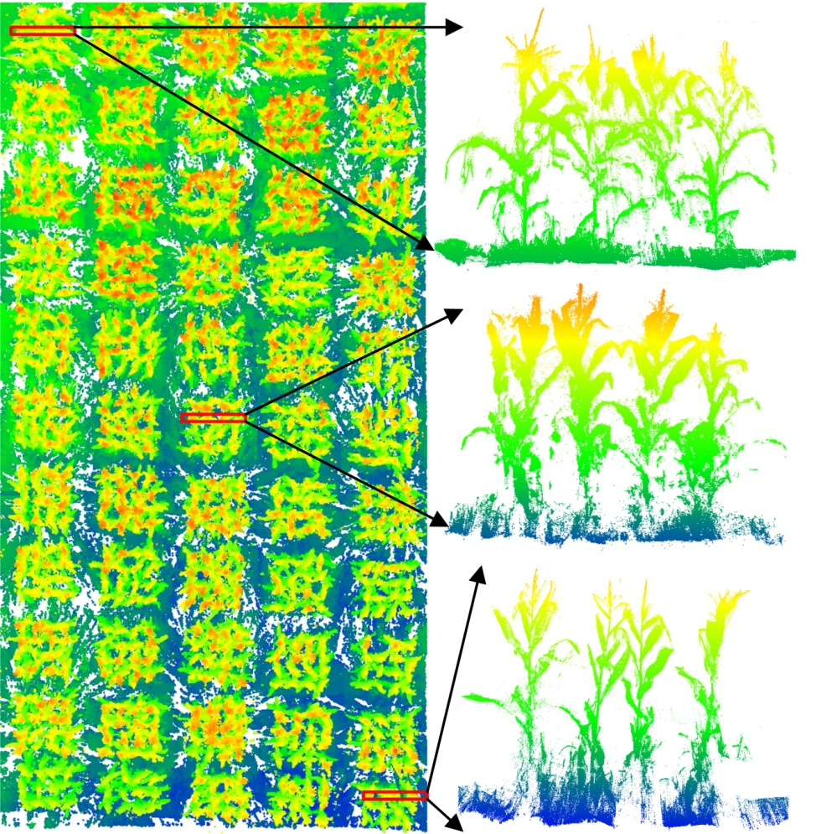
Figure S1. Point cloud examples of three randomly selected profiles with a width of 0.4 m

