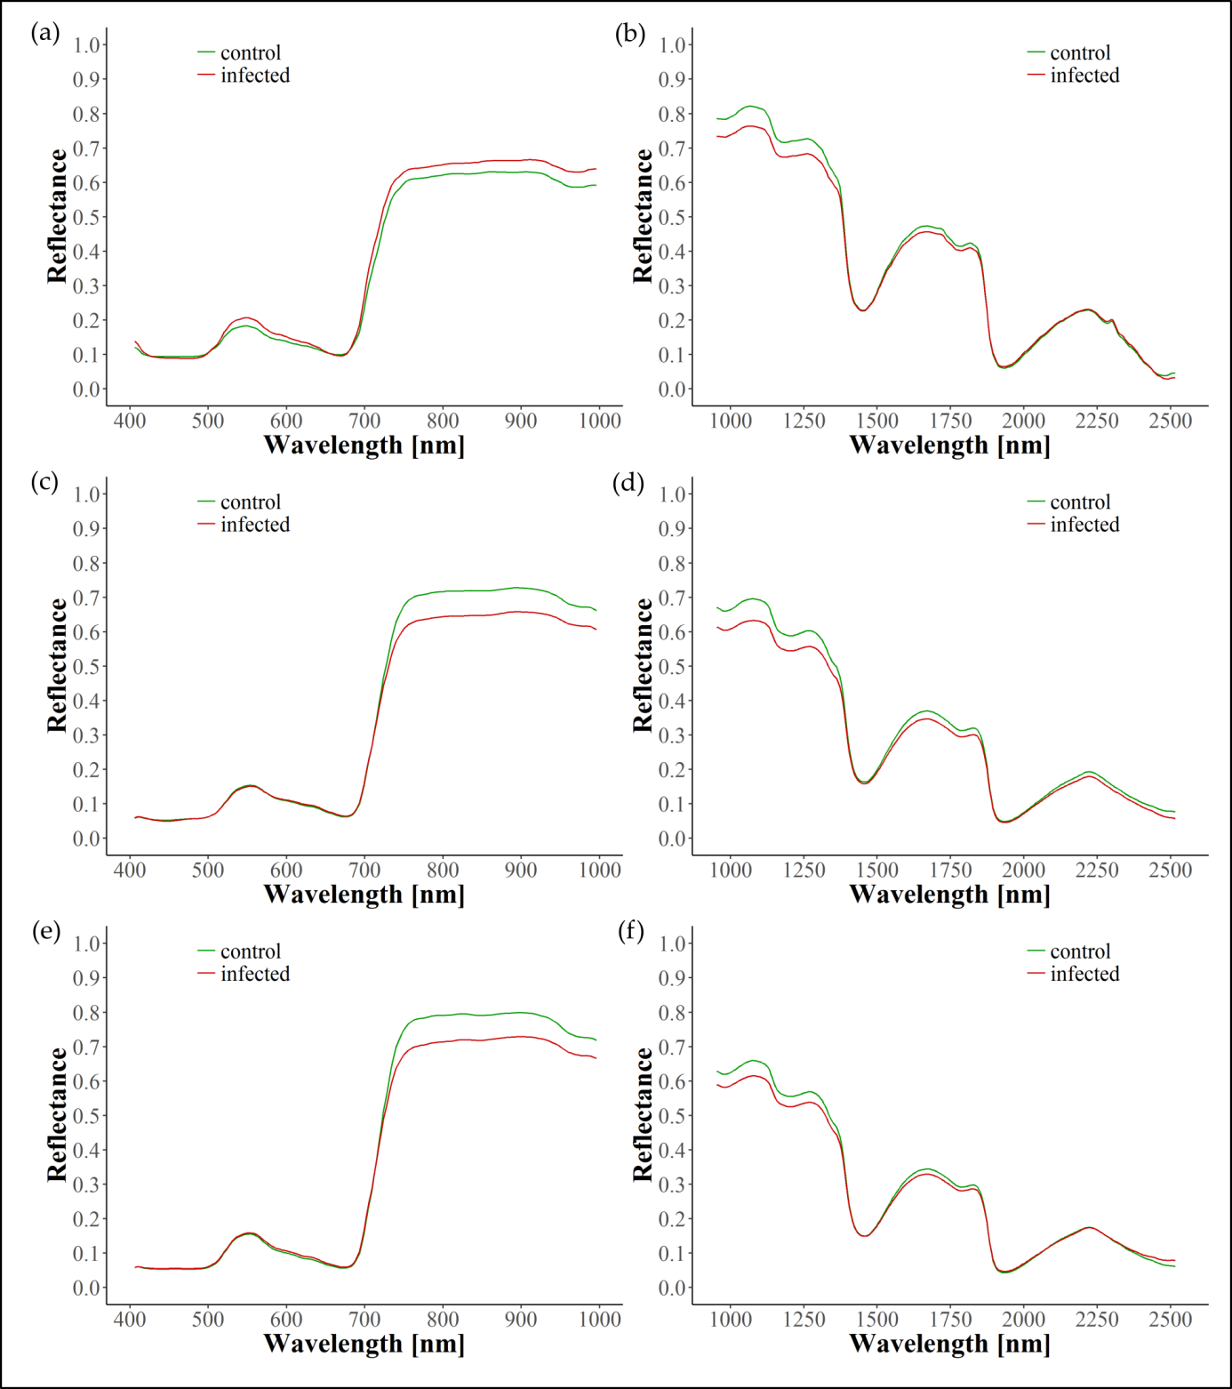
Figure 1: Spectral reflectance corresponding to the average of control (green) and infected (red) symptomatic (original) leaves for VNIR (left) and SWIR (right). Spectra are depicted for the years 2016 (a, b), 2017 (c, d), and 2018 (e, f).

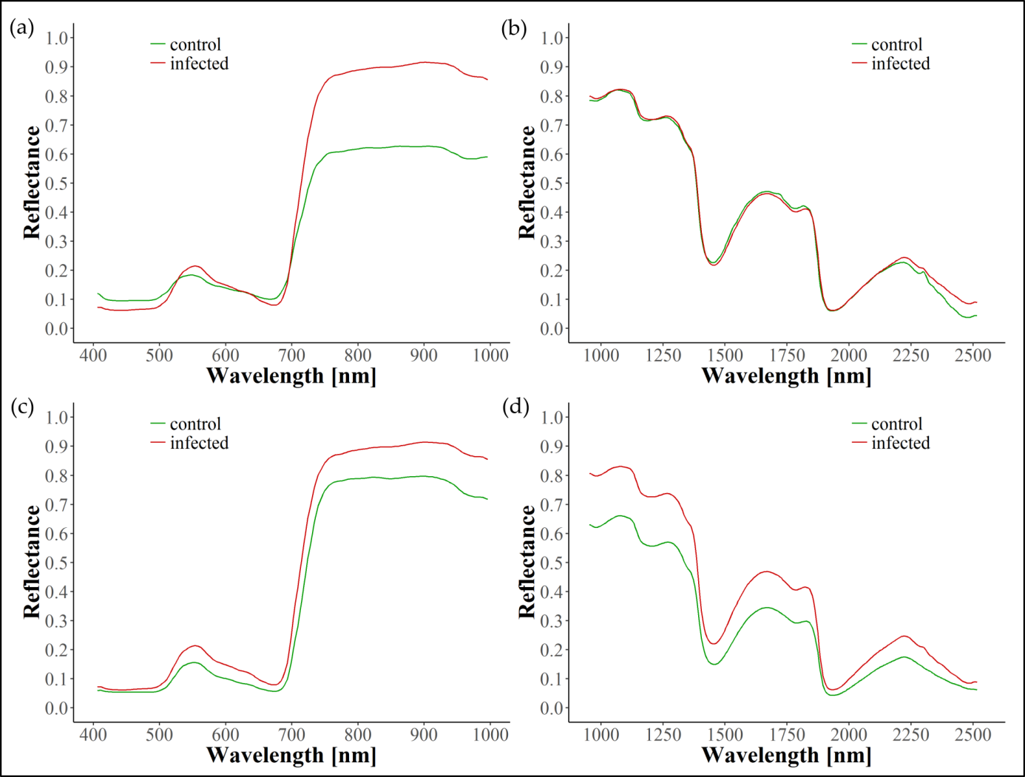
Figure 2: Spectral reflectance corresponding to the average of control (green) and infected (red) symptomatic (annotated) leaves for VNIR (left) and SWIR (right). Spectra are depicted for the years 2016 (a, b) and 2018 (c, d).

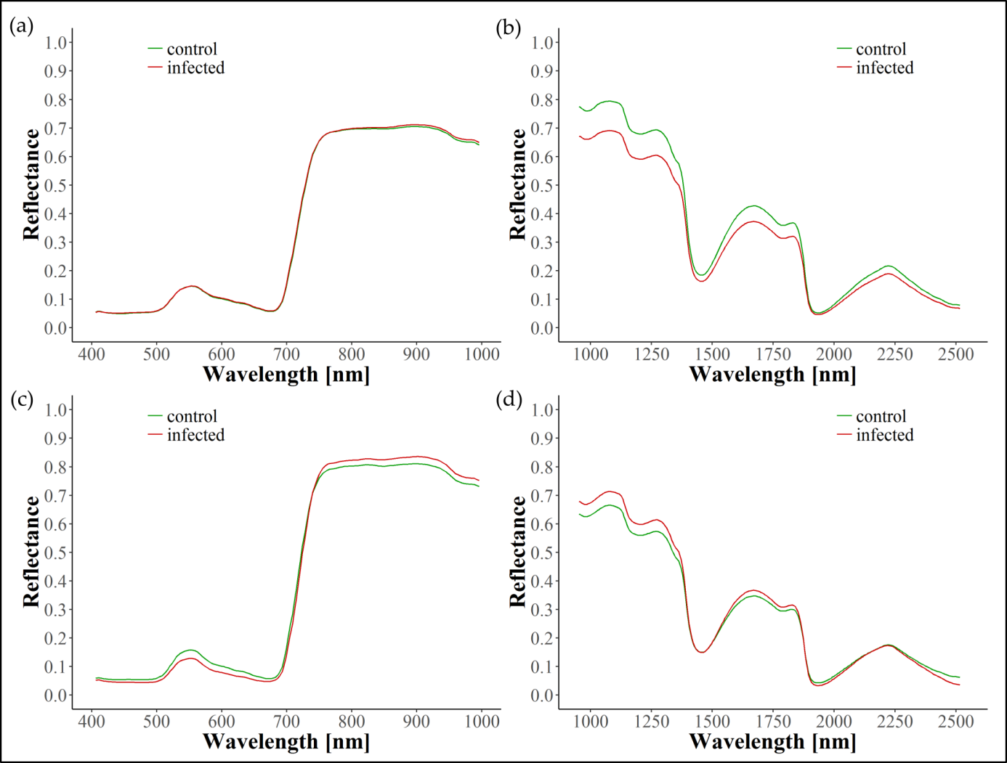
Figure 3: Spectral reflectance corresponding to the average of control (green) and infected (red) pre-symptomatic leaves for VNIR (left) and SWIR (right). Spectra are depicted for the years 2017 (a, b) and 2018 (c, d).

