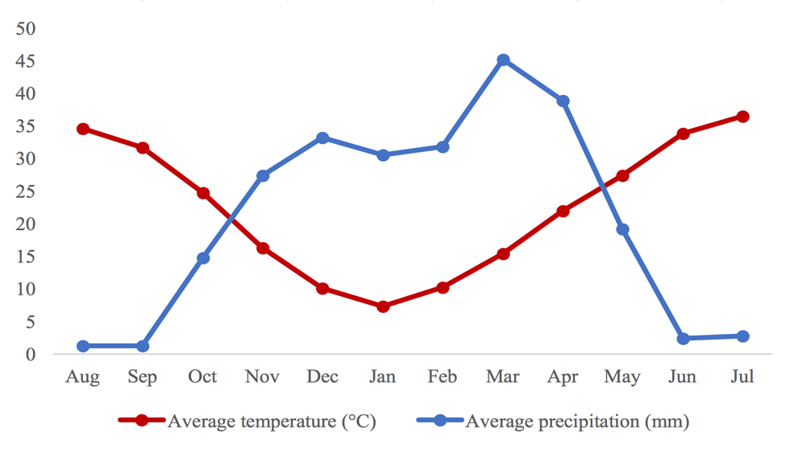
Fig. S2 Climate condition including average temperature (ºC) and precipitation (mm) at the Kheirabad Agricultural Research Station in Zanjan province during the 2017-2018 cropping season.

