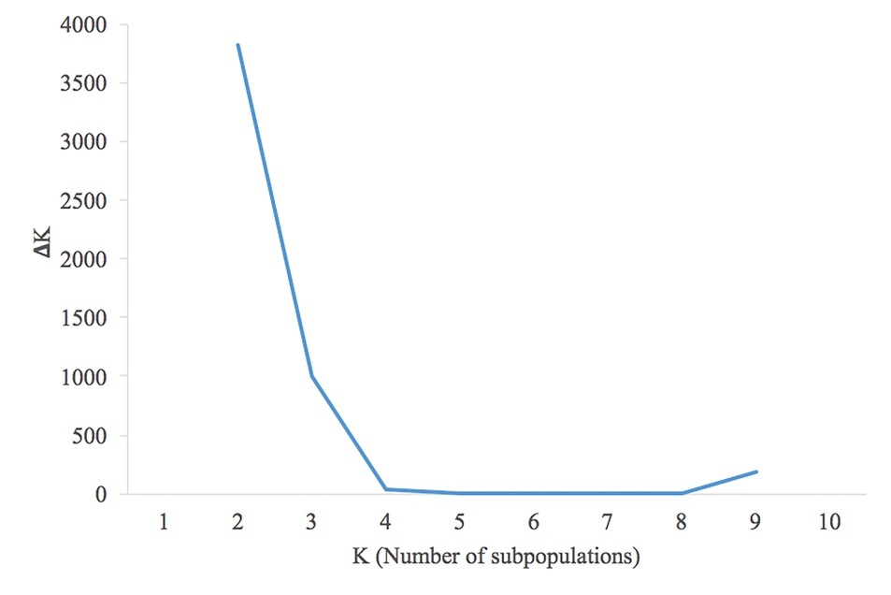

Fig. S3 ∆K values calculated for K = 1 to 10 to determine the number of subpopulations in a panel of 286 bread wheat accessions from Iran historical germplasm.

