Supplemental materials

Fast photosynthesis measurements for phenotyping photosynthetic capacity of rice

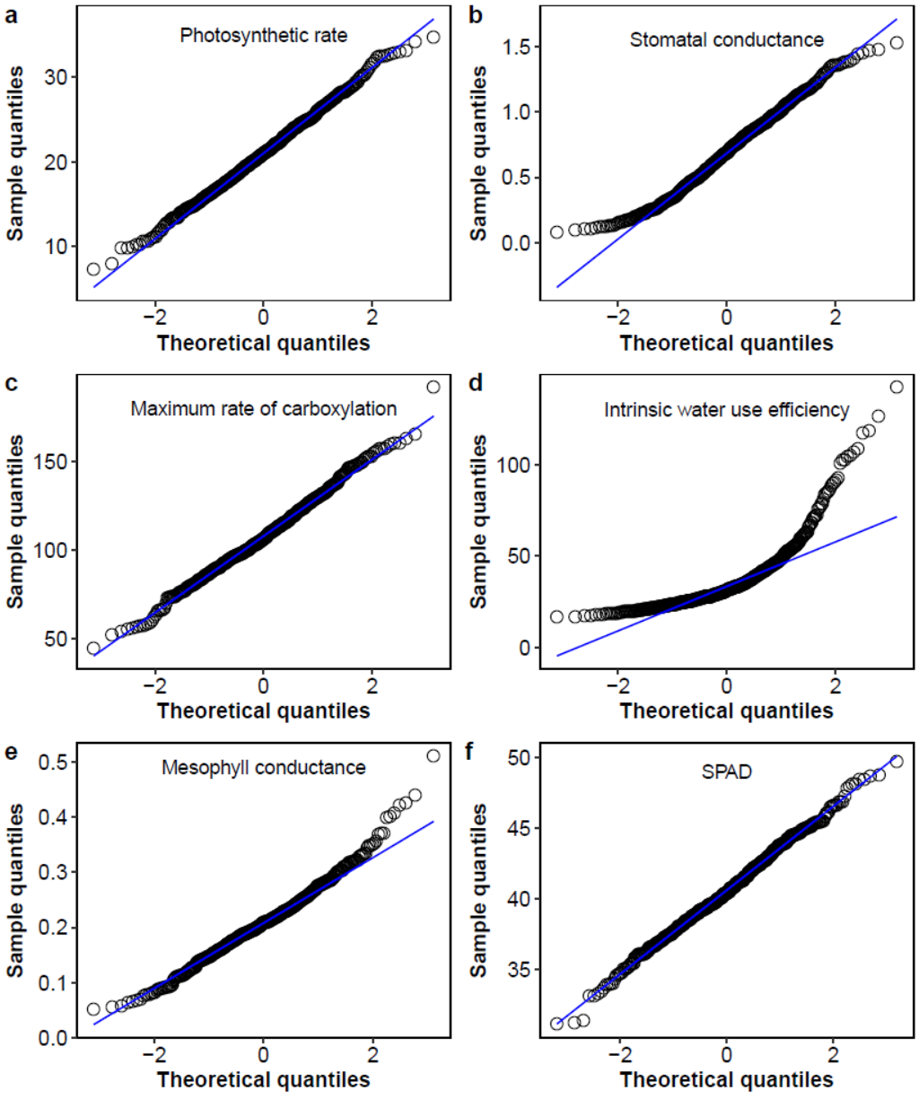

Figure S1 Normal Q-Q plot of photosynthetic traits.

