Additional File 1
Figure S1. Calibration curve of the miniature air flow transmitters. The straight line represents the overall regression (all sensors).

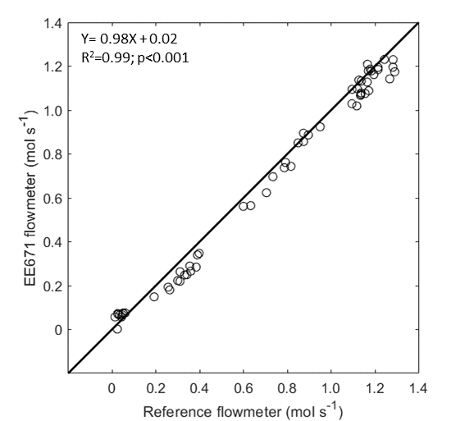

Figure S2. Changes in ΔCO₂ at different air flux levels when scrubbing the air with soda lime. The data show all ramps (i.e. different pump speeds) normalized from 0 to 1 and averaged every 20 seconds.

