Electronic Supplemental Information

Simple and Efficient Isolation of Plant Genomic DNA using Magnetic Ionic Liquids
Miranda N. Emaus, Cecilia Cagliero, Morgan R. Gostel, Gabriel Johnson, and
Jared L. Anderson*
Author details
MNE: Department of Chemistry, Iowa State University, Ames, Iowa 50011, USA, email: memaus@iastate.edu
CC: Dipartimento di Scienza e Tecnologia del Farmaco, Università degli Studi di Torino, I-10125, Turin, Italy, email: cecilia.cagliero@unito.it
MRG: Botanical Research Institute of Texas, Fort Worth, Texas 76132, USA, email: mgostel@brit.org
GJ: Smithsonian Institution, Suitland, Maryland 20746, USA, email: JohnsonG@si.edu
JLA: Department of Chemistry, Iowa State University, Ames, Iowa 50011, USA, email: andersoj@iastate.edu
* Corresponding author:
Jared L. Anderson
Department of Chemistry
Iowa State University
1605 Gilman Hall
Ames, IA 50011
Tel.: +1 515-294-8356
E-mail address: andersoj@iastate.edu

Table of Contents

Table S1 | p. S3
Table S2 | p. S4
Table S3 | p. S5
Figure S1 | p. S6
Figure S2 | p. S7
Figure S3 | p. S8
Figure S4 | p. S9
Figure S5 | p. S10
Figure S6 | p. S11
Figure S7 | p. S12
Figure S8 | p. S13
Figure S9 | p. S14
Figure S10 | p. S15
Figure S11 | p. S16
Figure S12 | p. S17
Figure S13 | p. S18
Figure S14 | p. S19
Figure S15 | p. S20
Figure S16 | p. S21
Figure S17 | p. S22
Figure S18 | p. S23
Figure S19 | p. S24
Figure S20 | p. S25
Figure S21 | p. S26
Figure S22 | p. S27

Table S1: Sequences of the ITS primers and DNA sequences used in this study.
Name | Sequence
ITS 3 | 5’-GCA TCG ATG AAG AAC GCA GC-3’
ITS 4 | 5’-TCC TCC GCT TAT TGA TAT GC-3’
Forward Non-target Primer | 5’-TTCATGAAGACCTCACAGTAAA-3’
Reverse Non-target Primer | 5’-GGATCCAGACAACTGTTCAA-3’
98 bp Non-target Sequence | 5’-TTCATGAAGACCTCACAGTAAAAATAGGTGAT TTTGGTCTAGCTACAGtGAAATCTCGATGGAGTGGG  TCCCATCAGTTTGAACAGTTGTCTGGATCC-3’
210 bp Insert | 5’-TATATTTCTTCATGAAGACCTCACAGTAAAAA TAGGTGATTTTGGTCTAGCTACAGTGAAATCT CGATGGAGTGGGTCCCATCAGTTTGAACAGT TGTCTGGATCCATTTTGTGGATGTAAGAATTG AGGCTATTTTTCCACTGATTAAATTTTTGGCCC TGAGATGCTGCTGAGTTACTAGAAAGTCATTG  AAGGTCTCAACTATAGT-3’

Table S2: Summary of thermocycling parameters used in this study.
 | Volume of Solvent (µL) | Initial Hold (min) | Denaturation Temperature (°C) | Denaturation Time (s) | Annealing Temperature (°C) | Annealing Time (s) | qPCR compatible
Genomic Plant DNA | 0.3 | 10 | 95 | 15 | 65 | 45 | Yes
Genomic Plant DNA | 6 | 10 | 95 | 15 | 60 | 45 | Yes
Non-target DNA sequence | 0.3 | 2 | 95 | 5 | 60 | 30 | Yes
Non-target DNA sequence | 6 | 2 | 95 | 5 | 60 | 30 | Yes
Phire Assay | N/A | 5 | 98 | 5 | 62 | 20 | No

Table S3: Summary of all PCR assays used in this study.
DNA Sequence | MIL or IL | Volume of MIL (µL) | Reaction Volume (µL) | Buffer Type | Primer Concentration (nM) | Additives
Plant Genomic DNA | N/A | 0 | 20 | SSO Supermix | 200 | None
Plant Genomic DNA | [P_{6,6,6,14}⁺][Ni(hfacac)₃⁻], [P_{6,6,6,14}⁺][Co(hfacac)₃⁻], and [P_{6,6,6,14}⁺][NTf₂⁻] | 0.3 | 20 | SSO Supermix | 200 | - 1x Sybr Green
Plant Genomic DNA | [P_{6,6,6,14}⁺][Ni(hfacac)₃⁻] | 6 | 20 | SSO Supermix | 200 | - 2x Sybr green  - 0.05% Tween20  - 2.5% DMSO  - 5 mM MgCl₂
Plant Genomic DNA | [P_{6,6,6,14}⁺][NTf₂⁻] | 6 | 20 | SSO Supermix | 200 | - 2x Sybr green  - 0.05% Tween20  - 2.5% DMSO
Plant Genomic DNA | N/A | N/A | 50 | Phire Buffer | 500 | None
Non-target DNA | N/A | 0 | 20 | SSO Supermix | 1000 | None
Non-target DNA | [P_{6,6,6,14}⁺][Ni(hfacac)₃⁻], [P_{6,6,6,14}⁺][Co(hfacac)₃⁻], and [P_{6,6,6,14}⁺][NTf₂⁻] | 0.3 | 20 | SSO Supermix | 1000 | 1x Sybr Green
Non-target DNA | [P_{6,6,6,14}⁺][Ni(hfacac)₃⁻] | 6 | 20 | SSO Supermix | 1000 | - 2x Sybr green  - 0.05% Tween20  - 2.5% DMSO  - 5 mM MgCl₂
Non-target DNA | [P_{6,6,6,14}⁺][NTf₂⁻] | 6 | 20 | SSO Supermix | 1000 | - 2x Sybr green  - 0.05% Tween20  - 2.5% DMSO

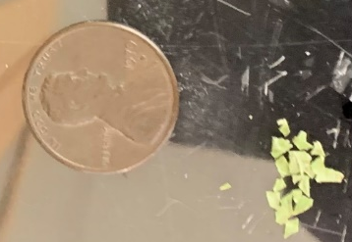
Figure S1: Image of the cut-up plant tissue next to a US penny as a scale.

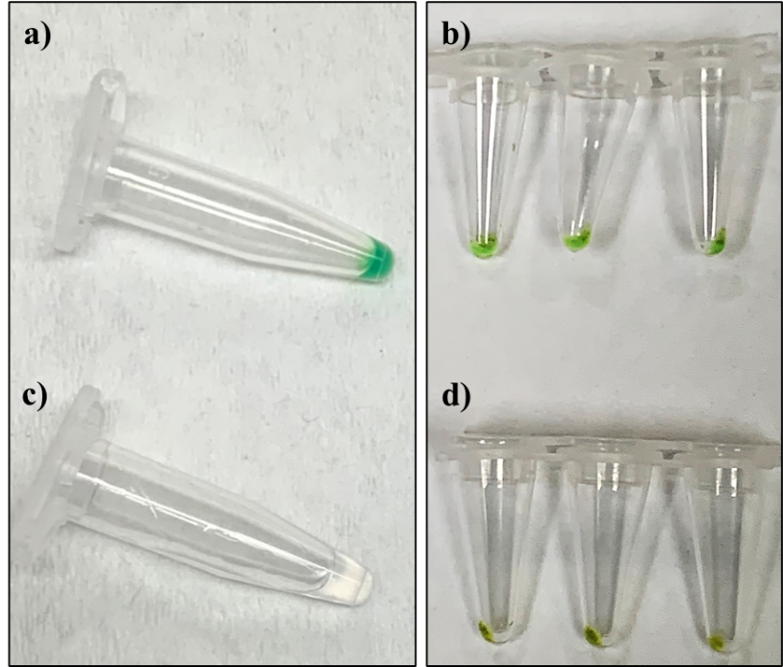
Figure S2: The a) [P_{6,6,6,14}⁺][Ni(hfacac)₃⁻] MIL and c) [P_{6,6,6,14}⁺][NTf₂⁻] IL prior to cell disruption and extraction, and the b) [P_{6,6,6,14}⁺][Ni(hfacac)₃⁻] MIL and d) [P_{6,6,6,14}⁺][NTf₂⁻] IL after exposing the hydrophobic solvent to 40 mg of ground plant tissue for 30 min.

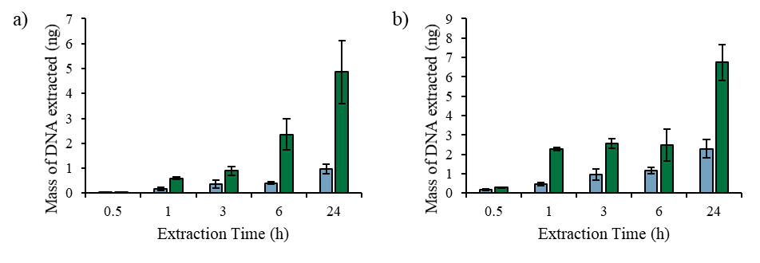
Figure S3: DNA extracted from 40 mg of (blue) in-tact and (green) cut-up plant tissue using the (a) [P_{6,6,6,14}⁺][Ni(hfacac)₃⁻] MIL and (b) [P_{6,6,6,14}⁺][NTf₂⁻] IL.

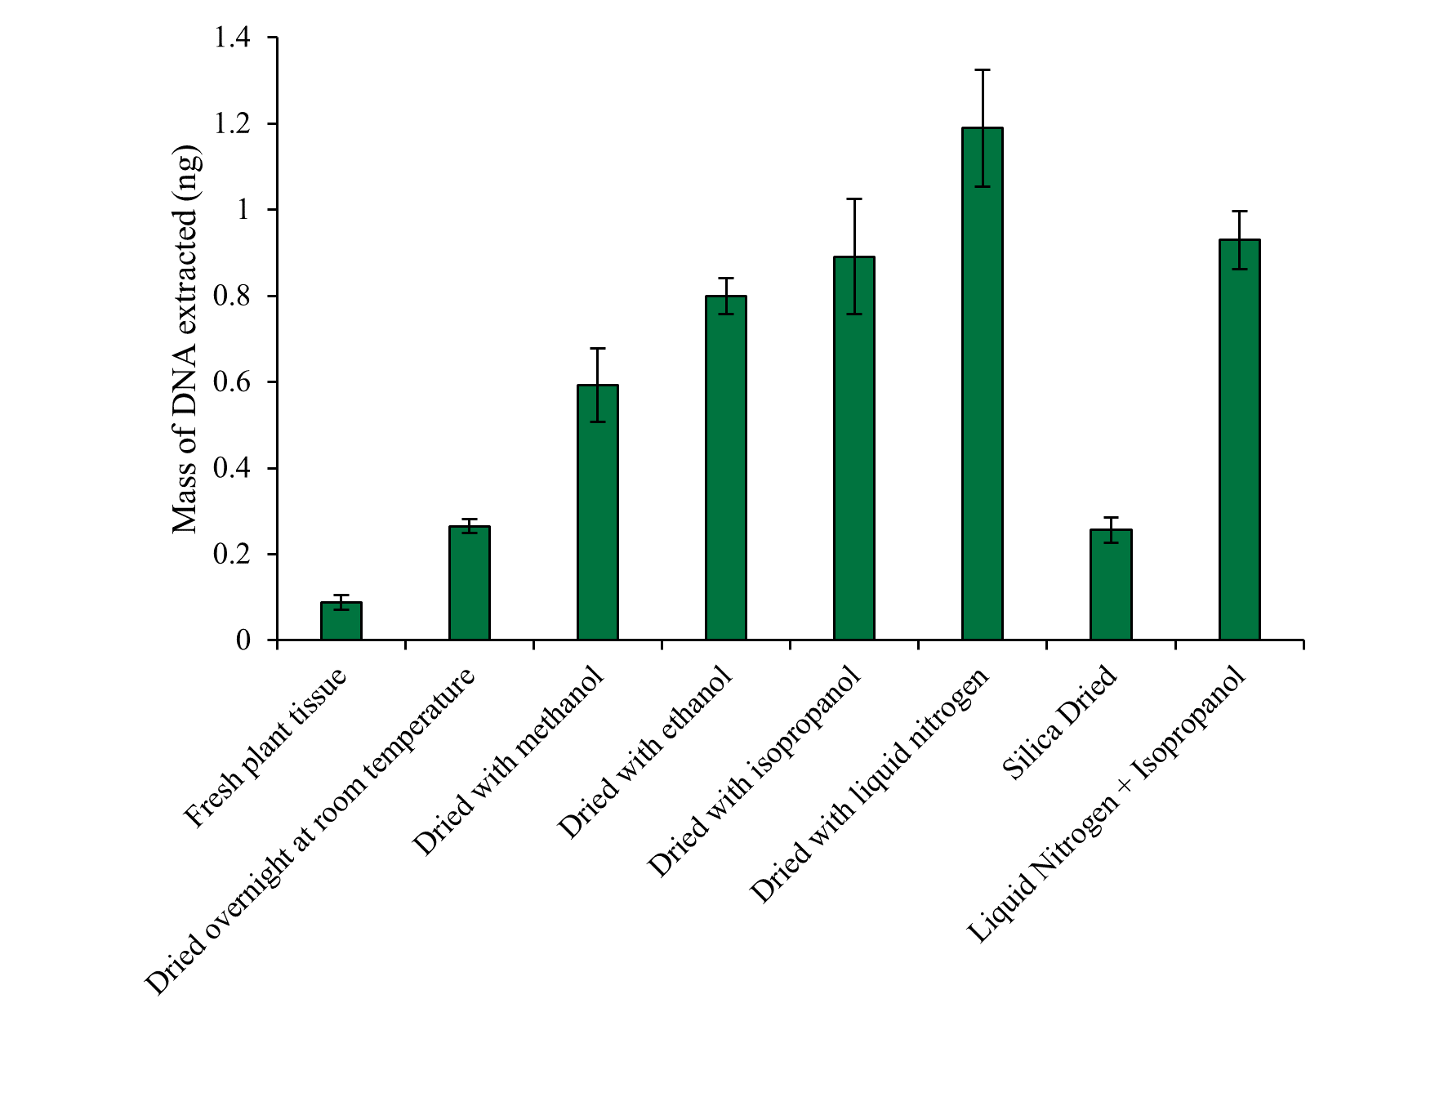
Figure S4: Effect of different drying methods on the static lysis method using [P_{6,6,6,14}⁺][Ni(hfacac)₃⁻] MIL. Tissue mass: 40 mg; volume of MIL: 6 µL; incubation time: 1 h.

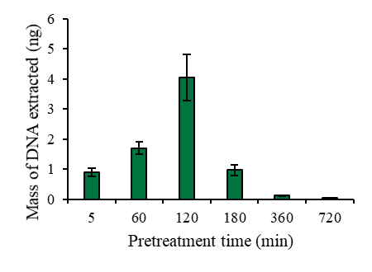
Figure S5: Effect of treating plant tissue with isopropanol overtime using the [P_{6,6,6,14}⁺][Ni(hfacac)₃⁻] MIL. Tissue mass: 40 mg; volume of MIL: 6 µL; incubation time: 1 h.

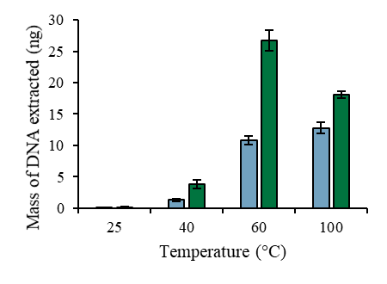
Figure S6: Effect of temperature on the lysis of cut-up plant tissue with the (blue) [P_{6,6,6,14}⁺][Ni(hfacac)₃⁻] MIL and (green) [P_{6,6,6,14}⁺][NTf₂⁻] IL. Tissue mass: 40 mg; volume of MIL: 6 µL; incubation time: 0.5 h.

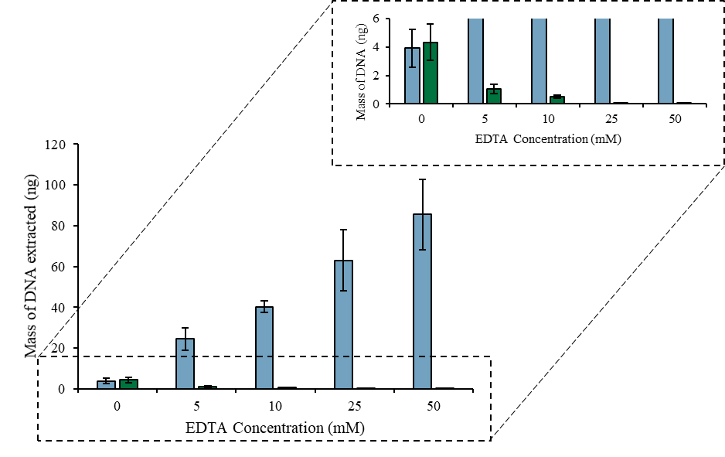
Figure S7: EDTA optimization while optimizing the dispersive MIL-lysis and DNA extraction with the (blue) [P_{6,6,6,14}⁺][Ni(hfacac)₃⁻] and (green) [P_{6,6,6,14}⁺][Co(hfacac)₃⁻] MIL. Tissue mass: 40 mg; volume of MIL: 6 µL; vortex time: 1 min; sample volume: 0.5 mL.

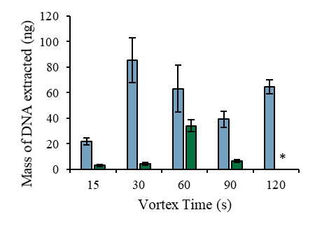
Figure S8: Extraction time optimization while optimizing the dispersive MIL-lysis and DNA extraction with the (blue) [P_{6,6,6,14}⁺][Ni(hfacac)₃⁻] and (green) [P_{6,6,6,14}⁺][Co(hfacac)₃⁻] MIL. Tissue mass: 40 mg; volume of MIL: 6 µL; sample volume: 0.5 mL.

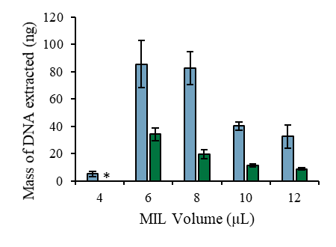
Figure S9: Optimization of the volume of MIL dispersed to lyse plant cells and extract genomic DNA using the (blue) [P_{6,6,6,14}⁺][Ni(hfacac)₃⁻] and (green) [P_{6,6,6,14}⁺][Co(hfacac)₃⁻] MIL. Tissue mass: 40 mg; sample volume: 0.5 mL. *Amplification was not observed.

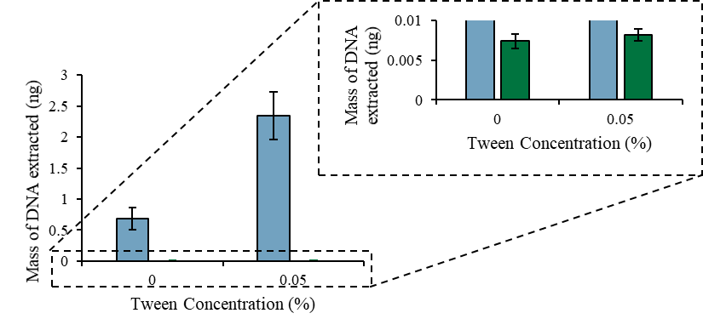
Figure S10: Effect of adding Tween20 to the desorption solution aids on the recovery of DNA from the (blue) [P_{6,6,6,14}⁺][Ni(hfacac)₃⁻] and (green) [P_{6,6,6,14}⁺][Co(hfacac)₃⁻] MIL. Tissue mass: 40 mg; sample volume: 0.5 mL; extraction time: 30 s with the [P_{6,6,6,14}⁺][Ni(hfacac)₃⁻] MIL and 60 s with the [P_{6,6,6,14}⁺][Co(hfacac)₃⁻] MIL; desorption time: 10 min.

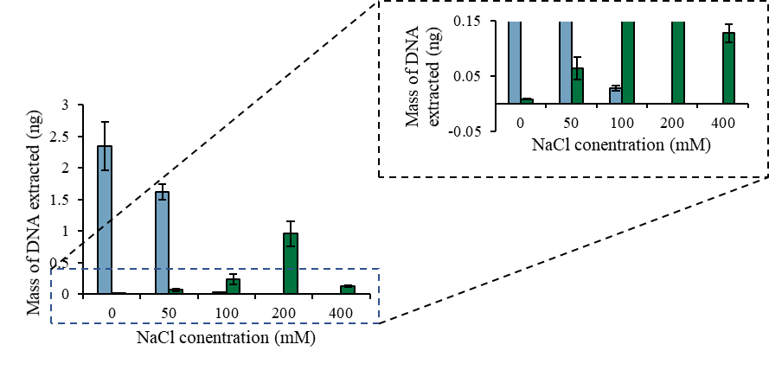
Figure S11: Effect of incorporating sodium chloride to the desorption solution for the recovery of DNA from the (blue) [P_{6,6,6,14}⁺][Ni(hfacac)₃⁻] and (green) [P_{6,6,6,14}⁺][Co(hfacac)₃⁻] MIL. Tissue mass: 40 mg; sample volume: 0.5 mL; extraction time: 30 s with the [P_{6,6,6,14}⁺][Ni(hfacac)₃⁻] MIL and 60 s with the [P_{6,6,6,14}⁺][Co(hfacac)₃⁻] MIL; desorption time: 10 min; desorption solution: 2 mM Tris, 0.05% Tween20.

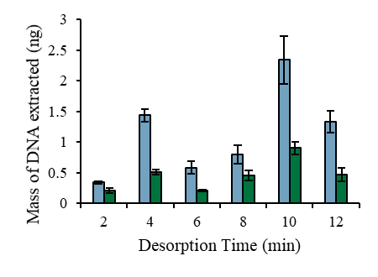
Figure S12: Impact of the desorption time towards the recovery of DNA from the (blue) [P_{6,6,6,14}⁺][Ni(hfacac)₃⁻] and (green) [P_{6,6,6,14}⁺][Co(hfacac)₃⁻] MIL. Tissue mass: 40 mg; sample volume: 0.5 mL; extraction time: 30 s with the [P_{6,6,6,14}⁺][Ni(hfacac)₃⁻] MIL and 60 s with the [P_{6,6,6,14}⁺][Co(hfacac)₃⁻] MIL; desorption solution: 2 mM Tris, 0.05% Tween20 with the [P_{6,6,6,14}⁺][Ni(hfacac)₃⁻] MIL and : 2 mM Tris, 0.05% Tween20, 200 mM NaCl with the [P_{6,6,6,14}⁺][Co(hfacac)₃⁻] MIL.

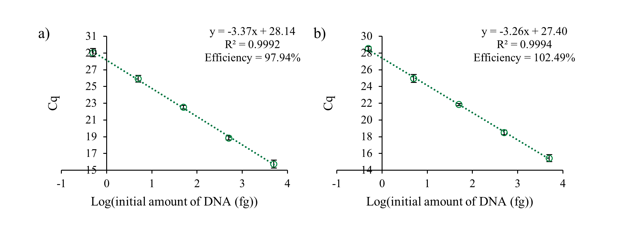
Figure S13: Standard curves generated by adding 0.3 µL of the (a) [P_{6,6,6,14}⁺][Ni(hfacac)₃⁻] and (b) [P_{6,6,6,14}⁺][Co(hfacac)₃⁻] MIL that was dispersed in a suspension of 40 mg A. thaliana tissue.

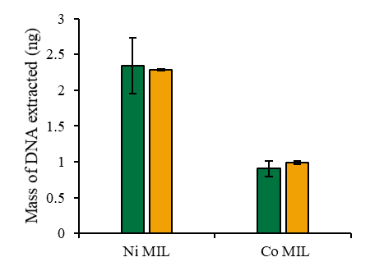
Figure S14: Comparison of the amount of DNA recovered from the [P_{6,6,6,14}⁺][Ni(hfacac)₃⁻] and [P_{6,6,6,14}⁺][Co(hfacac)₃⁻] MIL and quantified using (green) qPCR and (orange) Qubit.

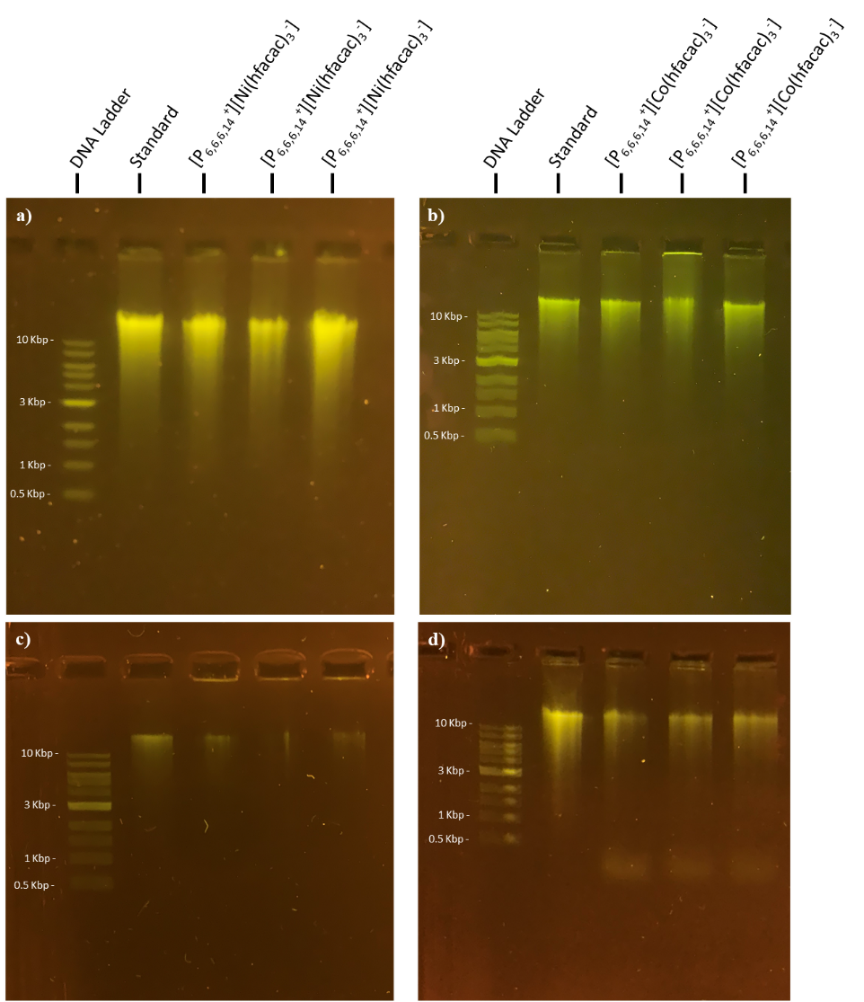
Figure S15: Agarose gel separation of and fluorescence detection of stDNA recovered from the (a,c) [P_{6,6,6,14}⁺][Ni(hfacac)₃⁻] and (b,d) [P_{6,6,6,14}⁺][Co(hfacac)₃⁻] MIL after incubating at room temperature for (a,b) 1 h and (c,d) 24 h. DNA was originally isolated from a plant tissue suspension spiked with stDNA.

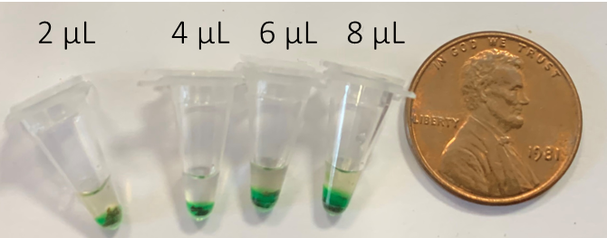
Figure S16: Results of adding different volumes of the [P_{6,6,6,14}⁺][Ni(hfacac)₃⁻] MIL and 1 mg of A. thaliana tissue to the qPCR assay.

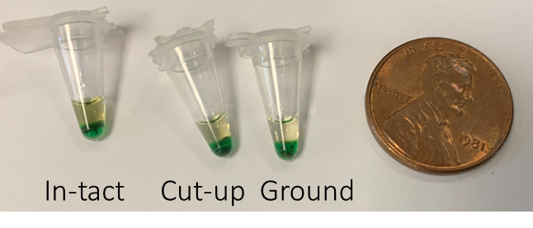
Figure S17: The effect of integrating 1 mg of in-tact, cut-up, or ground up A. thaliana tissue to the qPCR assay with 6 µL of [P_{6,6,6,14}⁺][Ni(hfacac)₃⁻] MIL.

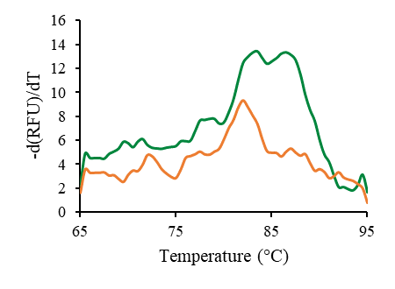
Figure S18: Melt curves associated with the (green) successful and (orange) unsuccessful amplification of genomic A. thaliana DNA after directly integrating 1 mg of plant tissue and 6 µL [P_{6,6,6,14}⁺][Ni(hfacac)₃⁻] MIL into the qPCR assay.

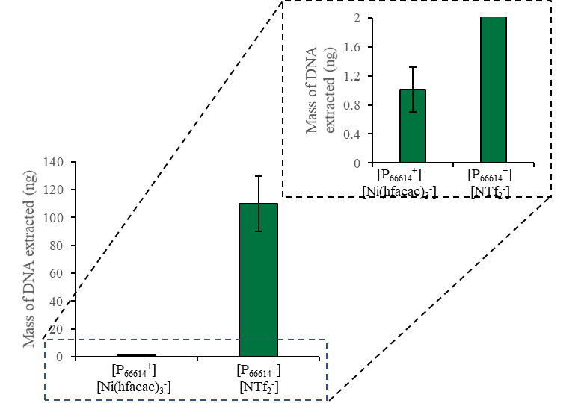
Figure S19: Mass of DNA detected when directly integrating 1 mg of fresh A. thaliana tissue and 6 µL of MIL or IL into the qPCR assay.

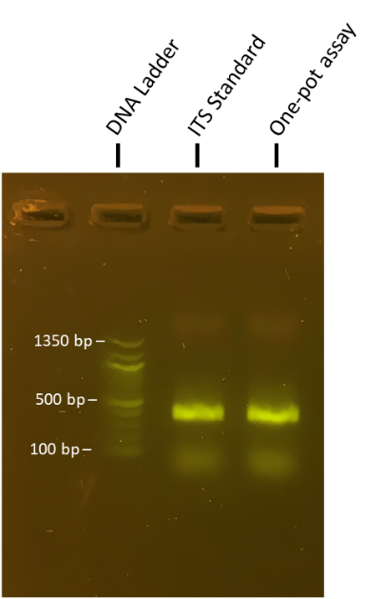
Figure S20: Agarose gel detection of the ITS amplicon that was amplified using the Phire assay with 1 mg A. thaliana tissue directly integrated into the PCR assay.

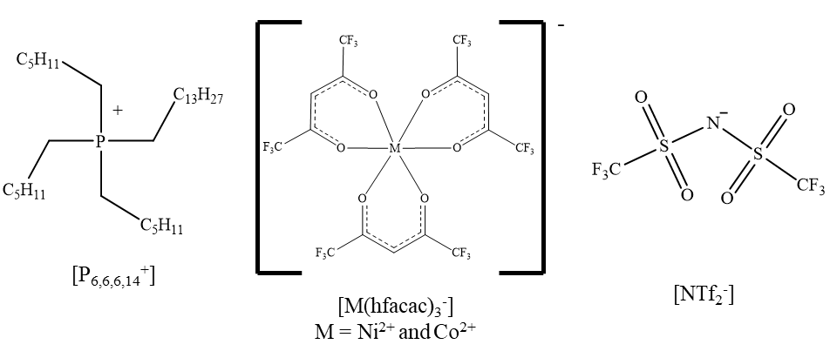
Figure S21: Chemical structures of the cations and anions comprising the MILs and IL examined in this study.

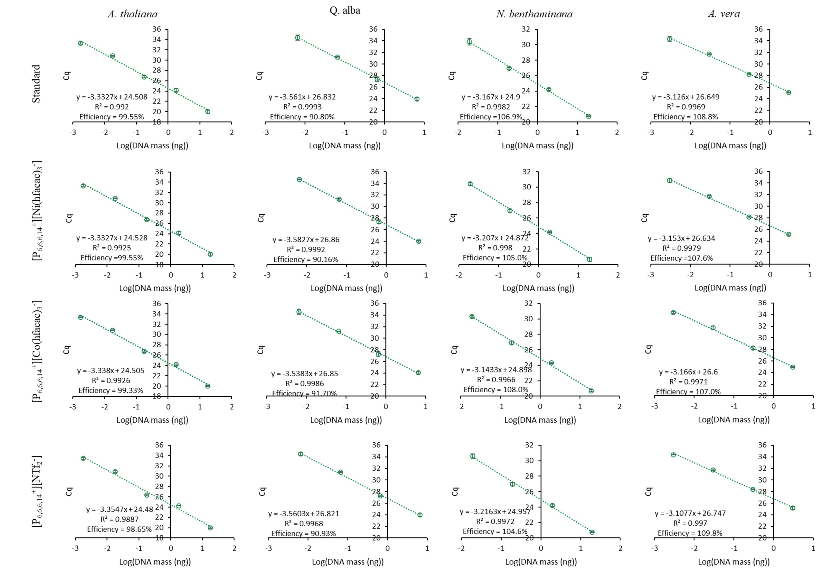
Figure S22: Standard curves associated with the qPCR amplification of A. thaliana, white oak, N. benthaminana, and A. vera with 0.3 µL of [P_{6,6,6,14}⁺][Ni(hfacac)₃⁻] MIL, [P_{6,6,6,14}⁺][Co(hfacac)₃⁻] MIL and [P_{6,6,6,14}⁺][NTf₂⁻] IL.

