Supplementary Information
Table S1 Test condition parameters of wheat cultivation in the intelligent artificial climate chamber
Fertilization  /Water volume | Nitrogen fertiliser（N1） | Nitrogen fertiliser（N2） |  | Nitrogen fertiliser（N3） | Potash fertiliser | Phosphate  Fertiliser |  | Irrigation volume
Fertilization  /Water volume | 80 kg/hm² | 160 kg/hm² |  | 240 kg/hm² | 120 kg/hm² | 120 kg/hm² |  | 450 m³/hm²
Environmental conditions | Period | CO₂ |  | Humidity | Illumination | Air pressure | Temperature
Environmental conditions | Growth Period | 500 PPM |  | 70% RH | Day100%  Night30% | 500BAR | Day (25 ℃) |  | Night (18 ℃)
Acquisition time | Trefoil stage |  | 27 November 2020  28 November 2020  29 November 2020 |  |  | 9:00–9:30  13:00–13:30  16:00–16:30
Acquisition time | Pre-tillering stage |  | 17 December 2020  18 December 2020  19 December 2020 |  |  | 9:00–9:30  13:00–13:30  16:00–16:30
Acquisition time | Late tillering stage |  | 19 January 2021  20 January 2021  21 January 2021 |  |  | 9:00–9:30  13:00–13:30  16:00–16:30
Acquisition time | Jointing stage |  | 17 March 2021  18 March 2021  19 March 2021 |  |  | 9:00–9:30  13:00–13:30  16:00–16:30

Table S2 Main environmental factor regulation parameter table
Environmental parameters | Adjustment range
Temperature | 0 ℃–50 ℃
Illumination | 0–3000 Lux
Air pressure | 0.03-0.1MPa
Humidity | 10%–80% RH
CO₂ concentration | 1000–1500 PPM

Table S3 Main equipment parameter table of environmental control system
Device name | Model | Core Parameters | Features
HMI | Delta HMC08-N500S52 | 800 x 480 (pixels) | Stable operation and friendly operation
PLC | Delta DVP-EH3 PLC | 4 axes 200 kHz, 32-bit CPU + ASIC | Good stability and powerful computing power
Air pressure sensor | DLK301 | ±0.5%FS、±1%FS | High-sensitivity imported probe, accurate data monitoring
Temperature Sensor | WZP-PT100-230 | ±(0.15%+0.002%) | Platinum thermal resistance, wide temperature range and high precision
Humidity Sensor | LR9502 | ±3%RH（5%RH~95%RH，25℃） | Small volume specification, high measurement accuracy, easy operation
CO₂ sensor | BMG-CO₂-NDIR | ±5%； | Protection type, not affected by external high humidity environment
Copeland Hermetic Compressor | ZB38KQE | 5.0HP,50Hz | High volumetric efficiency and high adiabatic efficiency
Digital display light touch temperature controller | XMTG-3002 CU50 | ≤0.75%FS | Operational amplifier signal acquisition, high control accuracy

Table S4 Main equipment parameters of high-precision mechanical transmission device
Equipment | Model | Core Parameters
HMI | DOP-107EV | 400cd/m²，COM1:RS-232, COM2:RS-232/485, COM3:RS-422/485
PLC | DVP-SV2 | 4 axes 200 kHz,32-bit CPU + ASIC
server Driver | ASD-B2-0421-B | 400W/220V，Single/three-phase,550HZ
servo motor | ECMA-C20604RS | pixels: 17 bit (160000 ppr)
Precision rolling guide pair | GGB25IAA | ±20μm (Accuracy)

Table S5 Parameters of imaging camera in the crop-phenotype acquisition system
Sensor type |  | 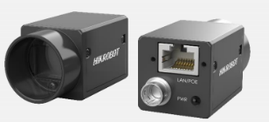  RGB camera | 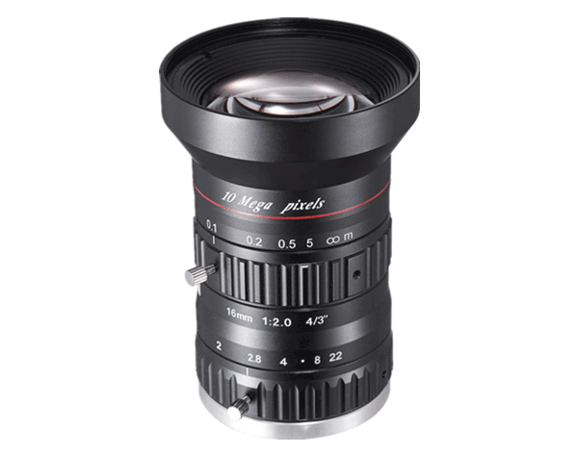  RGB camera lens | 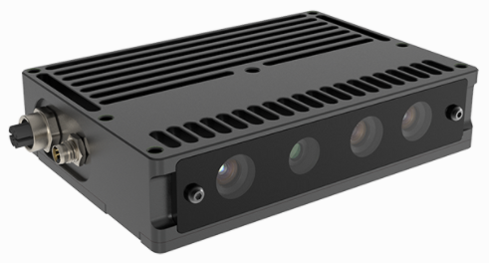  Depth camera | 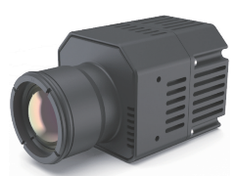  Thermal imaging cameras
 | Type | LT384H/640H | SA1620 M-10MP | FM850-GI-E1 | LT640H
 | Detector Type | CMOS | - | RGB-D+IR | VOX uncooled infrared focal plane
 | Resolution | 2592×2048 | - | 1280 x 960 @ 15 fps  2592 x 1944 @ 6 fps | 640×512
 | Interface | Gigabit Ethernet | C-mount | USB2.0 | RS-232/UART（3.3V）
 | Operating temperature | 0~50℃ | -10~50℃ | 0~45℃ | 0℃~60℃
 | Typical power consumption | <3.3W | - | <5.2W | <2W
 | Functional Features | Excellent image quality, fast real-time transmission, and support for multiple exposure modes | High resolution, excellent imaging quality, high transmittance, good stability | Active binocular, strong anti-interference ability, support trigger mode | High temperature measurement accuracy, support for secondary development, high frame rate

Table S6 Technical Parameters of Handheld Infrared Thermal Imager
Model | Display resolution |  | D：S (distance: measuring spot diameter) | IR spectral response | Infrared response time | Temperature measurement range | Measurement accuracy
Raytek ST80+ |  | 0.1℃  /0.1℉ | 50：1 | 8~14μm | ＜500ms | -32~750℃ | ±0.2℃

Table S7 Correlation analysis of systematic and manual measurements of phenotypic characteristic parameters in wheat growth period
Characteristic Parameters | Growth Period | N | P value | Pearson’ r
Leaf area  （cm²） | Trefoil stage | 23 | 3.57236E-7 | 0.84645*
Leaf area  （cm²） | Pre-tillering stage | 22 | 1.03253E-9 | 0.92242*
Leaf area  （cm²） | Late tillering stage | 23 | 1.29195E-8 | 0.89019*
Leaf area  （cm²） | Jointing stage | 23 | 4.5663E-12 | 0.94979*
Plant height  （cm） | Trefoil stage | 26 | 1.00043E-10 | 0. 84821*
Plant height  （cm） | Pre-tillering stage | 23 | 1.41311E-4 | 0.72357*
Plant height  （cm） | Late tillering stage | 26 | 2.50211E-6 | 0.78098*
Plant height  （cm） | Jointing stage | 26 | 5.0194E-9 | 0.87496*
Canopy temperature  （℃） | Trefoil stage | 18 | 2.86352E-8 | 0.92809*
Canopy temperature  （℃） | Pre-tillering stage | 19 | 2.28567E-8 | 0.92084*
Canopy temperature  （℃） | Late tillering stage | 18 | 2.20982E-9 | 0.94821*
Canopy temperature  （℃） | Jointing stage | 18 | 2.06348E-8 | 0.93106*
(Note: *at the 0.05 level (two-tailed), correlation is significant.)

Table S8 Comparison of fitting analysis between the systematic and manual measurement values of phenotypic characteristic parameters in wheat growth period
Characteristic Parameters | Growth Period | Fitting equation | R² | RSME
Leaf area  （cm²） | Trefoil stage | y=1.125x+3.043 | 0.7165 | 1.112
Leaf area  （cm²） | Pre-tillering stage | y=1.344x+2.681 | 0.8509 | 1.811
Leaf area  （cm²） | Late tillering stage | y=1.238x-3.146 | 0.7924 | 2.365
Leaf area  （cm²） | Jointing stage | y=1.098x-0.238 | 0.9021 | 2.046
Plant height  （cm） | Trefoil stage | y=0.5002x+3.833 | 0.8397 | 0.349
Plant height  （cm） | Pre-tillering stage | y=0.823x+2.443 | 0.8464 | 1.971
Plant height  （cm） | Late tillering stage | y=1.228x-1.799 | 0.8452 | 2.139
Plant height  （cm） | Jointing stage | y=0.8273x+2.013 | 0.8492 | 2.429
Canopy temperature（℃） | Trefoil stage | y=0.571x+13.93 | 0.8613 | 0.261
Canopy temperature（℃） | Pre-tillering stage | y=0.8234x+6.416 | 0.8479 | 1.285
Canopy temperature（℃） | Late tillering stage | y=0.9306x+0.604 | 0.8991 | 0.930
Canopy temperature（℃） | Jointing stage | y=0.7405x+5.564 | 0.8669 | 0.436

Table S9. The advantages and disadvantages of this system are compared with other platforms
 | Platform Type | Advantages | Disadvantages
Indoor | Conveyor type | High transmission efficiency, unaffected by harsh outdoor environments | High upfront investment and maintenance costs make it difficult to scale up; it can only be used on a fixed basis and cannot replace field phenotyping studies.
Indoor | Orbital type | The operation process is relatively simple, and the site required for platform erection is small
Outdoor | Fixed Rail Type | Wide monitoring range, suitable for large scale phenotype data detection | High investment and construction costs and the need for regular maintenance; susceptible to disruptions such as weather and environmental factors.
Outdoor | Drone Type | High degree of freedom, wide monitoring range and large scale. | High requirements for imaging sensors; limited by the UAV's carrying weight and endurance.
Outdoor | Vehicle-mounted | Automatic navigation is available, which is less costly, reduces manpower and improves work efficiency. | Impact on imaging quality due to uneven road surface and equipment shake; affects crop growth.

