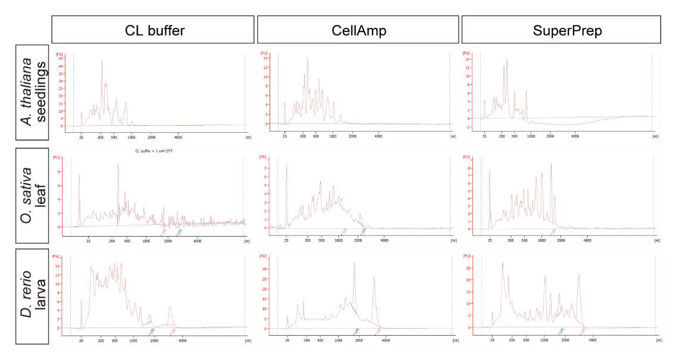
Supplemental Figure 1 Performance of previously reported buffers for mammalian cultured cells in direct-lysate reverse transcription of A. thaliana, O. sativa, and D. rerio.

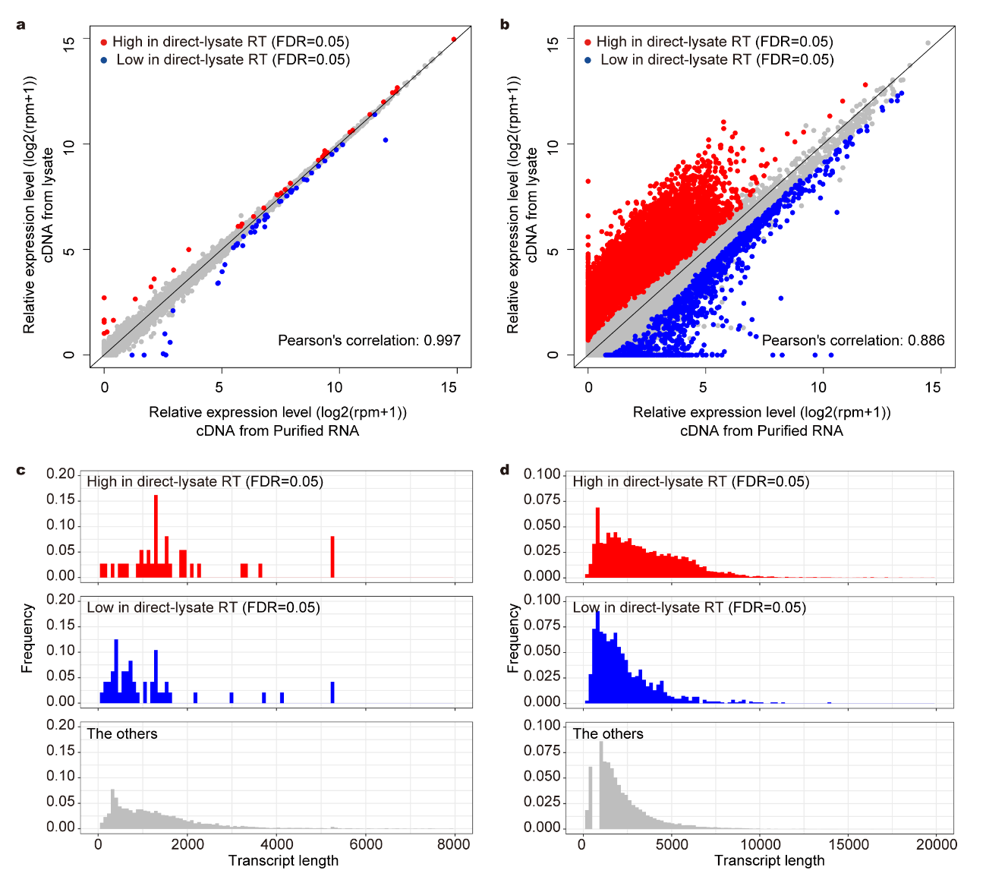
Supplemental Figure 2 Comparison of RNA-Seq results of purified RNA and lysate of S. cerevisiae and D. rerio.
The results of 3′ RNA-Seq of purified RNA and lysate of S. cerevisiae (a, c) and D. rerio (b, d) larva. (a, b) Scatter plot of log2 RPM+1 of each gene. Differentially quantified genes (DQGs) between purified RNA and lysate were detected (FDR = 0.05, n=6). (c, d) Transcript length distribution of DQGs with higher rpm values in the method using lysate and the other genes. The histograms show the results from 0 nt to 8000 nt in (c) and from 0 nt to 20000 nt in (d).

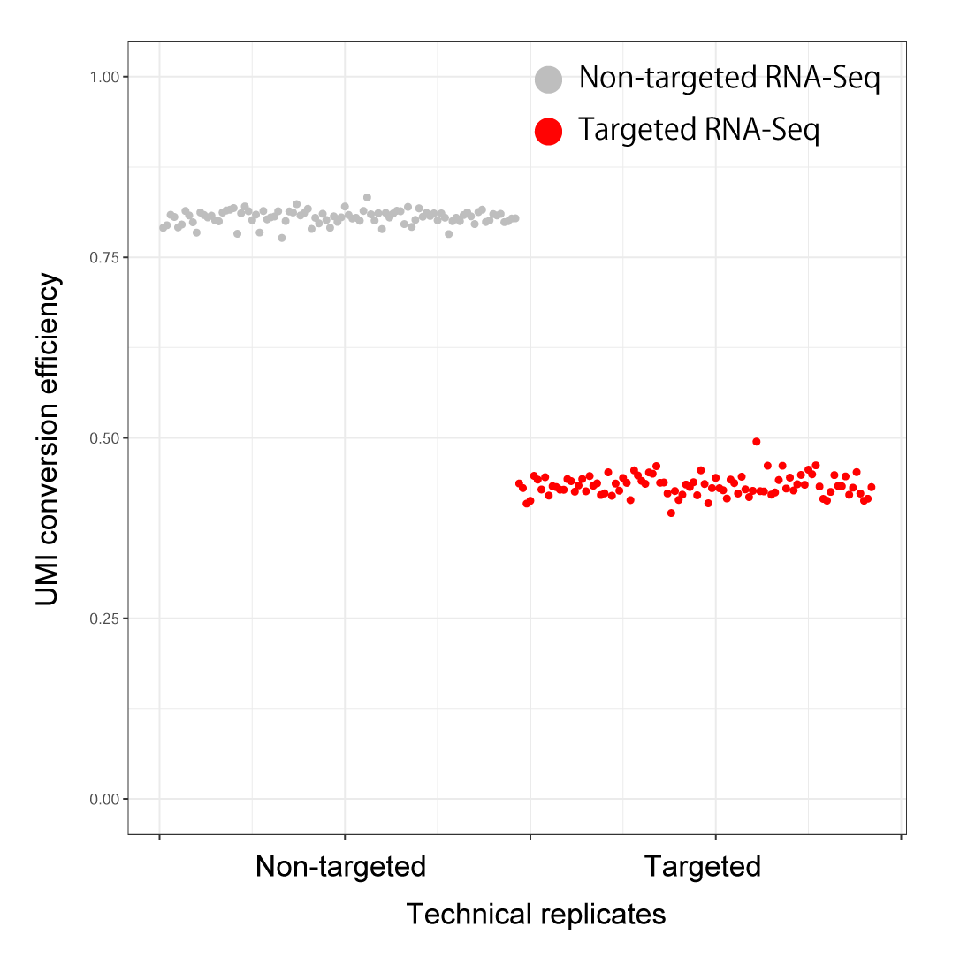
Supplemental Figure 3 UMI conversion efficiencies of 96 technical replicates of non-targeted and targeted RNA-Seq.
Plot of UMI conversion efficiencies of each technical replicate of non-targeted and targeted RNA-Seq.

