High-throughput and automatic structural and developmental root phenotyping on Arabidopsis seedlings

Authors:
Romain Fernandez^{1,2}, Amandine Crabos³, Morgan Maillard³, Philippe Nacry*³, Christophe Pradal*^{1,2,4}

¹CIRAD, UMR AGAP Institut, F-34398 Montpellier, France.
²UMR AGAP Institut, Univ Montpellier, CIRAD, INRAE, Institut Agro, F-34398 Montpellier, France.
³Institute for Plant Sciences of Montpellier (IPSiM), Univ Montpellier, CNRS, INRAE, Institut Agro, Montpellier, France.
⁴Inria & LIRMM, Univ Montpellier, CNRS, Montpellier, France.
*Co-corresponding authors

Corresponding authors:
Philippe Nacry: philippe.nacry@inrae.fr
Christophe Pradal: christophe.pradal@cirad.fr

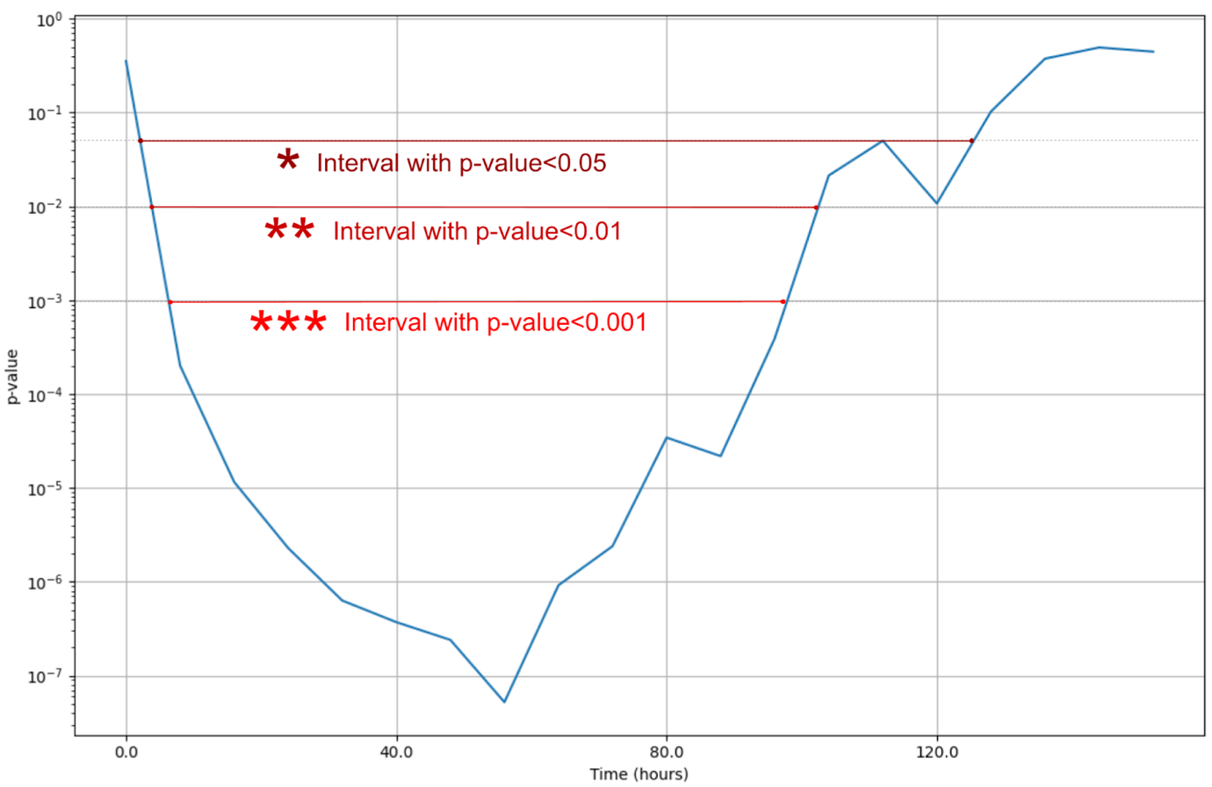
Figure S1: Successive p-values obtained at each time step with the Mann-Whitney test. This corresponds to the null hypothesis H0: ”At each timestep, the mean growth of the root systems under osmotic stress and the mean growth of the control root systems are equal.” (see Figure 9 for the original data).

