 | Bacterial Contaminated  i.e. Darul Hidayah_longitudinal cut method_7dph | Fungal Contaminated  i.e. Apuy_standard method_14dph | PPD  i.e. Baturaja_longitudinal cut method_14dph
RGB color | 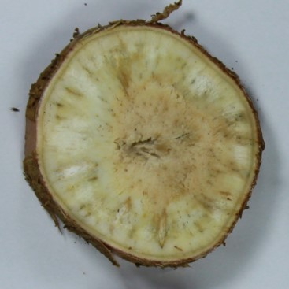 | 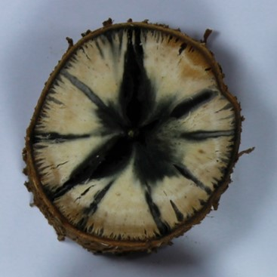 | 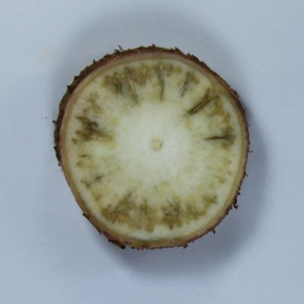
Grayscale color | 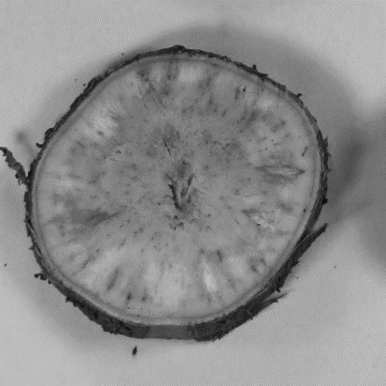 | 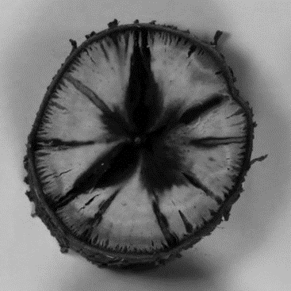 | 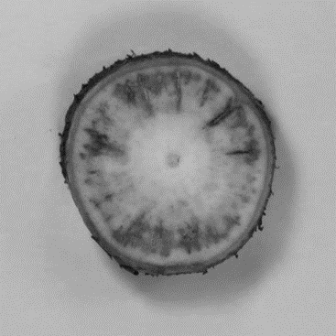
Additional file 2: Figure S1. Illustrations of fungal contamination in cassava storage roots subjected to PPD assessment method.

Additional file 2: Figure S2. Data analysis of PPD development by utilizing k-means clustering.

c
bc
Additional file 2: Figure S3. PPD scores of the selected cultivars assessed in 2012 and 2014.

