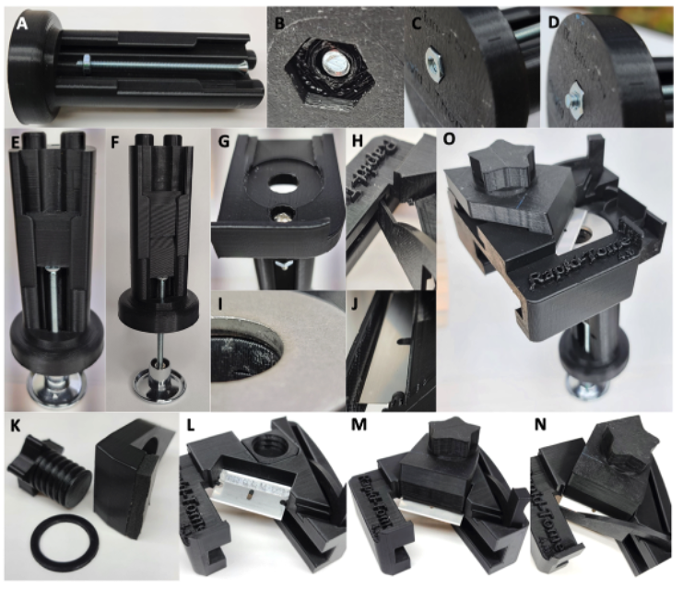
Additional File 1. Assembly of the Rapid-Tome. (A-D) The advancement bolt is installed first. (E-G) The slider is placed within the grooves of the handle before the stage is attached. (F) Two sliders can be stacked if a short sample is to be sectioned. (H-J) The washer and blade guard are attached. The blade clamp (K) is crucial and holds the blade in place (L-N). (O) Fully assembled Rapid-Tome. Sliding the sled into place over the stage against the inclined washer flexes the blade and ensures a flat cut is made. All plastic parts are 3-D printed with PLA.

