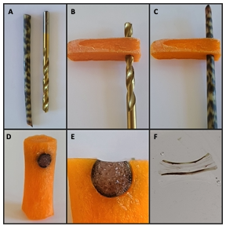
Additional File 2. Longitudinal sections can be made utilizing a hole cut through a carrot. (A) Select a drill bit that is the same diameter or slightly smaller than the Alocasia sp. stem segment. (B) Drill a hole through a carrot gently by hand. (C) Push the stem segment into the carrot until snug. (D) Use a razor blade to remove excess stem segment and carrot so that the carrot fits into the Rapid-Tome stage hole. (E) The carrot effectively holds the stem in place during sectioning. (F) Thin sections are possible even with fragile stem tissue.

