Additional file 1
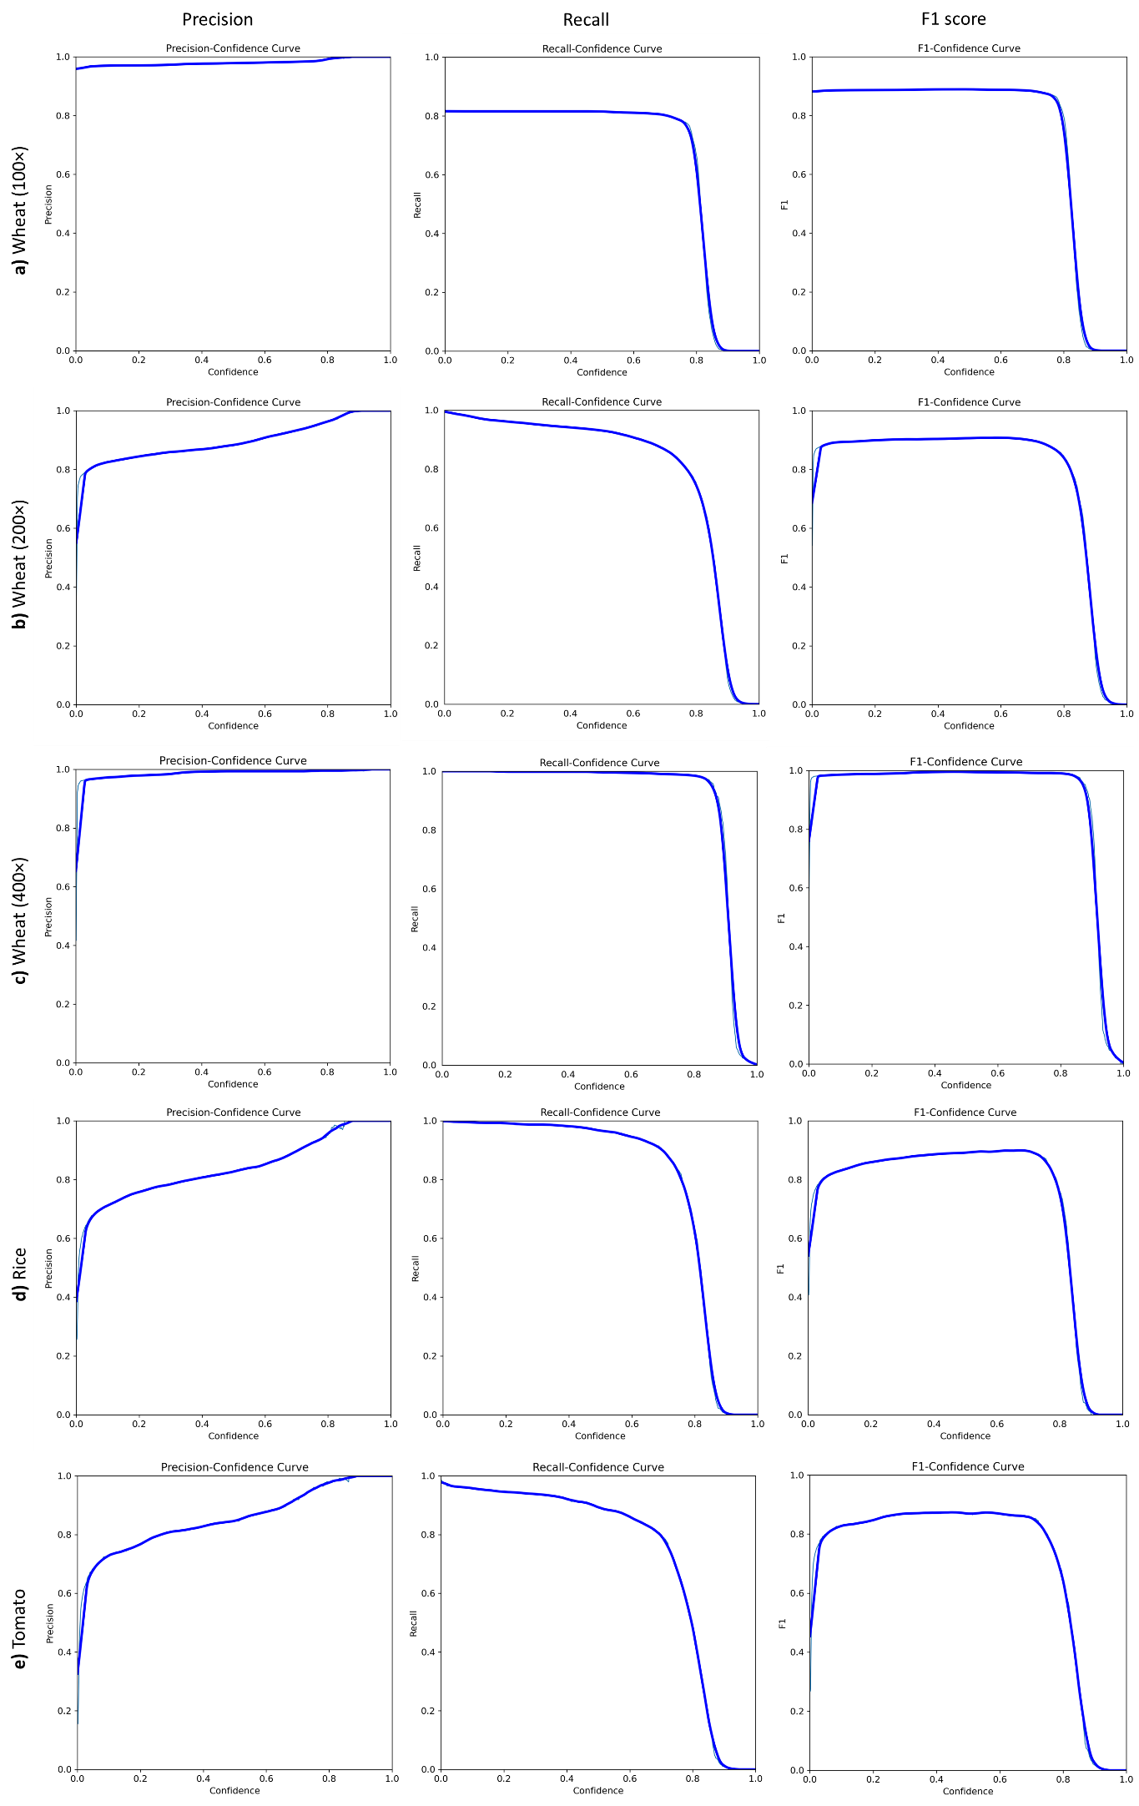
Fig. S1: Confidence curves of detection models of wheat with 100× (a), 200× (b) and 400× (c) magnification, rice (d), and tomato (e) with 400× magnification.

 |  | Number of images
Species | Magnification | Training set | Validation set | Testing set
Wheat | 400× | 417 | 40 | 20
Wheat | 200× | 486 | 46 | 23
Wheat | 100× | 450 | 42 | 21
Rice | 400× | 183 | 18 | 9
Tomato | 400× | 216 | 20 | 10
Table S1: Number of images used to develop stomata detection models.

 |  | Number of images
Species | Magnification | Training set | Validation set | Testing set
Wheat | 400× | 297 | 83 | 44
Rice | 400× | 280 | 80 | 40
Tomato | 400× | 295 | 85 | 43
Table S2: Number of images used to develop stomata measurement models.

