Additional file 1: Table S1. sgRNAs sequence used for carnation DcACO1 and DcACS1 gene editing.
Gene | Name | Sequence  ‘5 ˗ 3’ | Length | PAM
DcACO1 | g1 | TAGCGCAGACAGATGGTAAC | 20 | AGG
DcACO1 | g2 | CATCTGTCTGCGCTATCACG | 20 | CGG
DcACS1 | g1 | CATGGGCATGCCCGGCTTTA | 20 | GGG
DcACS1 | g2 | CCAGCATTTCACAAGCGAGC | 20 | TGG
DcACS1 | g3 | CGCGGCATTGTTTGTTTGGA | 20 | TGG
DcACS1 | g4 | CCTTCCTGTGCTCTGAGCCA | 20 | GGG
DcACS1 | g5 | CTCTGAGCCAGGGTGGTTTA | 20 | GGG

Additional file 1: Table S2. List of primers used for PCR and sequencing.
Name | Sequence 5’˗3’ | Expected Product  length (bp) | Rounds | Purpose
ACO1_F_1  ACO1_R_1 | AACATCTCCGAGGTCCCTGA  TGAGATGAGATGAGAGTGGCG | 852 | PCR | -
ACO1_F_2  ACO1_R_2 | GAAGCCGCCTCCGACTAATA  CAAACCTGGGCTCCTTCTCT | 325 | 2nd round PCR | Sequencing  for sgRNA 1 and 2
ACS1_F_1  ACS1_R_1 | ATGACATGCAGATTCCGCGA  ACCCTTCCACGGGTTACAAA | 1217 | PCR | -
ACS1_F1_2  ACS1_R1_2 | GTCACAAACCCGTCAAATCCC  TCGACATTCGACGAGCAGTT | 315 | 2nd round PCR | Sequencing  for sgRNA 1
ACS1_F2_2  ACS1_R2_2 | AAATCCTGGGTACGTCACTGC  GGTCGCATTGTCCATGTTGG | 280 | 2nd round PCR | Sequencing for sgRNA 2, 3, and 5

Additional file 1: Table S3. PGR combinations and concentration used for protoplast culture.
No | PGR (mg/l)
1 | 1.0 Zeatin
2 | 0.5 2,4-D
3 | 1.0 2,4-D
4 | 0.5 NAA
5 | 0.5 NAA 0.5 2,4-D
6 | 0.5 Zeatin, 1.0 2,4-D
7 | 1.0 Zeatin, 1.0 2,4-D
8 | 2.0 Zeatin, 1.0 2,4-D
9 | 0.5 BA, 1.0 2,4-D
10 | 1.0 BA, 1.0 2,4-D
11 | 0.5 TDZ, 1.0 2,4-D
12 | 1.0 TDZ, 1.0 2,4-D
13 | 1.0 Zeatin, 1.0 NAA
14 | 1.0 Zeatin, 3.0 NAA
15 | 1.0 Zeatin, 5.0 NAA

a.
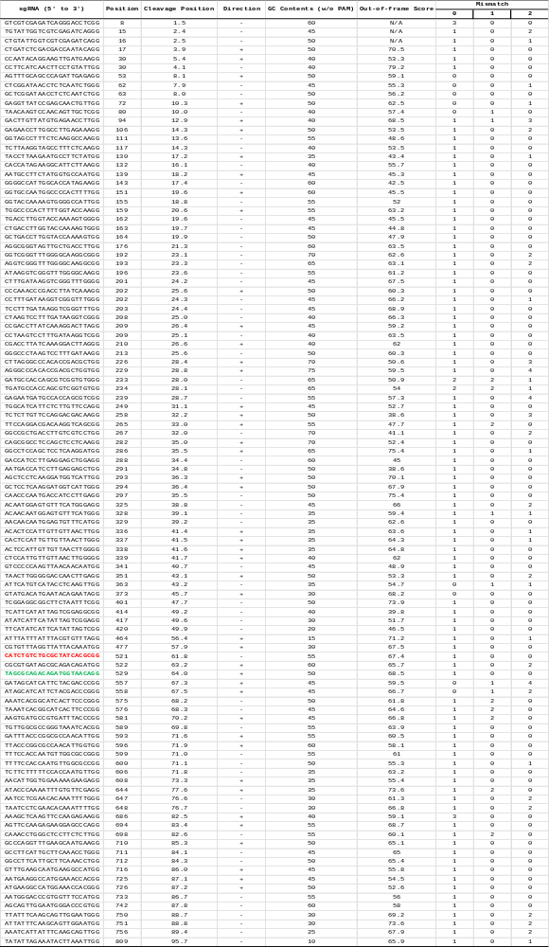
b.
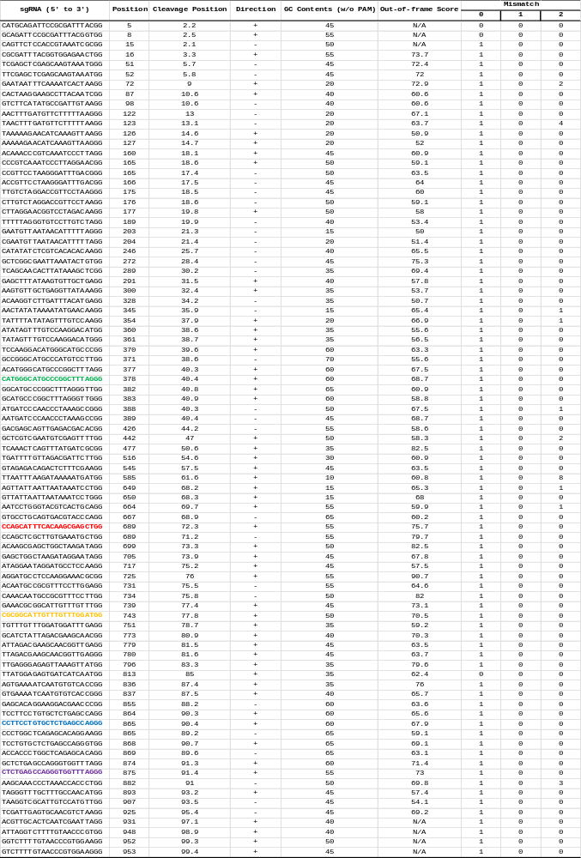
Additional file 1: Figure S1. List of sgRNA generated by Rgen Cas-designer tool. Selected sgRNAs are highlighted in colours. a. DcACO1 Green: sgRNA1, Red: sgRNA2. b. DcACS1 Green: sgRNA1, Red: sgRNA2, Yellow: sgRNA3, Blue: sgRNA4, Purple: sgRNA5
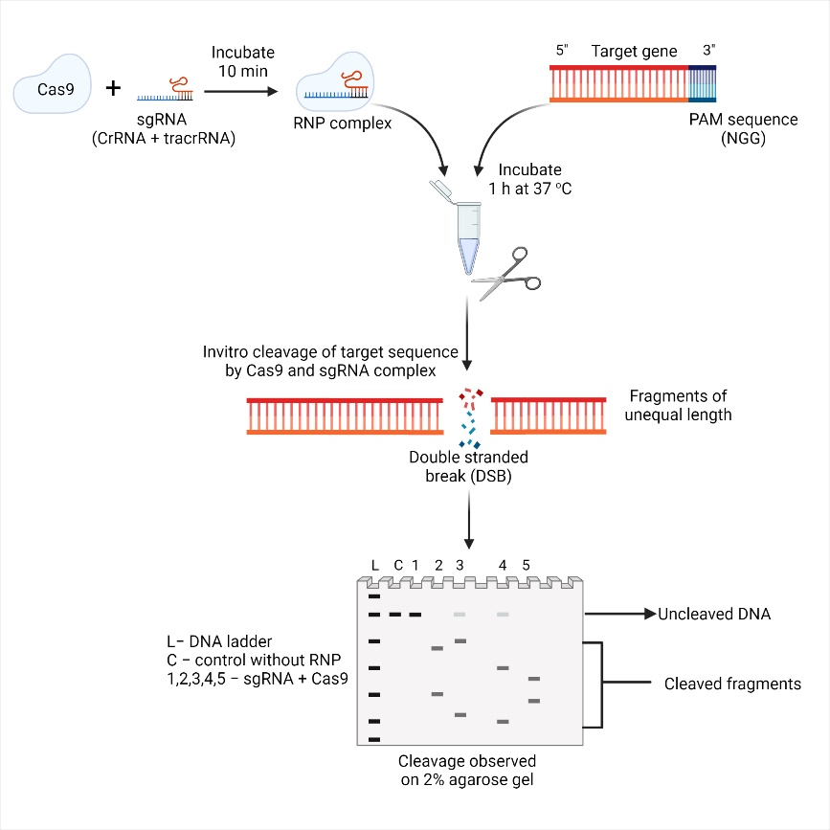

Additional file 1: Figure S2. Schematic flow chart of the cleavage assay, created with biorender.com

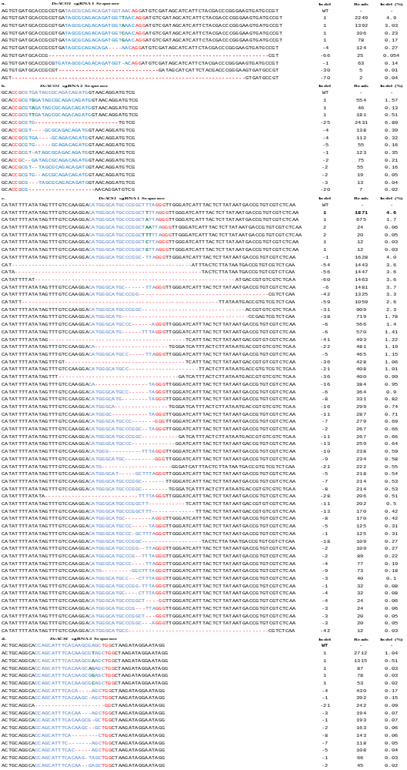
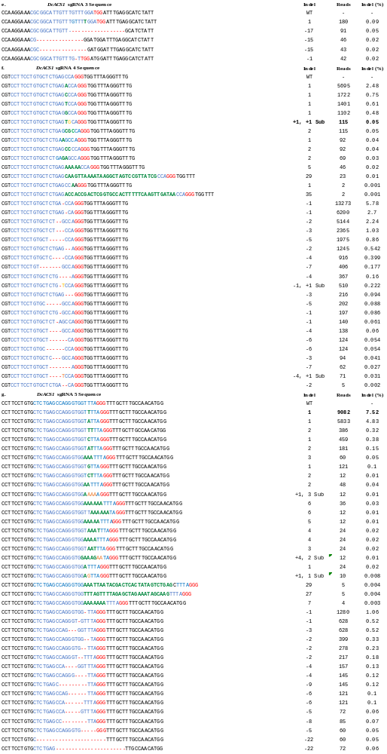
Additional file 1: Figure S3. Targeted deep sequencing analysis of transformed carnation protoplasts for DcACO1 and DcACS1 genes showing the complete indels and mutation patterns. Blue- Target sequence, red- PAM sequence, green- insertions, orange- substitution.

