Supplementary Information

Rapid real-time quantitative colorimetric LAMP methodology for field detection of Verticillium dahliae in crude olive-plant samples
Maria Megariti¹, Alexandra Panagou³, Georgios Patsis³, George Papadakis¹, Alexandros Pantazis¹, Epaminondas J. Paplomatas³, Aliki K. Tzima^{3, *}, Emmanouil A. Markakis^{4,5 *}, Electra Gizeli^{1,2, *}

Table S1 Results on the Verticillium dahliae isolation frequency and SYBR qPCR on DNA from olive branches or petioles with primers Vd-F/Vd-R normalized with the olive actin gene (OeACT-F / OeACT-R) by applying the 2^{-ΔCt} method (Livak et al. 2001) on all samples presented in Table 1 in the manuscript.

Olive orchard | Sampled  tree cultivar | Sample code | Isolation ratio (0-1)  (branch) | Relative V. dahliae DNA by qPCR (branch/petiole)
# 1 | Kalamon | 1.1. | 0.0 | 0.0/0.0
# 1 | Kalamon | 1.3. | 0.8 | 147.9/3.5
# 1 | Kalamon | 1.4. | 0.0 | 0.0/0.0
# 1 | Kalamon | 1.6. | 0.0 | 0.0/0.0
# 1 | Kalamon | 1.8. | 1.0 | 70.7/1.2
# 2 | Megaritiki | 2.1. | 0.8 | 2019.0/15.3
# 2 | Megaritiki | 2.2. | 1.0 | 239.7/0.0
# 2 | Megaritiki | 2.3. | 0.1 | 0.4/0.2
# 2 | Megaritiki | 2.4. | 1.0 | 11362.0/0.8
# 2 | Megaritiki | 2.7. | 0.9 | 1884.0/0.6
# 3 | Amfissis | 3.1. | 0.9 | 1025.0/3.9
# 3 | Amfissis | 3.2. | 0.1 | 0.3/0.2
# 3 | Amfissis | 3.3. | 0.0 | 0.0/0.0
# 3 | Amfissis | 3.4. | 0.0 | 0.2/0.0
 | Amfissis | 3.5. | 0.6 | 559.0/0.2
# 4 | Chalkidikis | 4.1. | 0.0 | 0.0/0.0
# 4 | Chalkidikis | 4.2. | 0.8 | 25.1/0.0
# 5 | Amfissis | 7.3. | 1.0 | 140.7/1.7
# 5 | Amfissis | 7.5. | 0.0 | 0.2/0.0
# 6 | Megaritiki | 8.1. | 0.0 | 0.0/0.0

Table S2 Results on the detection of Verticillium dahliae in crude extracts and purified DNA for all samples shown in Table 2 in the manuscript (i.e., olive tissues (branches) from naturally infested trees) using PCR and qPCR.
Sample info |  |  | Crude extract | Purified DNA
Olive orchard | Sampled tree cultivar | Tree code | qPCR or nested PCR | PCR | Relative V. dahliae DNA by qPCR
# 1 | Kalamon | A1_AUA | undetected | + | 0.006
# 1 | Kalamon | A2_AUA | undetected | + | 0.004
# 1 | Kalamon | A6_AUA | undetected | + | 0.004
# 1 | Kalamon | B6_AUA | undetected | + | 0.019
# 1 | Kalamon | G8_AUA | undetected | + | 0.009
# 2 | Amfissis | Amfissa 1 | undetected | + | 0.111
# 2 | Amfissis | Amfissa 3 | undetected | + | 0.014
# 2 | Amfissis | Amfissa 4 | undetected | + | 0.404
# 2 | Amfissis | Amfissa 5 | undetected | + | 0.131
# 2 | Amfissis | Amfissa 6 | undetected | + | 0.003
# 2 | Amfissis | Amfissa 7 | undetected | + | 0.016
# 2 | Amfissis | Amfissa 8 | undetected | + | 0.093
# 2 | Amfissis | Amfissa 9 | undetected | + | 0.746
# 2 | Amfissis | Amfissa 10 | undetected | + | 0.004
# 2 | Amfissis | Amfissa 11 | undetected | + | 0.081
# 2 | Amfissis | Amfissa 15 | undetected | + | 0.010
# 2 | Amfissis | Amfissa 16 | undetected | + | 0.012
# 2 | Amfissis | Amfissa 18 | undetected | + | 0.008
# 2 | Amfissis | Amfissa 19 | undetected | + | 0.012
# 2 | Amfissis | Amfissa 20 | undetected | + | 0.013

Figure S1 Reproducibility of LAMP reaction time on naturally infected V. dahliae crude samples (N=18), fungal purified DNA positive samples (N=4) and samples from healthy trees (N=4). No amplification was observed in healthy plants and NTCs (N=4).

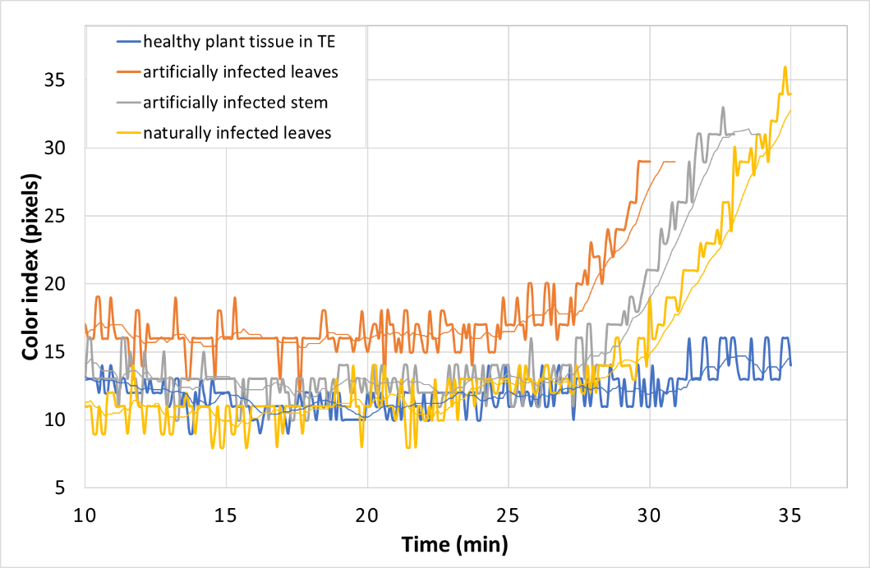

Figure S2. Real time colorimetric LAMP amplification using as template 1 μl of naturally infected plant leaves tissue in water (yellow line), 1 μl artificially infected plant leaves tissue in TE buffer (orange line), 1 μl artificially infected plant stem tissue in TE buffer (grey line), 1 μl healthy plant tissue in TE buffer (blue line).

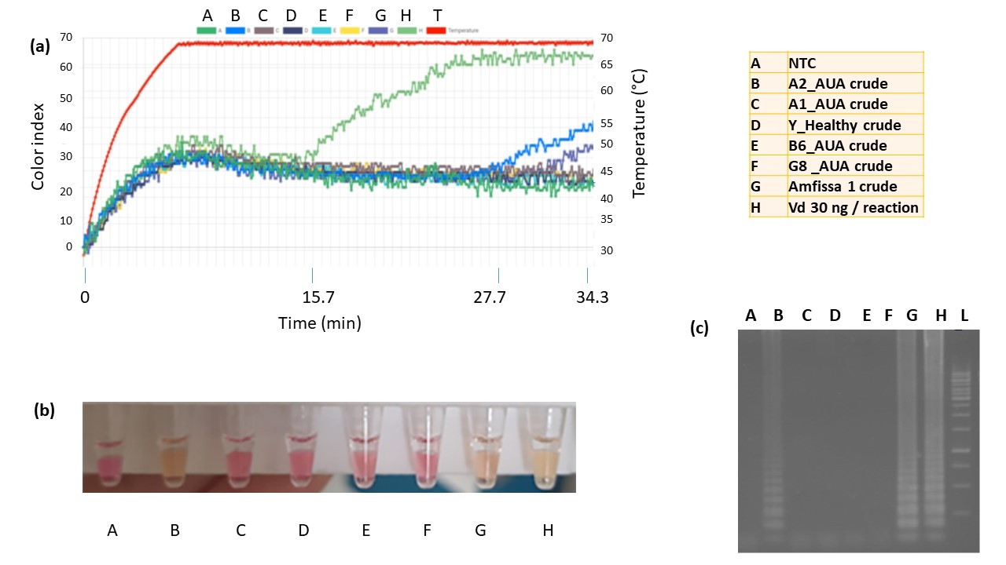

Figure S3 Demonstration of colorimetric LAMP assay for detection of Veticillium dahliae on crude samples of branches collected from naturally infested olive trees. (a) Tablet snapshot showing real time colorimetric LAMP assay run on the iris apparatus; (b) Field-based end-point colorimetric detection by naked eye. Positive samples are yellow due to pH change of the phenol red dye, while non-template control (NTC) and negative samples retain a pink color; (c) Standard lab-based gel electrophoresis of the qcLAMP reaction showing multiple zones in 3 positive samples (lanes B, G, H), and absence of signal in negative samples (A, C, D, E, F). Samples B-G were collected from trees with code A2_AUA, A1_AUA, Health tree, B6_AUA, G8_AUA, Amfissa 1, respectively. Sample A corresponds to NTC while sample Vd corresponds to the positive control (70V genomic DNA, 1.5 ng / μl reaction).

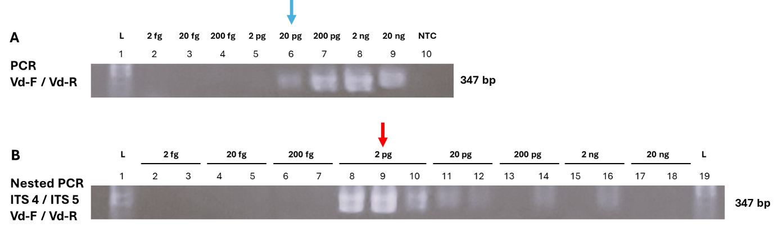

C

Figure S4: Detection limit of: (A) the conventional PCR using specific primers Vd-F/ Vd-R, shown to be 20 pg /reaction (1 pg/μl rection); (B) Nested PCR using universal primers ITS4 / ITS5 in the first round and specific primers Vd-F/ Vd-R in the second round of amplification, shown a detection limit of 2 pg /reaction (100 fg/μl rection). Assays were performed in 20 μl reaction volume, yielding a 347 bp amplicon; (C) SYBR assay targeting the ITS (Internal Transcribed Spacer) region of Verticillium dahliae strain 70V. Real time SYBR qPCR using as template seven 10-fold serial dilutions of 1 ng/μl reaction of genomic DNA extracted from the V. dahliae strain 70V. PCR reactions were performed in 20 μl volume using primers Vd-F/ Vd-R.

F3 CTTTGAACGCACATGGCG
FIP=F1c-F2 is forward
F2: TTCCAGTATCCTGGGAGGC
F1c: CGTAGATCCCCAACACCGGG
F1c _rc: cccggtgttggggatctacg

BIP= B1c-B2 is reverseB3 rc 5’- GCGCTTGCCTCTAAACCC-3’
B2: ACTCCGATGCGAGCTGTA
B2rc: TACAGCTCGCATCGGAGT
B1c: 5’- ccttaaaagcagtggcggaccc-3’

KP083229Fmed tcatcgaatctttgaacgcaccttgcgccccttggtattccgaggggcatgcctgtttga 460
AY366914Fonseca tcatcgaatctttgaacgcacattgcgccctttggtattccgaagggcatgcctgttcga 361
MG817475Aa --------------------------------------------AAGGGCATGCCTTCGA 236
KP666172Aa TCATCGAATCTTTGAACGCACATTGCGCCCTTTGGTATTCCAAAGGGCATGCCTGTTCGA 298
JQ074093Aa TCATCGAATCTTTGAACGCACATTGCGCCCTTTGGTATTCCAAAGGGCATGCCTGTTCGA 293
FJ884071Aa TCATCGAATCTTTGAACGCACATTGCGCCCTTTGGTATTCCAAAGGGCATGCCTGTTCGA 330
FJ884070Aa TCATCGAATCTTTGAACGCACATTGCGCCCTTTGGTATTCCAAAGGGCATGCCTGTTCGA 332
AF3384031So TCATCGAATCTTTGAACGCACATTGCGCCCCCTGGTATTCCGGGGGGCACACCTGTTCGA 305
AF3384011_So TCATCGAATCATTGAACGCACATTGCGCCCCCTGGTATTCCGGGGGGCACACCTGTTCGA 305
AF3384021So TCATCGAATCTTTGAACGCACATTGCGCCCCCTGGTATTCCGGGGGGCACACCTGTTCGA 304
KF7661511Bd TCATCGAATCTTTGAACGCACATTGCGCCCTTTGGTATTCCGAAGGGCATGCCTGTTCGA 367
AF364018Vd tcatcgaatctttgaacgcacatggcgccttccagtatcctgggaggcatgcctgtccga 191
JX997433Vd tcatcgaatctttgaacgcacatggcgccttccagtatcctgggaggcatgcctgtccga 294
NR_126124Vd tcatcgaatctttgaacgcacatggcgccttccagtatcctgggaggcatgcctgtccga 318
JX997431Vd tcatcgaatctttgaacgcacatggcgccttccagtatcctgggaggcatgcctgtccga 294
JX997432Vd tcatcgaatctttgaacgcacatggcgccttccagtatcctgggaggcatgcctgtccga 294
Z29511Vd tcatcgaatCTTTGAACGCACATGGCGccTTCCAGTATCCTGGGAGGCatgcctgtccga 277
AF364000Vd tcatcgaatctttgaacgcacatggcgccttccagtatcctgggaggcatgcctgtccga 277
AF104926Vd tcatcgaatctttgaacgcacatggcgccttccagtatcctgggaggcatgcctgtccga 2681
KC592087Vtr tcatcgaatctttgaacgcacatggcgccttccagtatcctgggaggcatgcctgtccga 317
KC592088Vtr tcatcgaatctttgaacgcacatggcgccttccagtatcctgggaggcatgcctgtccga 317
NR_126134Vaa tcatcgaatctttgaacgcacatggcgccttccagtatcctgggaggcatgcctgtccga 316
KM052900FOL tcatcgaatctttgaacgcacattgcgcccgccagtattctggcgggcatgcctgttcga 563
KY305483Ca TCATCGAATCTTTGAACGCACATTGCGCTCGCCAGCATTCTGGCGAGCATGCCTGTTCGA 315
NR_144794Ca TCATCGAATCTTTGAACGCACATTGCGCTCGCCAGCATTCTGGCGAGCATGCCTGTTCGA 340
KP903617Ca TCATCGAATCTTTGAACGCACATTGCGCTCGCCAGCATTCTGGCGAGCATGCCTGTTCGA 359
KP903585Ca TCATCGAATCTTTGAACGCACATTGCGCTCGCCAGCATTCTGGCGAGCATGCCTGTTCGA 357
KP903622Ca TCATCGAATCTTTGAACGCACATTGCGCTCGCCAGCATTCTGGCGAGCATGCCTGTTCGA 370
KP903592Ca TCATCGAATCTTTGAACGCACATTGCGCTCGCCAGCATTCTGGCGAGCATGCCTGTTCGA 358
FJ904825Cg TCATCGAATCTTTGAACGCACATTGCGCCCGCCAGCATTCTGGCGGGCATGCCTGTTCGA 371
FJ884081Cg TCATCGAATCTTTGAACGCACATTGCGCCCGCCAGCATTCTGGCGGGCATGCCTGTTCGA 349
JX944164Cg TCATCGAATCTTTGAACGCACATTGCGCCCGCCAGCATTCTGGCGGGCATGCCTGTTCGA 268
NR_160754Cg TCATCGAATCTTTGAACGCACATTGCGCCCGCCAGCATTCTGGCGGGCATGCCTGTTCGA 366
JX944157Cg TCATCGAATCTTTGAACGCACATTGCGCCCGCCAGCATTCTGGCGGGCATGCCTGTTCGA 266

KP083229Fmed gtgtcatgtaattctcaatcctcttttttcttaattgaaggagggggcttggacttggag 520
AY366914Fonseca gcgtcattatcaccccctcaagcccctgtgcttggtgttggacggcttggtggagcgagt 421
MG817475Aa GCGTCATTTGTACCTCA------------------------------------------- 253
KP666172Aa GCGTCATTTGTACCCTCAAGCT-TTGCTTGGTGTTGGGCGTCTTGTCTCTAGCTTTGCTG 357
JQ074093Aa GCGTCATTTGTACCCTCAAGCT-TTGCTTGGTGTTGGGCGTCTTGTCTCTAGCTTTGCTG 352
FJ884071Aa GCGTCATTTGTACCCTCAAGCT-TTGCTTGGTGTTGGGCGTCTTGTCTCTAGCTTTGCTG 389
FJ884070Aa GCGTCATTTGTACCCTCAAGCT-TTGCTTGGTGTTGGGCGTCTTGTCTCTAGCTTTGCTG 391
AF3384031So GCGCCATTTCTACCCTGGAGCC-CTGCTCTGTGATGGGCCCCGTCCTCGCGGACGGGCCC 364
AF3384011_So GCGCCATTTCTACCCTGGAGCC-CTGCTCTGTGATGGGCCCCGTCCTCGCGGACGGGCCC 364
AF3384021So GCGCCATTTCTACTCTGGAGCC-CTGCTCTGTGATGGGCCCCGTCCTCGCGGACGGGCCC 363
KF7661511Bd GCGTCATTACAACCCTCAAGCT-CTGCTTGGTATTGGGCACCGTCCTTTGCGGGCGCGCC 426
AF364018Vd gcgtcgtttcaaccctcgagccccagtggcccggtgttggggatctacgtctgtaggccc 251
JX997433Vd gcgtcgtttcaaccctcgagccccagtggcccggtgttggggatctacgtctgtaggccc 354
NR_126124Vd gcgtcgtttcaaccctcgagccccagtggcccggtgttggggatctacgtctgtaggccc 378
JX997431Vd gcgtcgtttcaaccctcgagccccagtggcccggtgttggggatctacgtctgtaggccc 354
JX997432Vd gcgtcgtttcaaccctcgagccccagtggcccggtgttggggatctacgtctgtaggccc 354
Z29511Vd gcgtcgtttcaaccctcgagccccagtggcccggtgttggggatctacgtctgtaggccc 337
AF364000Vd gcgtcgtttcaaccctcgagccccagtggcccggtgttggggatctacgtctgtaggccc 337
AF104926Vd gcgtcgtttcaaccctcgagccccagtggcccggtgttggggatctacgtctgtaggccc 2741
KC592087Vtr gcgtcgtttcaaccctcgagccctagtggcccggtgttggggatctacttctgtaggccc 377
KC592088Vtr gcgtcgtttcaaccctcgagccctagtggcccggtgttggggatctacttctgtaggccc 377
NR_126134Vaa gcgtcgtttcaaccctcgagccctagtggcccggtgttggggatctacttctgtaggccc 376
KM052900FOL gcgtcatttcaac-cctcaagctcagcttggtgttgggactcgcggtaacccgcgttccc 622
KY305483Ca GCGTCATTTCAAC-CCTCAAGCACCGCTTGGTTTTGGGGCCCCACGGCAGACGTGGGCCC 374
NR_144794Ca GCGTCATTTCAAC-CCTCAAGCACCGCTTGGTTTTGGGGCCCCACGGCAGACGTGGGCCC 399
KP903617Ca GCGTCATTTCAAC-CCTCAAGCACCGCTTGGTTTTGGGGCCCCACGGCCGACGTGGGCCC 418
KP903585Ca GCGTCATTTCAAC-CCTCAAGCACCGCTTGGTTTTGGGGCCCCACGGCCGACGTGGGCCC 416
KP903622Ca GCGTCATTTCAAC-CCTCAAGCACCGCTTGGTTTTGGGGCCCCACGGCCGACGTGGGCCC 429
KP903592Ca GCGTCATTTCAAC-CCTCAAGCACCGCTTGGTTTTGGGGCCCCACGGCCGACGTGGGCCC 417
FJ904825Cg GCGTCATTTCAACCCCTCAAGCTCTGCTTGGTGTTGGGGCTCTACGGTCGACGTAGGCCC 431
FJ884081Cg GCGTCATTTCAAC-CCTCAAGCTCTGCTTGGTGTTGGGGCCCTACAGCTGATGTAGGCCC 408
JX944164Cg GCGTCATTTCAAC-CCTCAAGCTCTGCTTGGTGTTGGGGCCCTACAGCTGATGTAGGCCC 327
NR_160754Cg GCGTCATTTCAAC-CCTCAAGCTCTGCTTGGTGTTGGGGCCCTACAGCCGATGTAGGCCC 425
JX944157Cg GCGTCATTTCAAC-CCTCAAGCTCTGCTTGGTGTTGGGGCCCTACAGCTGATGTAGGCCC 325

KP083229Fmed gttaatatatacatgctggtactgtctgtatcg----gctcctctaaaatgcattagctg 576
AY366914Fonseca tcacactttccacccctcctaaagacaatgacggcggcctgcggaacccccg-------- 473
MG817475Aa ------------------------------------------------------------ 253
KP666172Aa GAGACTCGCCTTAAAGTAATTGGCAGCCGGCCTACTGGTTTCGGAGCGCTTCACAAGTCG 417
JQ074093Aa GAGACTCGCCTTAAAGTAATTGGCAGCCGGCCTACTGGTTTCGGAGCGCAGCACAAGTCG 412
FJ884071Aa GAGACTCGCCTTAAAGTAATTGGCAGCCGGCCTACTGGTTTCGGAGCGCAGCACAAGTCG 449
FJ884070Aa GAGACTCGCCTTAAAGTAATTGGCAGCCGGCCTACTGGTTTCGGAGCGCAGCACAAGTCG 451
AF3384031So GAAACCCGTGGGCGC-CGTCGTCCGGCCCCGAG-CGTAGCAAGAGAAACCCCTCGCTCGG 422
AF3384011_So GAAACCCGTGGGCGC-CGTCGTCCGGCCCCGAG-CGTAGCAAGAGAAATCCCTCGCTCGG 422
AF3384021So GAAACCCGTGGGCGC-CGTCGTCCGGCCCCGAG-CGTAGCAAGAGAAATCCCTCGCTCGG 421
KF7661511Bd TCAAAGACCTCGGCGGTGGCGTCTTGCCTCAAG-CGTAGTAGAACATACATCTCGCTTCG 485
AF364018Vd ttaaaagcagtggcggacccgcgtggcccttcc-ttgcgtagtaattacagctcgcatcg 310
JX997433Vd ttaaaagcagtggcggacccgcgtggcccttcc-ttgcgtagtaattacagctcgcatcg 413
NR_126124Vd ttaaaagcagtggcggacccgcgtggcccttcc-ttgcgtagtagttacagctcgcatcg 437
JX997431Vd ttaaaagcagtggcggacccgcgtggcccttcc-ttgcgtagtagttacagctcgcatcg 413
JX997432Vd ttaaaagcagtggcggacccgcgtggcccttcc-ttgcgtagtagttacagctcgcatcg 413
Z29511Vd ttaaaagcagtggcggacccgcgtggcccttcc-ttgcgtagtagtTACAGCTCGCATCG 396
AF364000Vd ttaaaagcagtggcggacccgcgtggcccttcc-ttgcgtagtagttacagctcgcatcg 396
AF104926Vd ttaaaagcagtggcggacccgcgtggcccttcc-ttgcgtagtagttacagctcgcatcg 2800
KC592087Vtr ttaaaagcagtggcggacccgcgtggcccttcc-ttgcgtagtaattttcgctcgcatcg 436
KC592088Vtr ttaaaagcagtggcggacccgcgtggcccttcc-ttgcgtagtaattttcgctcgcatcg 436
NR_126134Vaa ttaaaatcagtggcggacccgcgtggcccttcc-ttgcgtagtaattttcgctcgcatcg 435
KM052900FOL caaatcgattggcgg---tcacgtcgagcttccatagcgtagtaatcatacacctcgtt- 678
KY305483Ca TTAAAGGTAGTGGCGGACCCTCCCGGAGCCTCCTTTGCGTAGTAAC-TAACGTCTCGCA- 432
NR_144794Ca TTAAAGGTAGTGGCGGACCCTCCCGGAGCCTCCTTTGCGTAGTAAC-TAACGTCTCGCA- 457
KP903617Ca TTAAAGGTAGTGGCGGACCCTCCCGGAGCCTCCTTTGCGTAGTAAC-TAACGTCTCGCA- 476
KP903585Ca TTAAAGGTAGTGGCGGACCCTCCCGGAGCCTCCTTTGCGTAGTAAC-TAACGTCTCGCA- 474
KP903622Ca TTAAAGGTAGTGGCGGACCCTCCCGGAGCCTCCTTTGCGTAGTAAC-TAACGTCTCGCA- 487
KP903592Ca TTAAAGGTAGTGGCGGACCCTCCCGGAGCCTCCTTTGCGTAGTAAC-TAACGTCTCGCA- 475
FJ904825Cg TCAAAGGTAGTGGCGGACCCTCCCGGAGCCTCCTTTGCGTAGTAACATTTCGTCTCGCA- 490
FJ884081Cg TCAAAGGTAGTGGCGGACCCTCCCGGAGCCTCCTTTGCGTAGTAACTTTACGTCTCGCA- 467
JX944164Cg TCAAAGGTAGTGGCGGACCCTCTCGGAGCCTCCTTTGCGTAGTAACTTTACGTCTCGCA- 386
NR_160754Cg TCAAAGGTAGTGGCGGACCCTCCCGGAGCCTCCTTTGCGTAGTAACTTTACGTCTCGCA- 484
JX944157Cg TCAAAGGTAGTGGCGGACCCTCTCGGAGCCTCCTTTGCGTAGTAACTTTACGTCTCGCA- 384

KP083229Fmed ga------ctgtagttcgcattgt-----ttggtgtagtaatagttttctatctatattc 625
AY366914Fonseca --------gtacactgagcttc---------tttattgagcacgtatcggatgaagggtg 516
MG817475Aa ------------------------------------------------------------ 253
KP666172Aa CAC-----TCTCTATCAGCAAAGGTCTAGCATCCATGGGGGGGGTTTTTTCAACCTTTTG 472
JQ074093Aa CAC-----TCTCTATCAGCAAAGGTCTAGCATCCATTAAGCCTTTTTTCAA--CTTTGAC 465
FJ884071Aa CAC-----TCTCTATCAGCAAAGGTCTAGCATCCATTAAGCCTTTTTTTCA--ACTTTTG 502
FJ884070Aa CAC-----TCTCTATCAGCAAAGGTCTAGCATCCATTAAGCCTTTTTTTCA--ACTTTTG 504
AF3384031So ---------AGCGCCTGGCGGCCG--GCCGCCCCGAA---ACCTACTTCTACAAG----- 463
AF3384011_So ---------AGCGCCTGGCGGCCG--GCCGCCCCGAA---ACCTACTTCTACAAG----- 463
AF3384021So ---------AGCGCCTGGCGGCCG--GCCGCCCCGAA---ACCTACTTCTACAAG----- 462
KF7661511Bd --------GAGCGCAGGGCGTCGCCCGCCGGACGAACCTTCTGAACTTTTCTCAAGGTTG 537
AF364018Vd gagtcccgcaggcacttgcctctaaaccccctacaagcccgcctcgtgcggcaacg---- 366
JX997433Vd gagtcccgcaggcacttgcctctaaaccccctacaagcccgcctcgtgcggcaacggttg 473
NR_126124Vd gagtcccgcaggcgcttgcctctaaaccccctacaagcccgcctcgtgcggcaac----- 492
JX997431Vd gagtcccgcaggcgcttgcctctaaaccccctacaagcccgcctcgtgcggcaacggttg 473
JX997432Vd gagtcccgcaggcgcttgcctctaaaccccctacaagcccgcctcgtgcggcaacggttg 473
Z29511Vd GAGTcccgcagGCGCTTGCCTCTAAACCCcctacaagcccgcctcgtgcggcaacg---- 452
AF364000Vd gagtcccgcaggcgcttgcctctaaaccccctacaagcccgcctcgtgcggcaacg---- 452
AF104926Vd gagtcccgcaggcgcttgcctctaaaccccctacaagcccgcctcgtgcggcaacggttg 2860
KC592087Vtr gagtcccgcaggcactagcctctaaaccccctacaagtccgc------------------ 478
KC592088Vtr gagtcccgcaggcactagcctctaaaccccctacaagtccgc------------------ 478
NR_126134Vaa gagtcccgtaggcaccagcctctaaaccccctacaagcccgtctcgtacggcaac----- 490
KM052900FOL --------actggtaatcgtcgcggccacgccgtaaaa---------------------- 708
KY305483Ca --------CTGGGATCCGGAGGGACTCTTGCCGTAAAACCCCC----------------- 467
NR_144794Ca --------CTGGGATCCGGAGGGACTCTTGCCGTAAAACCCCCAAATTCTTTACAGGTTG 509
KP903617Ca --------CTGGGATCCGGAGGGACTCTTGCCGTTAAACCCCCAAATTT-TTTCAGGTTG 527
KP903585Ca --------CTGGGATCCGGAGGGACTCTTGCCGTTAAACCCCCAAATTT-TTTCAGGTTG 525
KP903622Ca --------CTGGGATCCGGAGGGACTCTTGCCGTTAAACCCCCAAATTT-TTTCAGGTTG 538
KP903592Ca --------CTGGGATCCGGAGGGACTCTTGCCGTTAAACCCCCAAATTT-TTTCAGGTTG 526
FJ904825Cg --------CTGGGATCCGGAGGGACTCTTGCCGTAAAACCCCA---ATTTTCCAAGGTTG 539
FJ884081Cg --------CTGGGATCCGGAGGGACTCTTGCCGTAAAACCCCCCAATTTTCCAAAGGTTG 519
JX944164Cg --------CTGKKATCCGGAGG-------------------------------------- 400
NR_160754Cg --------CTGGGATCCGGAGGGACTCTTGCCGTAAAACCCCCCAATTTTCCAAAGGTTG 536
JX944157Cg --------CTGGGWTCCGGAGGGA------------------------------------ 400

Figure S5: LAMP primers were depicted on sequence alignment of the ITS (Internal Transcribed Spacer) region of Verticillium dahliae strain with Accession number Z29511, compared to other sequences of target and non-target fungi. Accession numbers are shown on the right site of the aligned sequences. Fungal species are indicated after Accession Numbers (Fmed: Fomitiporia mediterranea, Fonseca: Fonsecaea monophora, Aa: Alternaria alternata, So: Spilocaea oleaginea, Bd: Botryopshaeria dothidea, Vd: Verticillium dahliae, Vtr; Verticillium tricorpus, Vaa: Verticillium albo-atrum, FOL: Fusarium oxysporum f. sp. lycopersici, Ca: Colletotrichum acutatum, Cg: Colletotrichum gloeosporioides). Alignment was performed with Clustal Omega, using standard settings.

