- The settings of the camera when capturing the images
Image format: CR2 format.
Image size: L size (such as L size).
Color space: sRGB.
Sensitivity (ISO): Automatic ISO mode, ranging from 100 to 6400.
Focus mode: Single-shot Autofocus (One Shot AF).
White balance: Automatic white balance.
Shooting mode: Fully automatic mode.

- Pre-experiments to determine the appropriate frequencies.
Generate sine graphs of three phases with frequencies ranging from 20 to 170. Among them, sine graphs with frequencies generated successively with spans of 10 or 5 are mapped onto soybean samples. After preliminary image processing and comparison, it is shown that the preferred frequencies of 65, 75, and 85 (in units of: m⁻¹) can clearly display the area of sub-surface pest damage in soybean samples.
Example 1:
20 30 40
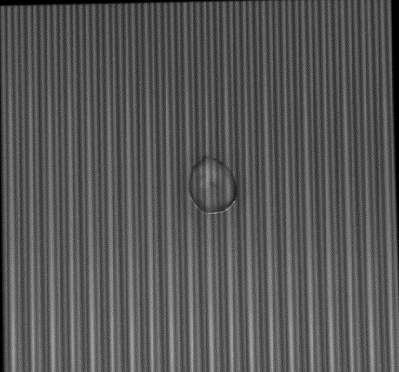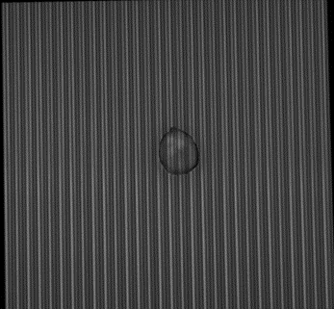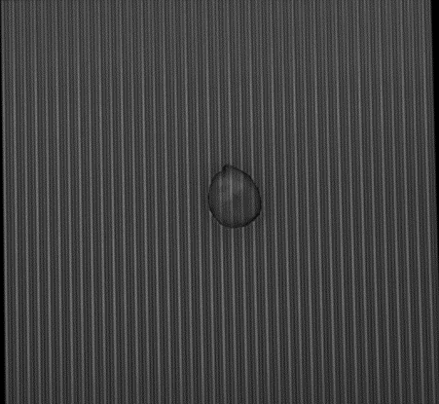
50 60 70
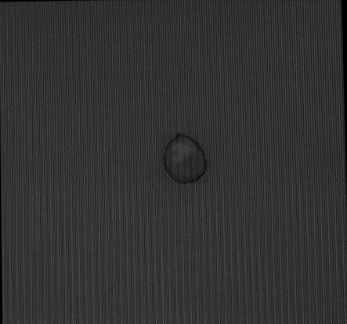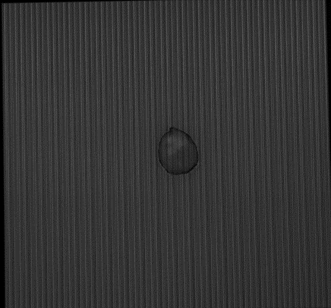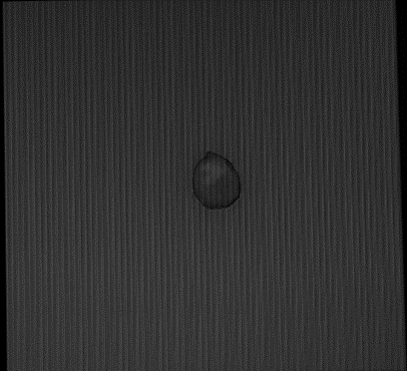
80 90 100
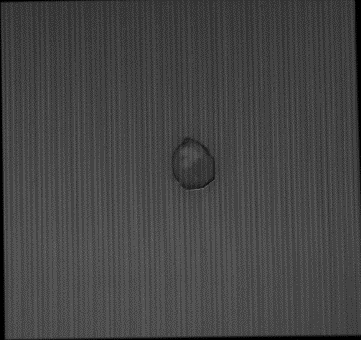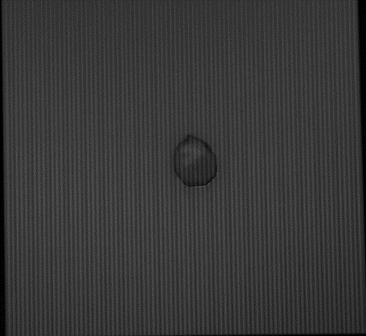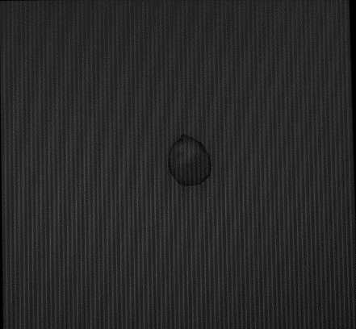
Example 2:
60 65 70
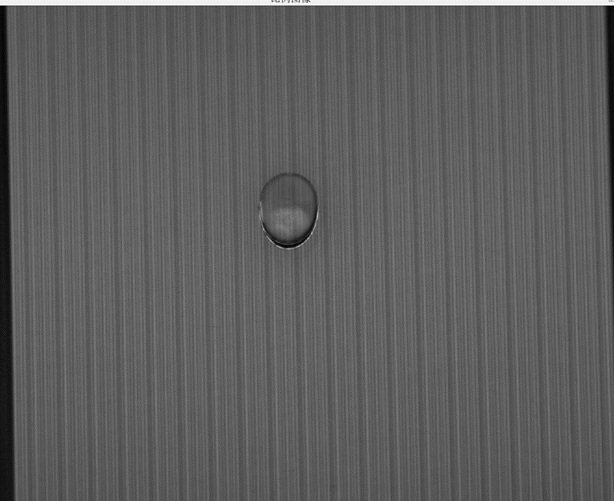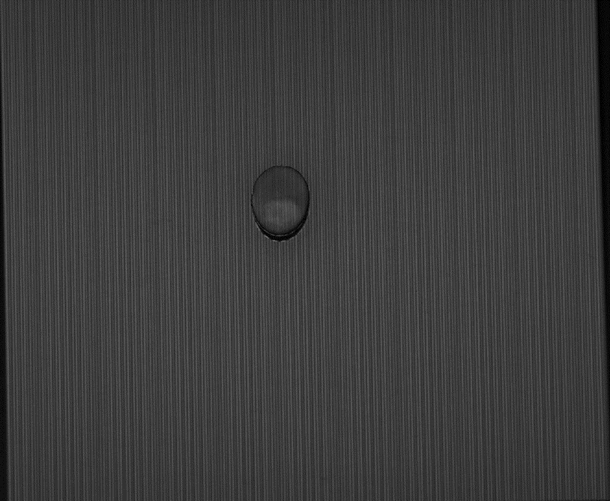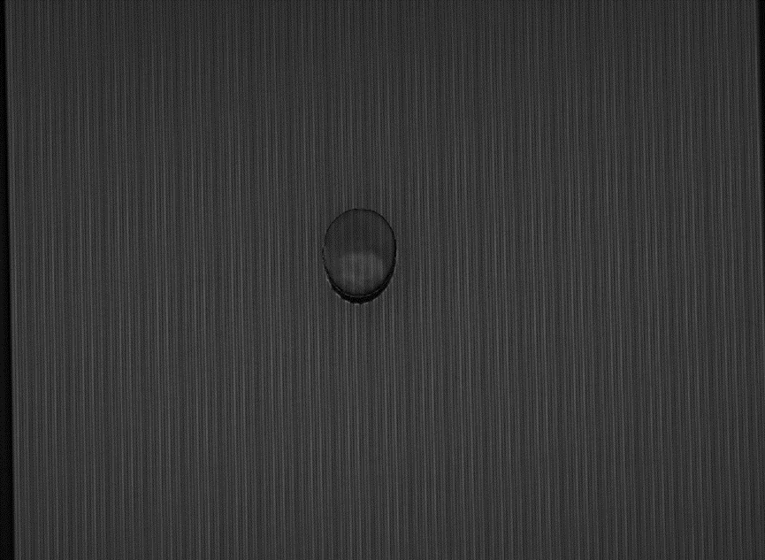
75 80 85
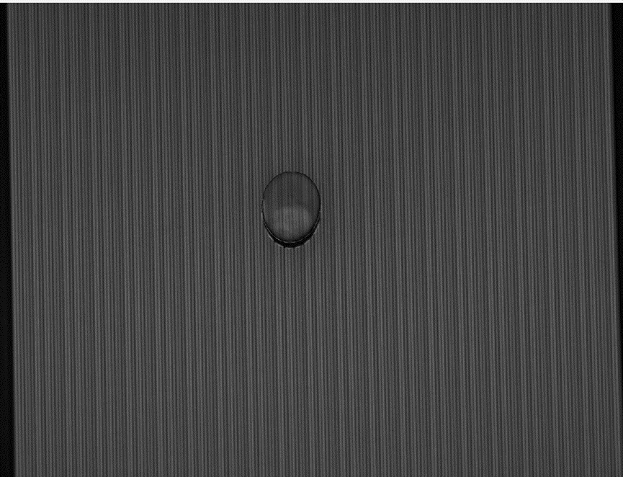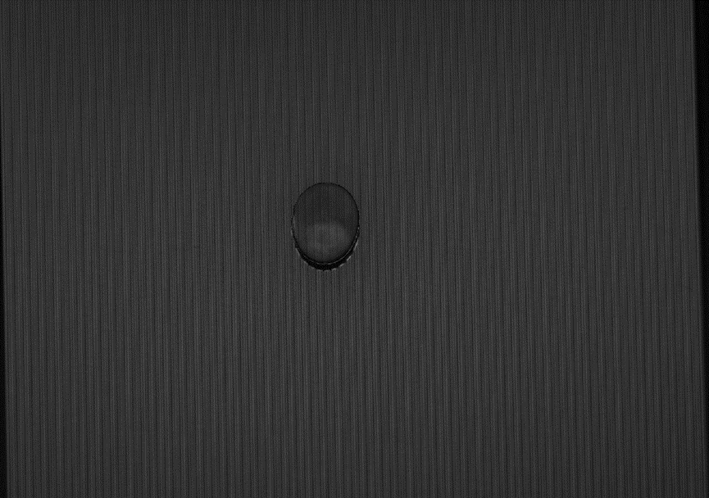
90 100 110
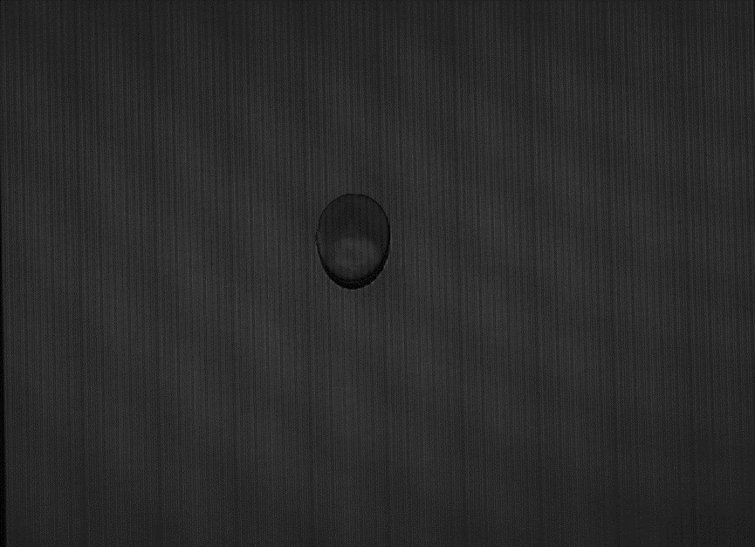
120 140 170


