Supplementary Information
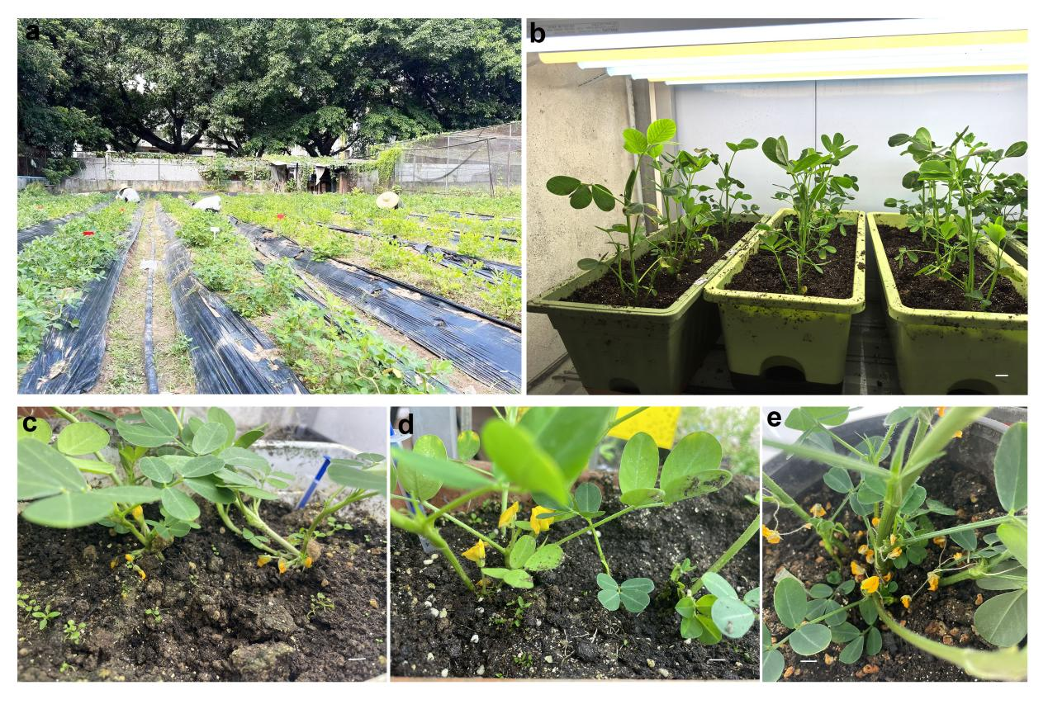
Fig. S1. Peanuts were cultivated for pollen tube injection
a. The transformation of peanut were conducted via the pollen tube injection operation in the biological park of the South China Normal University. b. The peanut plants were cultivated under a controlled light condition in an artificial climate room. c-d. The photograph indicated that the peanut plants exhibited well growth and normal flowering in the artificial climate room. e. Numerous flowers were produced after injecting DsRed-FT-assisted systems for several times. Scale bars represent 1 cm.

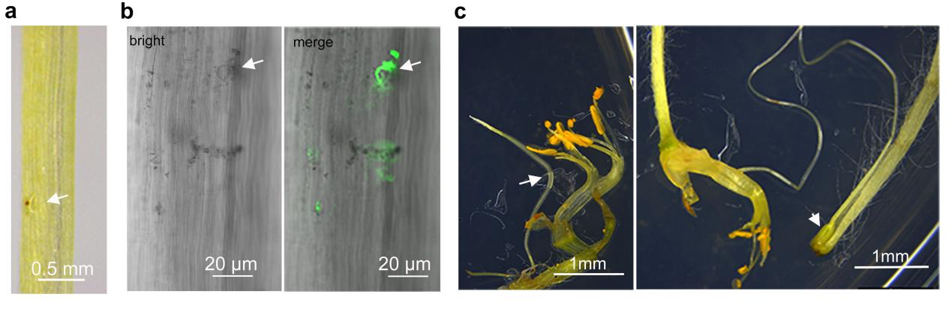
Fig. S2. Observation of male germ unit and style anatomy in peanuts
a. The ‘male germ unit’ was easily discernible and resembled a water drop under a light microscope. b. The ‘male germ unit’ was stained with SYTO™ (green) and subsequently observed under a microscope. c. The anatomy of peanut style revealed a direct connection between stigma and ovary.

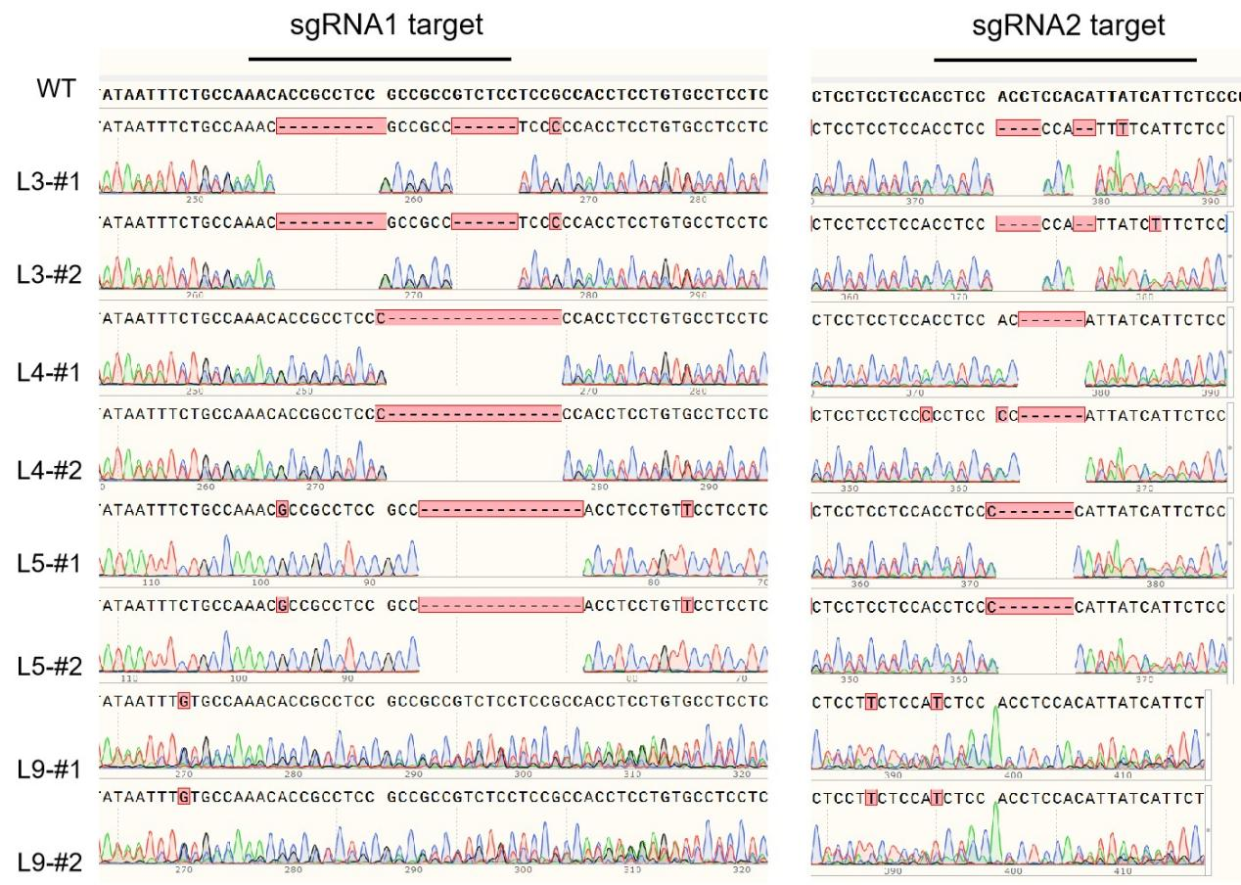

Fig. S3. Sequencing identification of the AhUP1-Cas9 transgenic lines
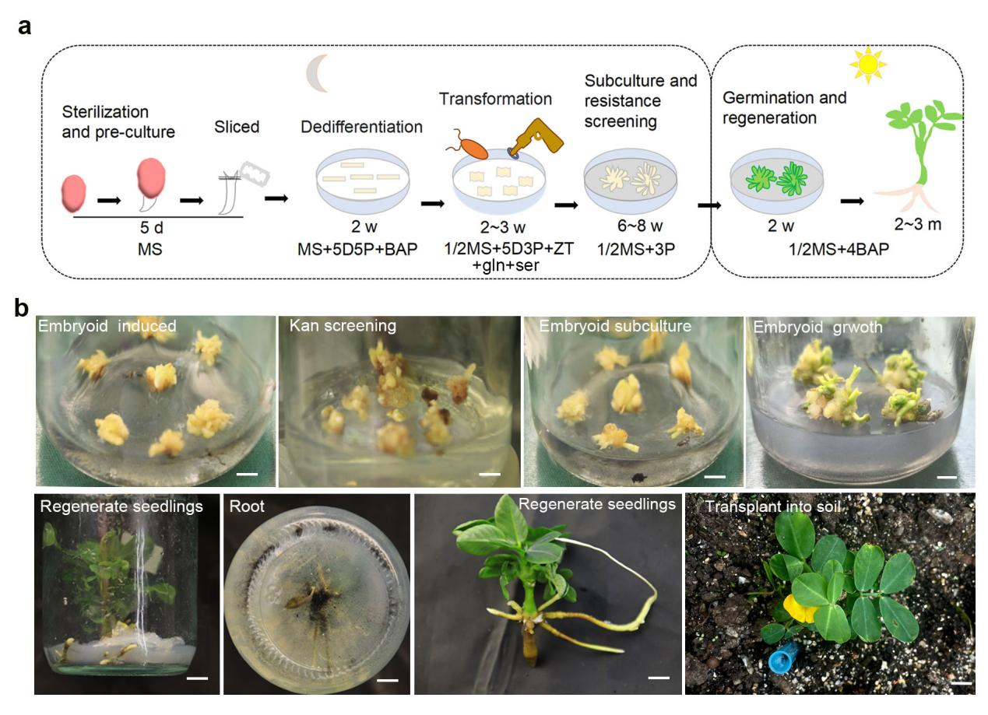
Fig. S4. Somatic embryo induction and transformation system in peanut
a, Schematic diagram showing the time required for the somatic embryo induction and transformation system of peanut. MS, Murashige and Skoog medium; 5D5P, 5 mg/L 2,4-D (2,4-dichlorophenoxyacetic acid) and 5 mg/L PIC (Picloram), gln, glutamate; ser, serine; ZT, 0.5 mg/L zeatin; 3P, 3 mg/L PIC; 4BAP, 4 mg/L 6-BA (6-benzylaminoterpin); 5 d, five days; 2 w, two weeks; 2~3 m, two to three months. b, The process of the somatic embryo transformation system in peanut. Scale bars, 1 cm.

Table. S1. Primers used in this study
Primer names | Primer sequences | Purpose
UP1-Cas9 | 5'-GGTCTCTTGCAGACGGCGGCGGAGGCGGTGTTGTTTCAGAGCTATGCTGGA-3' | Vector constriction
UP1-Cas9 | 5'-GGTCTCTAAACCCTCCACCTCCACATTATCATGCACCAGCCGGGAATCGA-3' | Vector constriction
DREB1-amiR | 5'-CTATCCTTCGCAAGACCCTTC-3' | Vector constriction
DREB1-amiR | 5'-TACTTGTACAGCTCGTCCAT-3' | Vector constriction
DREB1-Cas9 | 5'-GGTCTCTTGCAcagtactcagatccctttagGTTTCAGAGCTATGCTGGA-3' | Vector constriction
DREB1-Cas9 | 5'-GGTCTCTAAACtggttgggcctggatctgtTGCACCAGCCGGGAATCGA-3' | Vector constriction
DREB1-GFP | 5'-GGTATCGATAAGCTTatggcagcaatgatggat-3' | Vector constriction
DREB1-GFP | 5'-AGTGGATCCCCCGGGcagagaatcccaatcaat-3' | Vector constriction
UP1-amiR | 5'-TACCCCGACCACATGAAG-3' | Vector constriction
UP1-amiR | 5'-CTTCTCCGTCTTTCCCTGCTTC-3' | Vector constriction
PDK1-mCherry | 5'-GATTAACAGGGATCCATGGCGATGTCTAGACA-3' | Vector constriction
PDK1-mCherry | 5'-TTTCTTTCATGGATCCCAACTTTGGCAAAGAATGCA-3' | Vector constriction
UP1-mCherry | 5'-AGTGCGCCCGGGATGAATATGAAAGAAGTTGT-3' | Vector constriction
UP1-mCherry | 5'-GAGCCCGGTACCCTACATCCAAATTATACTAAGA-3' | Vector constriction
PDK1-Cas9 | 5'-GGTCTCTTGCAGGGCAGAAGTGAGGGAAACAGTTTCAGAGCTATGCTGGA-3' | Vector constriction
PDK1-Cas9 | 5'-GGTCTCTAAACGTTCCTGAAGTAGTGCCCATTGCACCAGCCGGGAATCGA-3' | Vector constriction
p1-UBQpro-F | 5'-tactcttcgatttgtgatttct-3' | PCR detection
p2-mCherry-R | 5'-CTTGTACAGCTCGTCCATG-3' | PCR detection
p1-KanR-F | 5'-GATGCGATGTTTCGCTTGGT-3' | PCR detection
p2-35St-R | 5'-CCCACTATCCTTCGCAAGACCT-3' | PCR detection
p1-GFPe2-F | 5'-gtgcccatcctggtcgagct-3' | PCR detection
p2-NOSt-R | 5'-catagatgacaccgcgcgcga-3' | PCR detection
p3-BAR-F | 5'-agaacgacgcccggccgacat-3' | PCR detection
p2-NOSt-R | 5'-catagatgacaccgcgcgcga-3' | PCR detection
p1-35S-F | 5'-GACCCTTCCTCTATATAAGGAAGTTCA-3' | PCR detection
p2-DsRED-R | 5'-CTACAGGAACAGGTGGTGGCGGCCCT-3' | PCR detection
mC-F | 5'-CTTTTACCAAACACCCCGC-3' | qPCR detection
MC-R | 5'-AATCAGAGTGCCATCTTCCAA-3' | qPCR detection
DREB1-F | 5'-gttaatggaggttcttgaacct-3' | qPCR detection
DREB1-r | 5'-cgttggacaagaaacagggttgt-3' | qPCR detection
Actin-F | 5'-TGCTGACAGGATGAGCAAGG-3' | qPCR detection
Actin-R | 5'-TCCTCTCTGGTGGTGCTACA-3' | qPCR detection

