Supplemental information

Table S1: Settings used for the experiments, if not otherwise mentioned
Section | Property | Value
Method | Resolution | 70,000
Method | AGC target | 1E06
Method | Maximum IT | Auto
Method | Spectrum data type | Profile
Tune file | Sheath gas flow rate | 10 a. u.
Tune file | Aux gas flow rate | 0 a. u.
Tune file | Spray voltage | 2.5 kV
Tune file | Capillary temperature | 320 °C
Tune file | S-lens RF level | 50
SESI | Intake line temperature | 100 °C
SESI | Ionizer core temperature | 130 °C

Table S2: Lock masses used for the experiments
MS Polarity | Exact Adduct Mass | Compound | Formula (excluding ionization)
Positive | 149.0233 | phthalic anhydrate | C₈H₄O₃
Positive | 279.1591 | diisobutyl phthalate | C₁₆H₂₂O₄
Positive | 445.1200 | polysiloxane (n6) | C₂₄H₃₆Si₆O₆
Positive | 158.96403 | sodium trifluoroacetate | C₂F₃NaO₂
Positive | 107.07027 | polypropylene glycole | C₃H₆O
Positive | 214.08963 | n-butyl benzenesulfonamide (plasticizer) | C₁₀H₁₅NO₂S

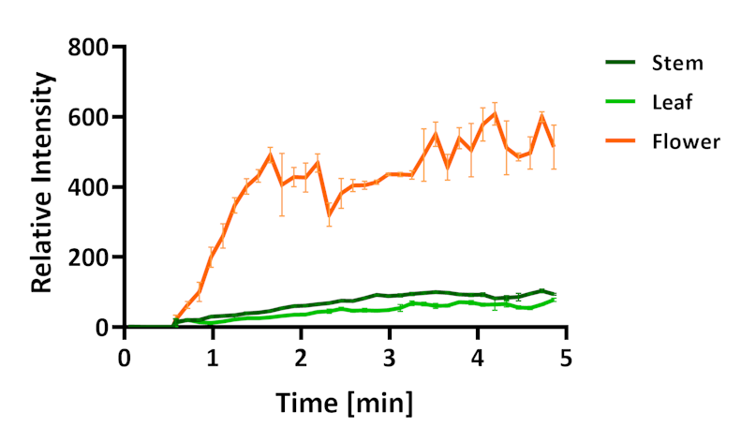
Figure S1. Real-time detection of Tulipalin A from various tulip organs from a different flower. The samples were hold in front of the SESI-Orbitrap MS for 0.5 mins to establish the baseline. Then, the plant material was crushed with a garlic press to monitor tulipalin A signal intensity overtime (n=3). All data was normalized to the average of background signal measured within 0.5 mins.

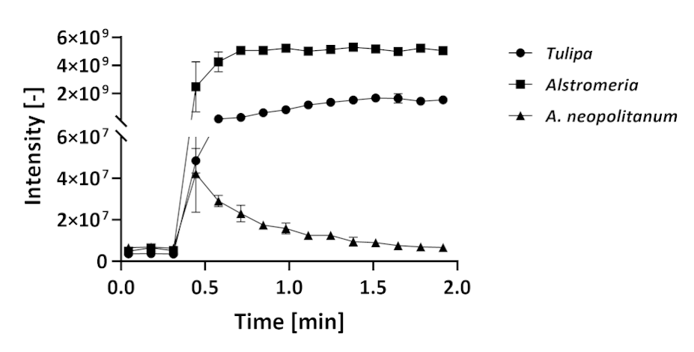
Figure S2. Real-time detection of Tulipalin A release from flowers of Tulipa, Alstromeria and A. neipolitanum. The samples were hold in front of the SESI-Orbitrap MS for 0.5 mins to establish the baseline. Next, the plant material was crushed with a garlic press to monitor tulipalin A signal intensity overtime (n=3). All data was normalized to the average of background signal measured within 0.5 mins.

