Two-fold Red Excess (TREx): A simple and novel digital color index that enables non-invasive real-time monitoring of green-leaved as well as anthocyanin-rich crops
Avinash Agarwal^{1,4}*, Filipe de Jesus Colwell², Viviana Andrea Correa Galvis², Tom R. Hill³, Neil Boonham¹, Ankush Prashar¹*
¹School of Natural and Environmental Sciences, Newcastle University, Newcastle upon Tyne, UK
²Crop Science R&D Division, Infarm - Indoor Urban Farming B.V., Amsterdam, The Netherlands
³Human Nutrition and Exercise Research Centre, Population Health Science Institute, Faculty of Medical Sciences, Newcastle University, Newcastle upon Tyne, UK
⁴Institute of Bio- and Geosciences: Plant Sciences (IBG-2), Forschungszentrum Jülich GmbH, Jülich, Germany
SUPPLEMENTARY MATERIAL
Supplementary figures
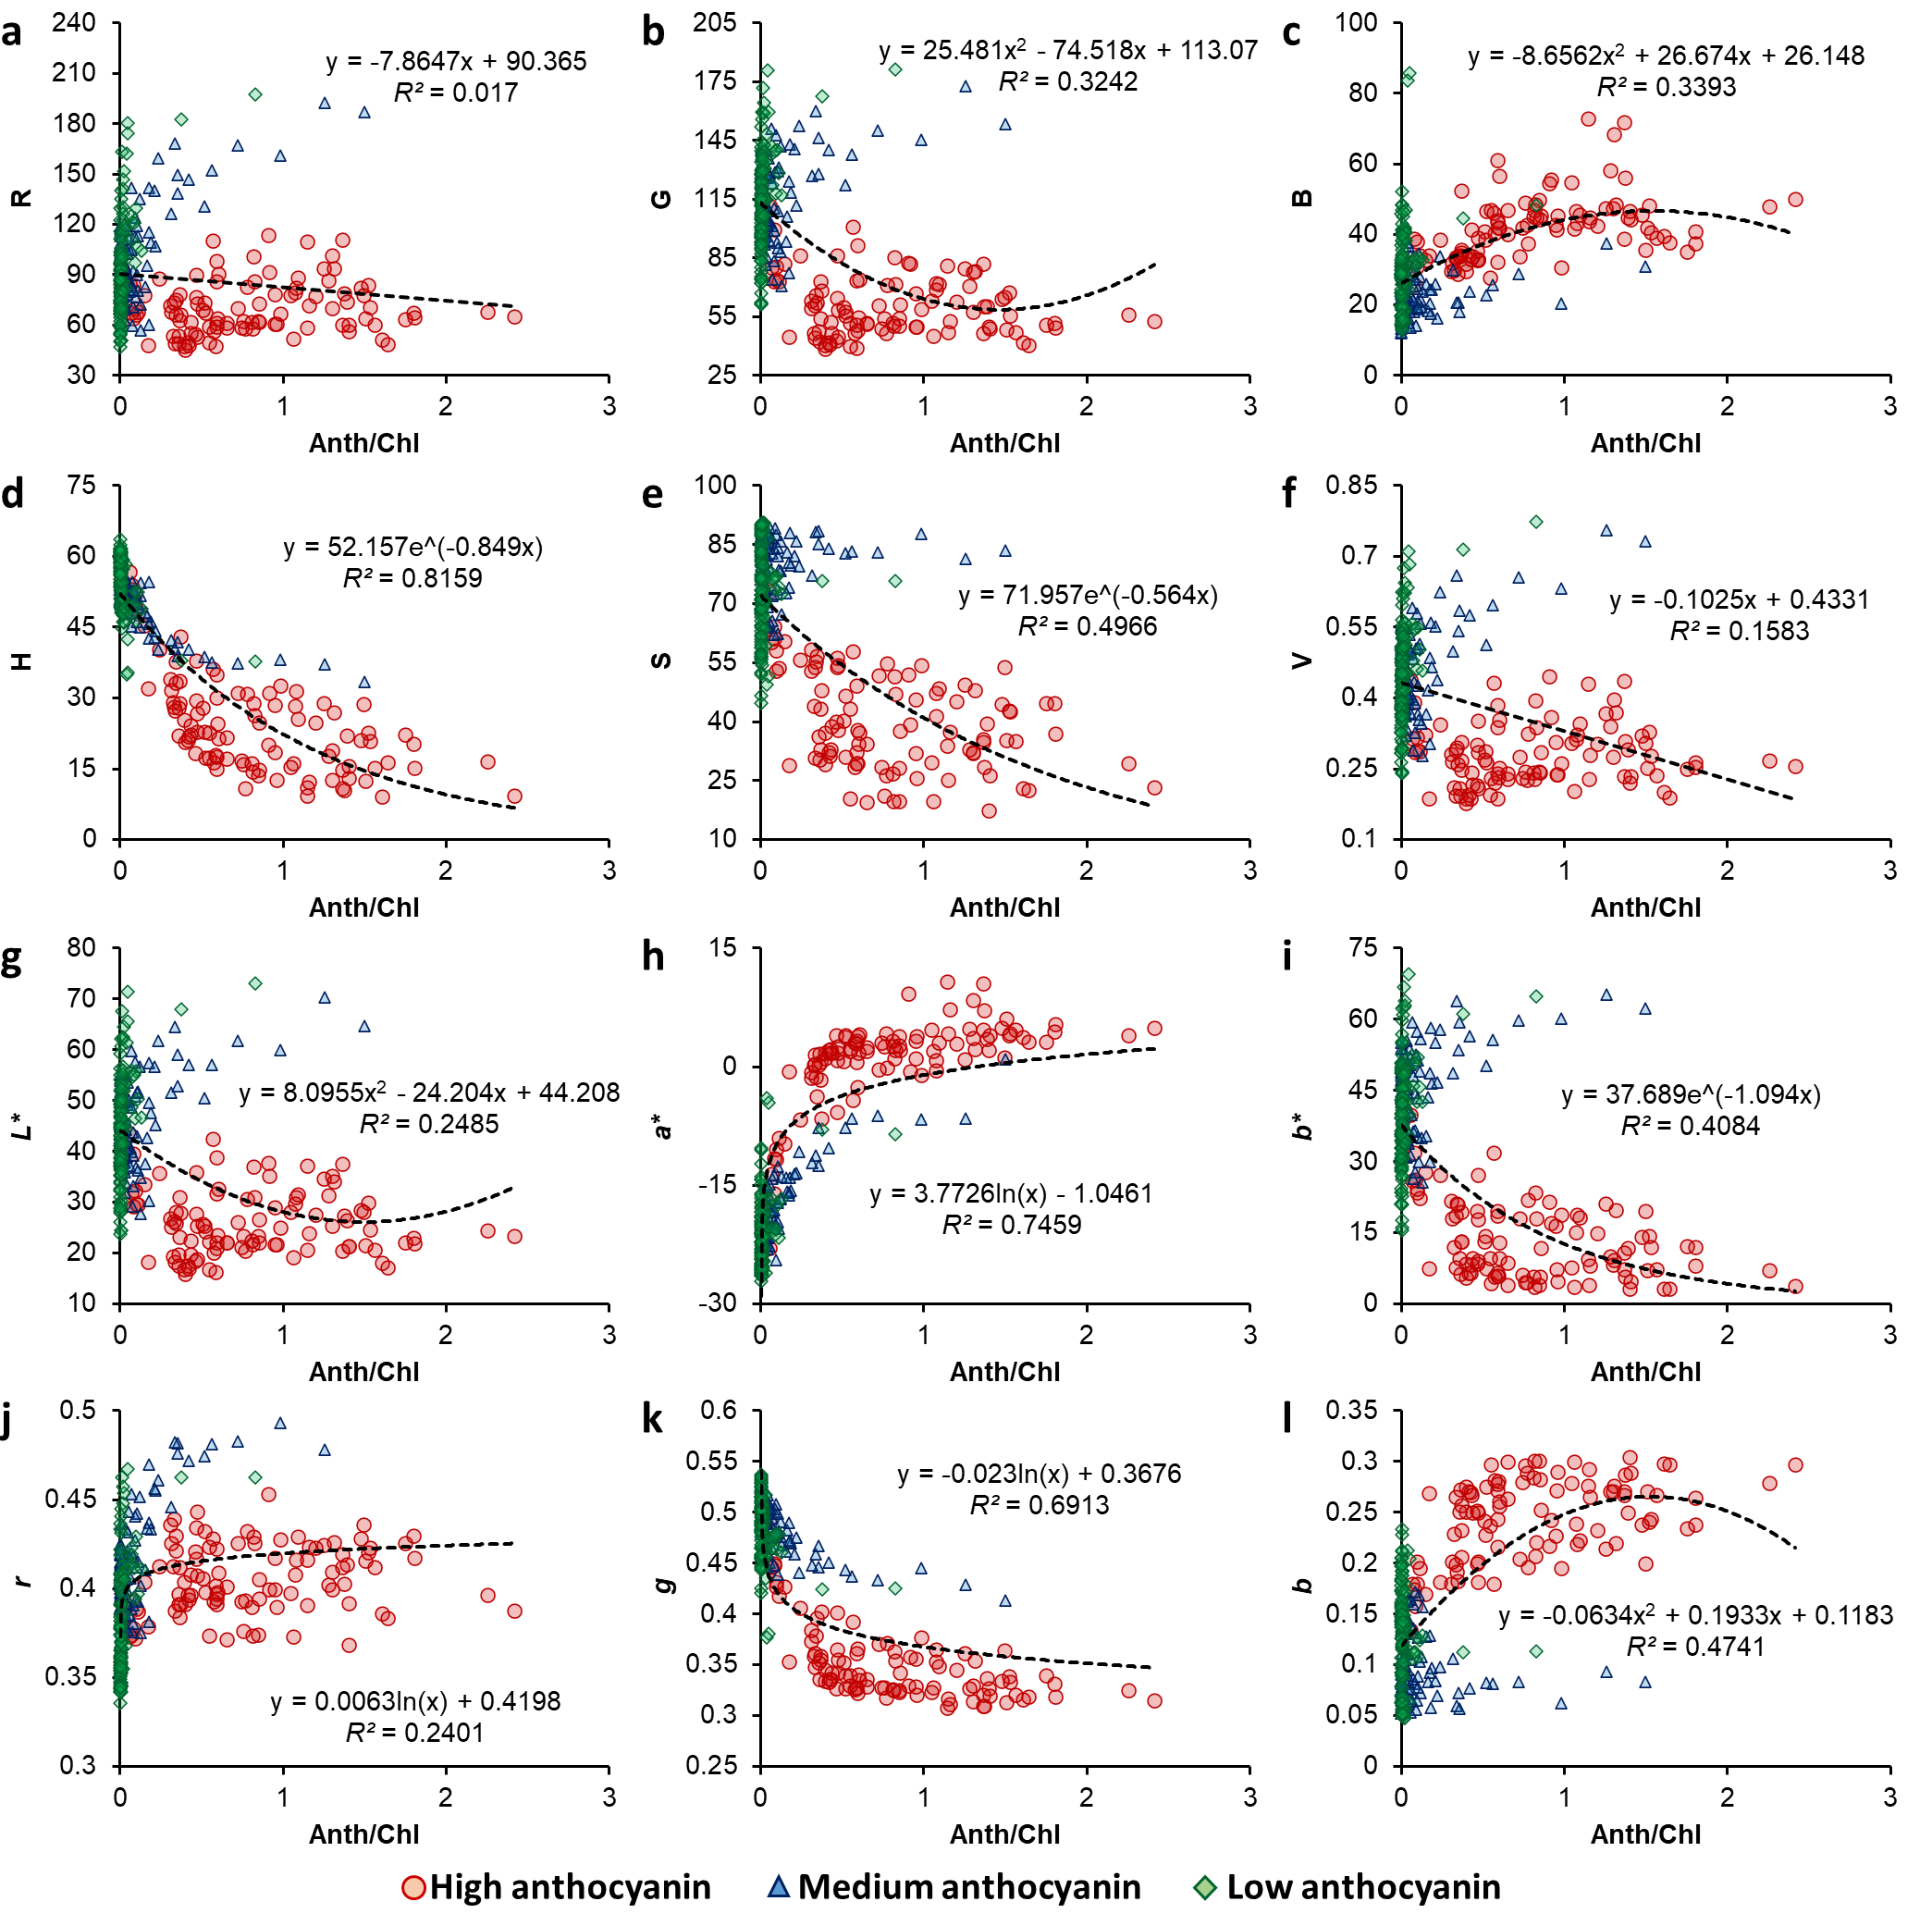
Fig. S1 Plots of anthocyanin/chlorophyll ratio (Anth/Chl) with different digital color features, i.e., Red (R), Green (G), Blue (B) (a–c), Hue (H), Saturation (S), Value (V) (d–f), Lightness (L*), Redness-greenness (a*), Yellowness-blueness (b*) (g–i), normalized Red (r), normalized Green (g), and normalized Blue (b) (j–l), for leaves with different levels of anthocyanin content. Coefficients of determination (R²) and equations have been presented for the best-fit curve (n = 320).
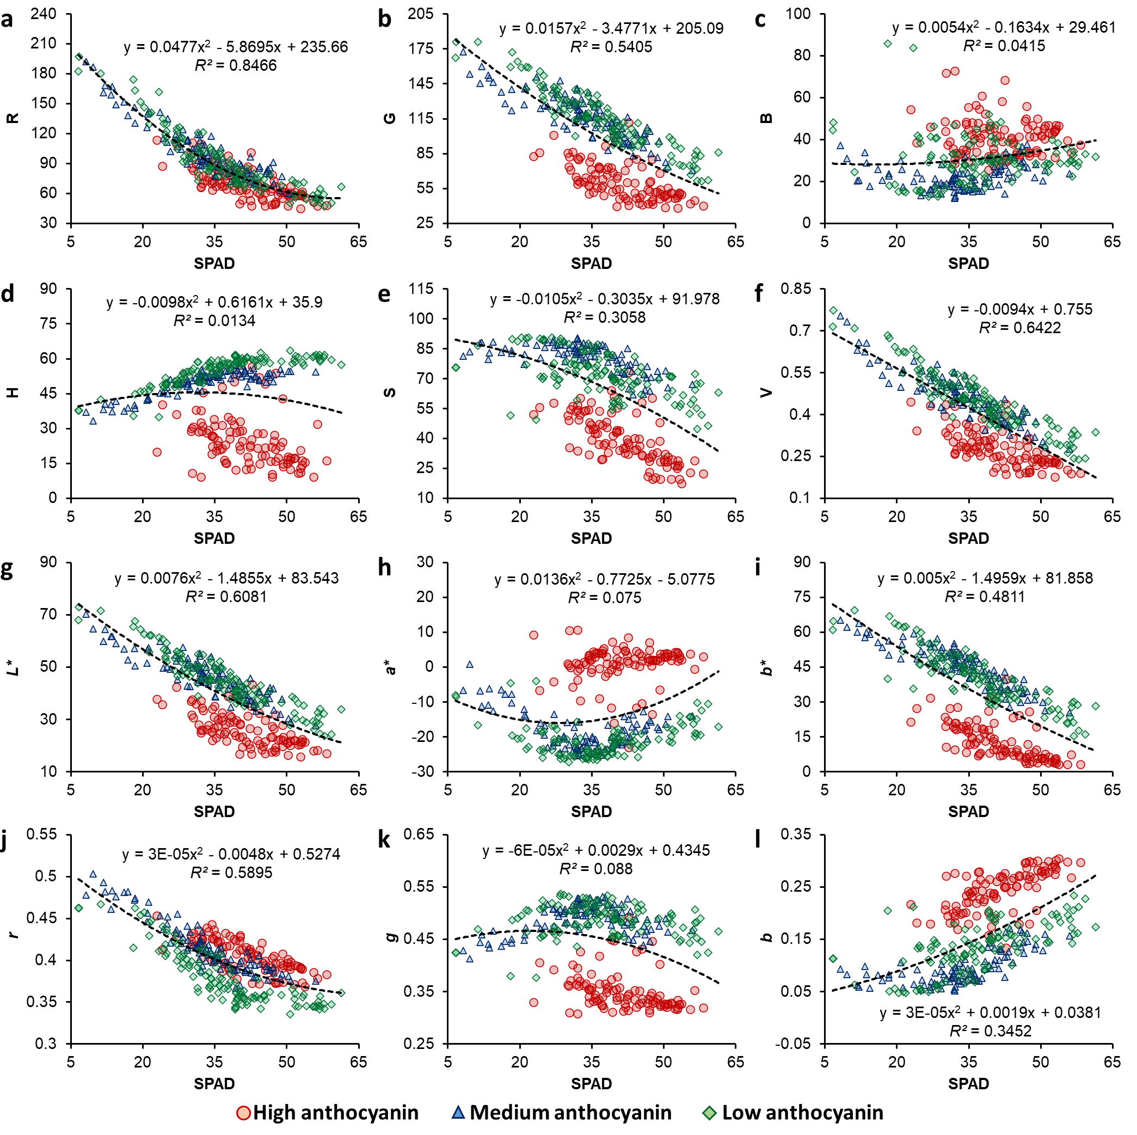
Fig. S2 Plots of SPAD measurements with different digital color features, i.e., Red (R), Green (G), Blue (B) (a–c), Hue (H), Saturation (S), Value (V) (d–f), Lightness (L*), Redness-greenness (a*), Yellowness-blueness (b*) (g–i), normalized Red (r), normalized Green (g), and normalized Blue (b) (j–l), for leaves with different levels of anthocyanin content. Coefficients of determination (R²) and equations have been presented for the best-fit curve (n = 320).

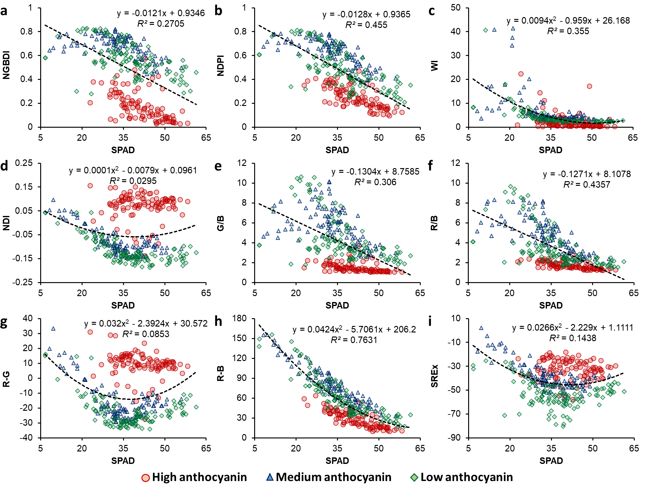
Fig. S3 Plots for SPAD measurements versus Normalized Green-Blue Difference Index (NGBDI; a), Normalized Difference Pigment Index (NDPI; b), Woebbecke’s Index (WI; c), Normalized Difference Index (NDI; d), Green-Blue ratio (G/B; e), Red-Blue ratio (R/B; f), Red-Green difference (R-G; g), Red-Blue difference (R-B; h), and Simple Red Excess index (SREx; i) for leafy vegetables with different levels of anthocyanin (indicated with different symbols). Coefficients of determination (R²) and equations have been presented for the best-fit curve for the combined dataset (n = 320).

