Supplementary material (Table S1, Fig. S1-S6)

Table S1 Basic parameters of 15 freeze-dried samples with three different sample amounts (Sample size) from the rhizosphere of five different plants (A-E). This table includes the sample dry weight used for the extraction of total RNA and the resulting concentration of total RNA in the eluate (Total RNA). Sample 6 was not included in the bioinformatics analyses as it contained too few reads.

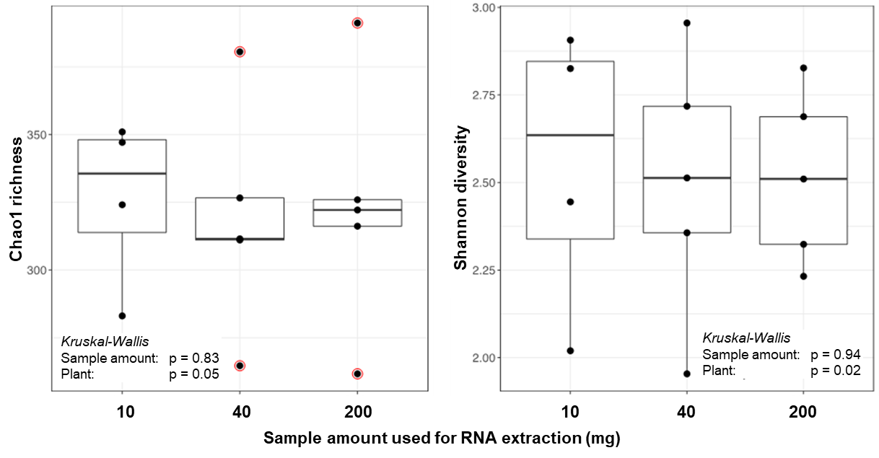
Fig. S1: Barley rhizoshpere microbiome Chao1 richness (A) and Shannon diversity (B) based on three different sample amounts used for RNA extraction for a eukaryotes only dataset. A Kruskal-Wallis test (inserted at bottom of the figures), showed that sample amount did not significantly affect Chao1 richness or Shannon diversity index (p>0.05). .
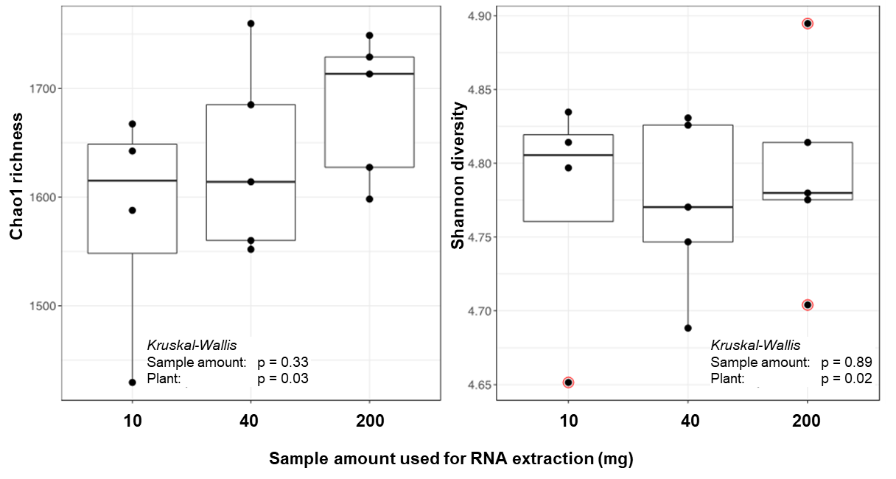
Fig. S2: Barley rhizoshpere microbiome Chao1 richness (A) and Shannon diversity (B) based on three different sample amounts used for RNA extraction for a prokaryotes only dataset. A Kruskal-Wallis test (inserted at bottom of the figures) showed that sample amount did not significantly affect Chao1 richness or Shannon diversity index (p>0.05).
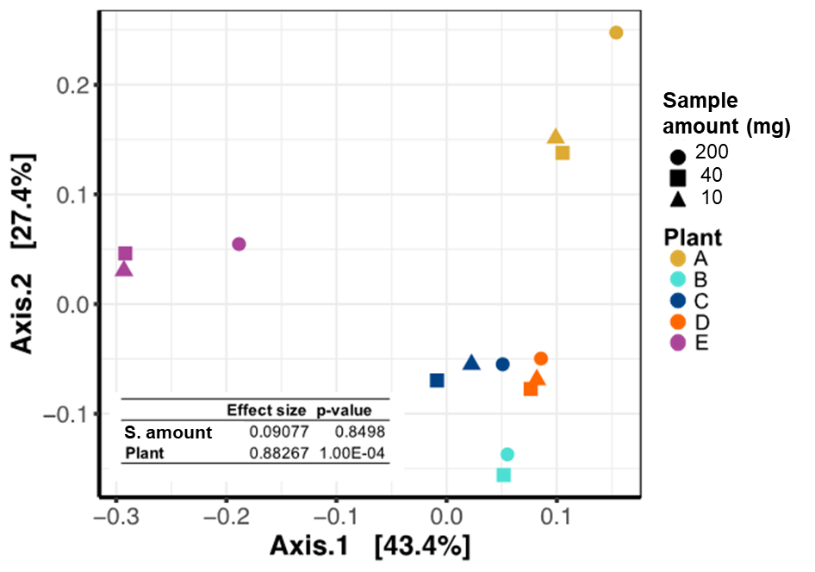
Fig. S3: Principal Coordinate Analysis (PCoA) computed on Bray-Curtis dissimilarity matrix of a eukaryotic only part of a rhizosphere microbiome for three different sample amounts (10, 40 and 200 mg). The percentages on the axes show how much variance the particular axis explains. Different dot shapes represent different sample amounts used in the RNA extraction. The different colours represent individual barley plants. Individual plant, but not sample amount, were significantly different. (PERMANOVA analyses, table at bottom left).
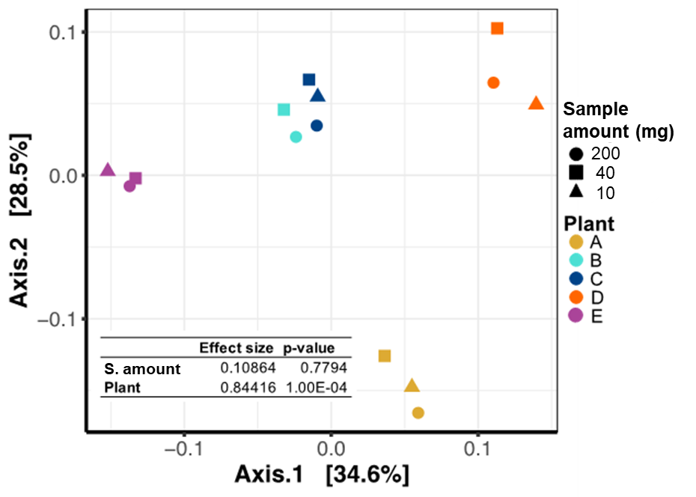
Fig. S4: Principal Coordinate Analysis (PCoA) computed on Bray-Curtis dissimilarity matrix of a prokaryotic only part the rhizosphere microbiome for three different sample amounts (10, 40 and 200 mg). The percentages on the axes show how much variance the particular axis explains. Different dot shapes represent different sample amounts used in the RNA extraction. The different colours represent individual barley plants. Individual plant, but not sample amount, were significantly different. (PERMANOVA analyses, table at bottom left).

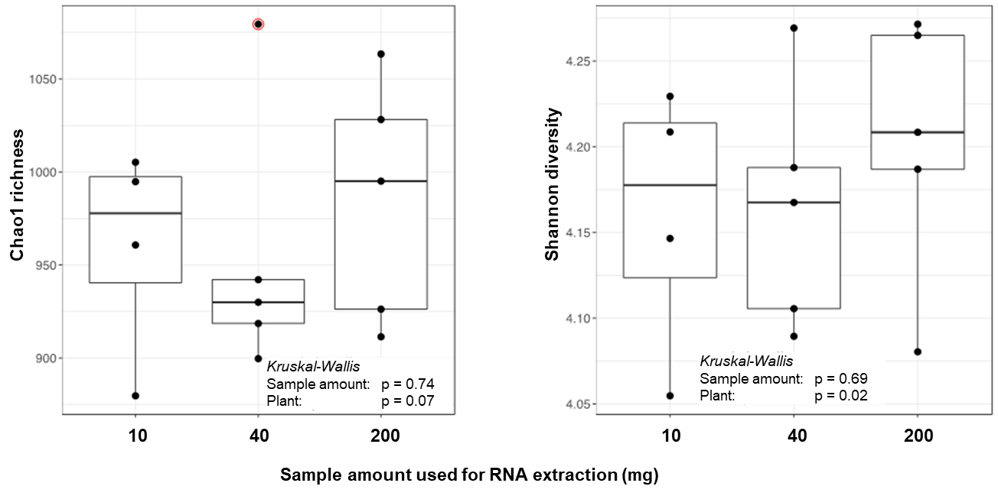
Fig. S5: Rhizoshpere microbiome Chao1 richness (A) and Shannon diversity (B) for three different sample amounts used for RNA extraction for the subsampled dataset using 1379 randomly selected OTUs from the full combined dataset. A Kruskal-Wallis test (inserted at bottom of the figures), showed that sample amount did not significantly affect Chao1 richness or Shannon diversity index (p>0.05).
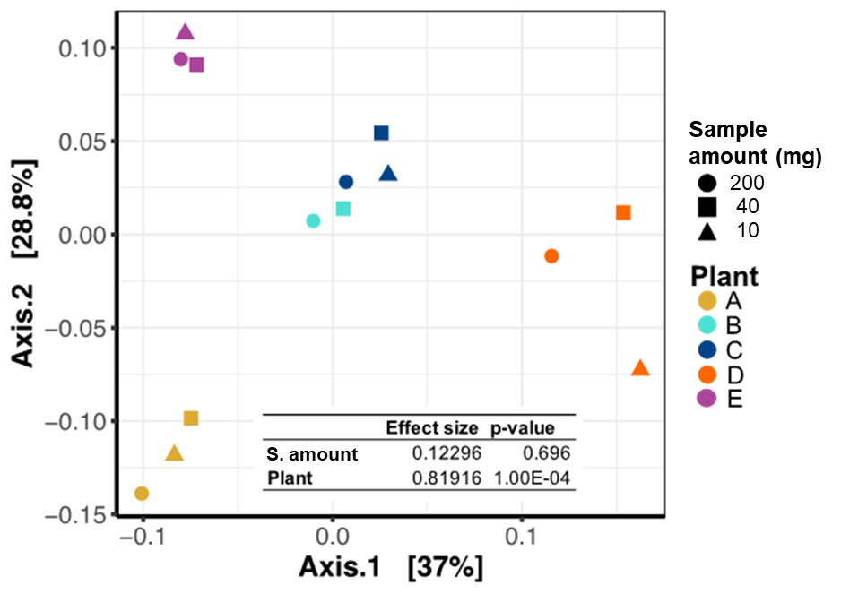
Fig. S6: Rhizoshpere microbiome Chao1 richness (A) and Shannon diversity (B) for three different sample amounts used for RNA extraction for the subsampled dataset using 1379 randomly selected OTUs from the full combined dataset. Individual plant, but not sample amount, were significantly different (PERMANOVA analyses, table at bottom left). (p>0.05).

