Supplementary Material

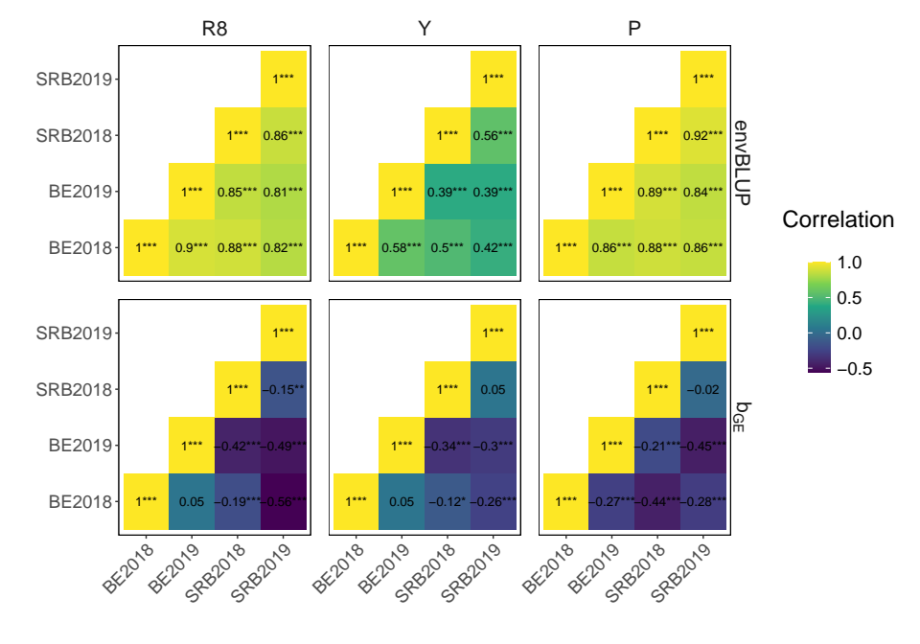Figure S1: Visualisation of the correlation matrix of environment-specific BLUPs (envBLUP) and genotype-by-environment interactions (b_{GE}) for the three traits maturity (R8), seed yield (Y) and protein content (P) across the four environments.

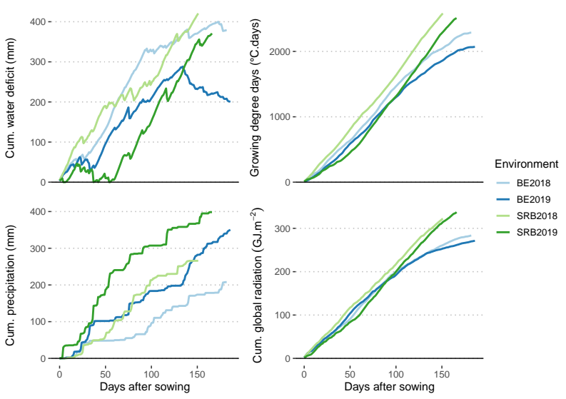Figure S2: Comparison of some key weather indicators over the growing season of soybean in the four environments. Registration of indicators started at the day of sowing and stopped when the last soybean variety reached maturity (R8). Data from the Agri4Cast Resources Portal (Agri4Cast, n.d.)
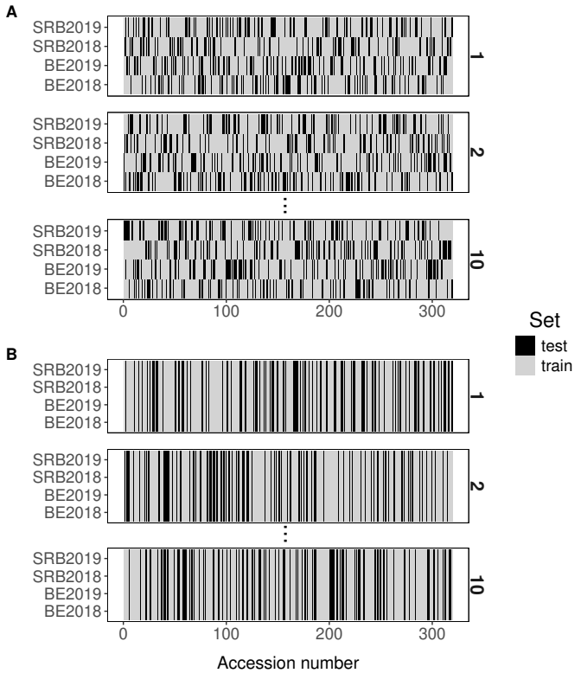Figure S3: Visual comparison of the used CV methods, with A depicting the random CV with environments, and B the k-fold CV. The number to the right of each panel indicates the fold number.

Table S1: Hyperparameters used for the machine learning models Random Forest and XGB. In the full model approach, different sets were used for k-fold CV and random CV with environments. In the split-component model, only tested for k-fold CV, different sets were used for predicting the main and interaction components. For XGB, different sets were used for the traits maturity (R8), seed yield (Y) and protein content (P). Parameter names are those used in the documentation of the R-packages (Chen et al., 2014; Wright & Ziegler, 2017)
 |  |  | Random Forest |  |  | XGB
 |  |  | num.trees | mtry | min.node.  size | gamma | max_depth | subsample | lambda | min_child_weight | alpha | eta | nrounds
Full model | k-fold CV | Y | 1910 | 776 | 10 | 5 | 8 | 0.33 | 9.34 | 39.25 | 8.82 | 0.035 | 79
Full model | k-fold CV | P | 1910 | 776 | 10 | 7 | 9 | 0.36 | 7.90 | 48.07 | 7.69 | 0.028 | 90
Full model | k-fold CV | R8 | 1910 | 776 | 10 | 5 | 8 | 0.43 | 8.13 | 33.58 | 9.92 | 0.039 | 74
Full model | random CV with environments | Y | 1989 | 1613 | 11 | 0 | 7 | 0.49 | 0.95 | 29.08 | 5.77 | 0.028 | 81
Full model | random CV with environments | P | 1989 | 1613 | 11 | 0 | 7 | 0.49 | 0.95 | 29.08 | 5.77 | 0.028 | 186
Full model | random CV with environments | R8 | 1989 | 1613 | 11 | 0 | 7 | 0.49 | 0.95 | 29.08 | 5.77 | 0.028 | 150
Split-component model | Main | Y | 217 | 1279 | 11 | 0 | 5 | 0.38 | 7.48 | 14.96 | 3.11 | 0.031 | 95
Split-component model | Main | P | 217 | 1279 | 11 | 5 | 7 | 0.35 | 3.47 | 16.35 | 1.67 | 0.047 | 87
Split-component model | Main | R8 | 217 | 1279 | 11 | 0 | 5 | 0.38 | 7.48 | 14.96 | 3.11 | 0.031 | 137
Split-component model | Interaction | Y | 1689 | 1015 | 9 | 6 | 9 | 0.56 | 7.75 | 27.45 | 4.70 | 0.014 | 96
Split-component model | Interaction | P | 1689 | 1015 | 9 | 0 | 5 | 0.53 | 5.74 | 42.77 | 3.19 | 0.036 | 58
Split-component model | Interaction | R8 | 1689 | 1015 | 9 | 6 | 9 | 0.56 | 7.75 | 27.45 | 4.70 | 0.014 | 122

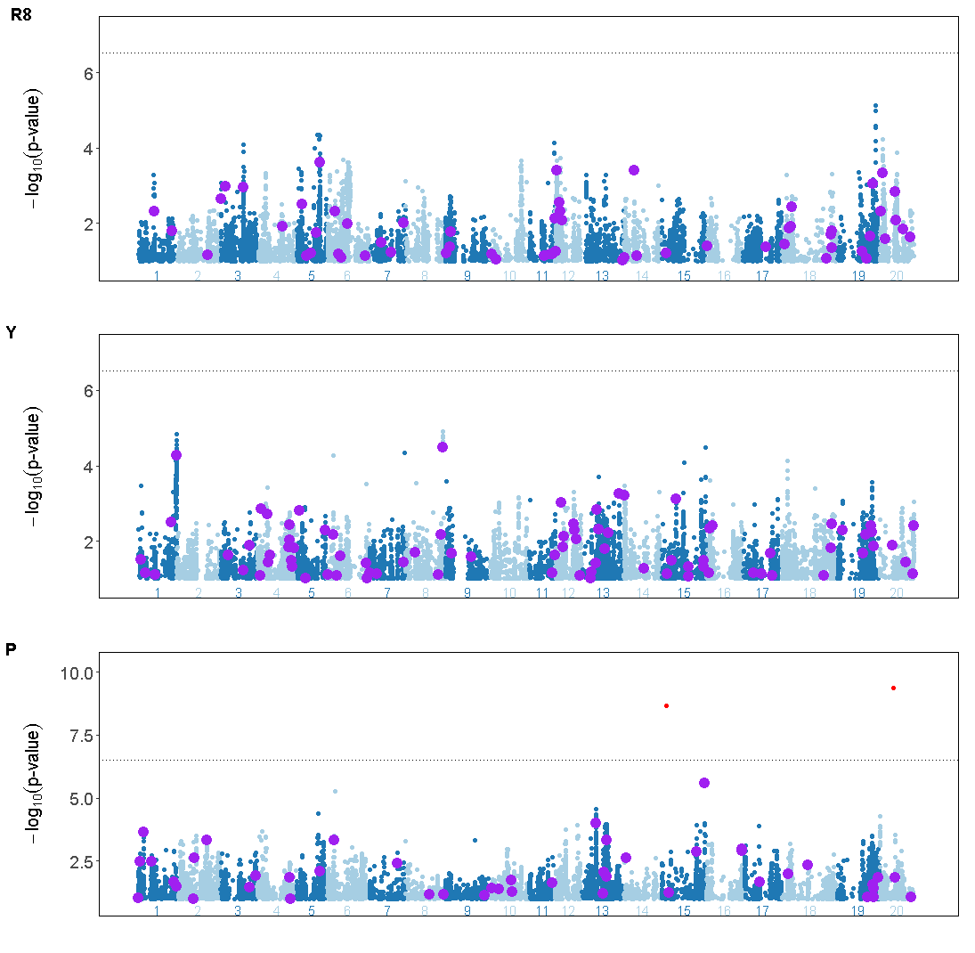Figure S4: A GWAS on the main component calculated using a multi-locus mixed-model with the extended Bayesian Information Criterion (eBIC) for marker significance shown as a dashed line. Purple larger dots are the important (f > 1), uncorrelated markers identified with the ML-GWAS method. Significant markers above the eBIC threshold are indicated in red.
Table S2: P-values for the paired t-test comparison between the large Random Forest model using all markers, and the small Random Forest model using only the top 50 most important, uncorrelated markers
Trait | Main component (b_{G}) | Interaction component (b_{GE}) | envBLUP
P | 0.64 | 0.36 | 0.65
Y | 0.07 | 0.43 | 0.53
R8 | 0.09 | 0.17 | 0.14

