Supplementary Figures
Supplementary Figure 1
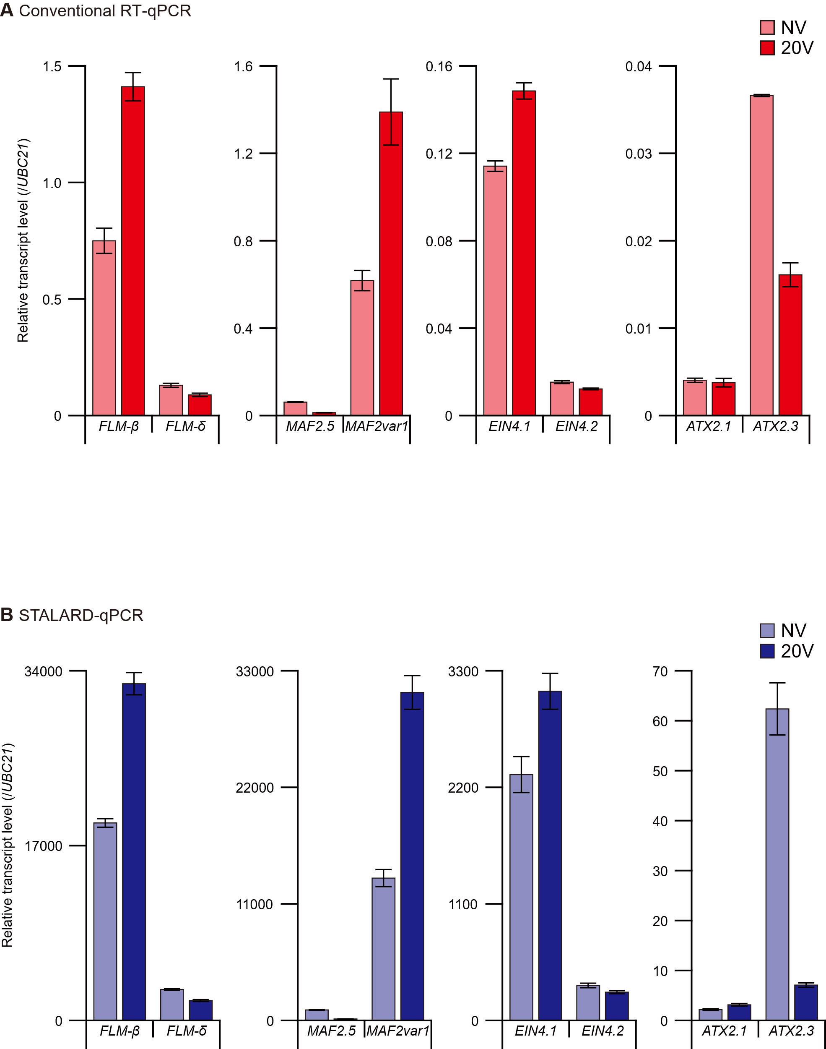
Supplementary Figure 1. Relative transcript levels of alternatively spliced isoforms.
A. Relative transcript levels of alternatively spliced isoforms under NV and 20V conditions, measured by conventional RT-qPCR. Data represent the mean ± SEM of three biological replicates. B. Relative transcript levels under NV and 20V conditions measured by STALARD-qPCR. Data represent the mean ± SEM from three biological replicates.

Supplementary Figure 2

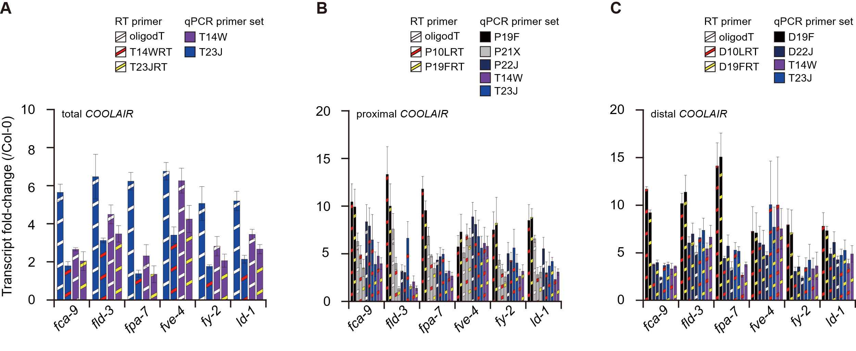
Supplementary Figure 2. Fold changes of COOLAIR transcript levels.
Fold changes in total COOLAIR (A), proximal COOLAIR (B), and distal COOLAIR (C) transcript levels in AP mutants relative to Col-0, quantified by conventional RT-qPCR using various primer sets. Data represent the mean ± SEM of three biological replicates.

