Profiling DNA-protein interactions in Meloidogyne incognita using dCas9-based affinity purification

Authors
Caroline Bournaud^{1*}, Alwéna Tollec², Etienne G J Danchin³, Yohann Couté² and Sebastian Eves-van den Akker^{4*}

Affiliations :
¹ Microbiologie, Adaptation et Pathogénie, UMR5240, Univ Lyon, Université Lyon 1, Bayer SAS, 69622 Villeurbanne, France.
² Univ. Grenoble Alpes, Inserm, CEA, UA13 BGE, CNRS, CEA, UAR2048 ProFI, 38000 Grenoble, France.
³ Institut Sophia Agrobiotech, INRAE, Université Côte d'Azur, CNRS, 400 routes des Chappes, 06903, Sophia-Antipolis, France
⁴ The Crop Science Centre, Department of Plant Sciences, University of Cambridge, Cambridge CB2 3EA, United Kingdom.

*Correspondence:
Caroline Bournaud
caroline.bournaud@univ-lyon1.fr
Sebastian Eves-van den Akker
se389@cam.ac.uk

Supplementary figures

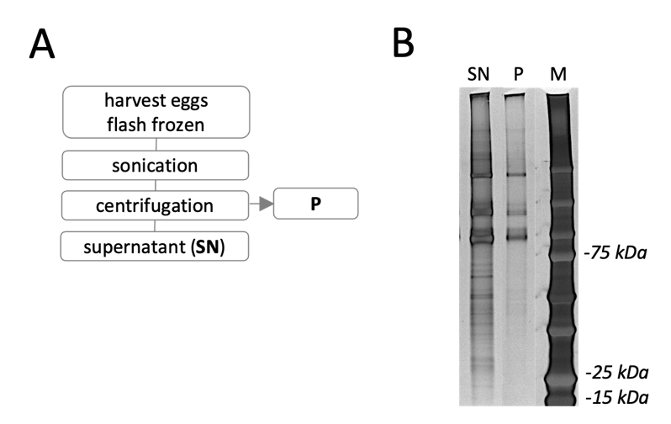
Supplementary Figure S1. Protein extracts after homogenization and sonication steps from M. incognita eggs. (A) Pipeline for chromatin isolation and shearing process using the Diagenode Bioruptor® as the sonication device. (B) Frozen eggs were directly sonicated, followed by centrifugation. Aliquots of protein extracts, comprising supernatant (SN) and pellet (P) fractions, were collected and separated by SDS-PAGE (4-15%), then visualized by silver staining. Each lane contains protein obtained by the preparation of 500 ppJ2. The presence of Histone 3 (H3, ~16 kDa) was not detected by immunoblotting using an anti-H3 antibody.
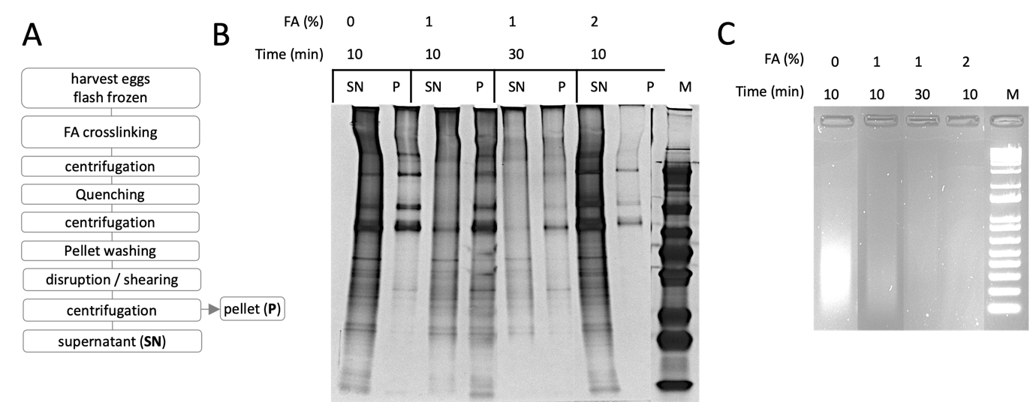
Supplementary Figure S2. Effect of crosslinking conditions on chromatin-protein isolation and DNA shearing in M. incognita eggs. (A) Pipeline for chromatin preparation following crosslinking of eggs, utilizing the Diagenode Bioruptor® as the sonication device. Frozen eggs were crosslinked using formaldehyde, then centrifuged before FA quenching (Tris-HCl, 5 min). Samples were subsequently centrifuged again, and pellets was washed with a physiological buffer. Crosslinked eggs were directly sonicated, followed by centrifugation, and their sheared chromatin profile was analyzed using silver-stained SDS-PAGE and agarose gel electrophoresis. (B) Aliquots of protein extracts, comprising supernatant (SN) and pellet (P) fractions, were collected, separated by SDS-PAGE (4-15 %), then visualized by silver staining. Each lane contains protein obtained by the preparation of 500 ppJ2. The presence of histones was not observed by immunoblotting with histone H3 antibody. (C) Chromatin samples generated in (B) were analyzed by SYBRSafe DNA electrophoresis in 2 % agarose gel. Fixation at 1 % formaldehyde for 10 min. presents optimal time and concentration for shearing chromatin, where most DNA fragments were distributed from 100 to 400 bp.
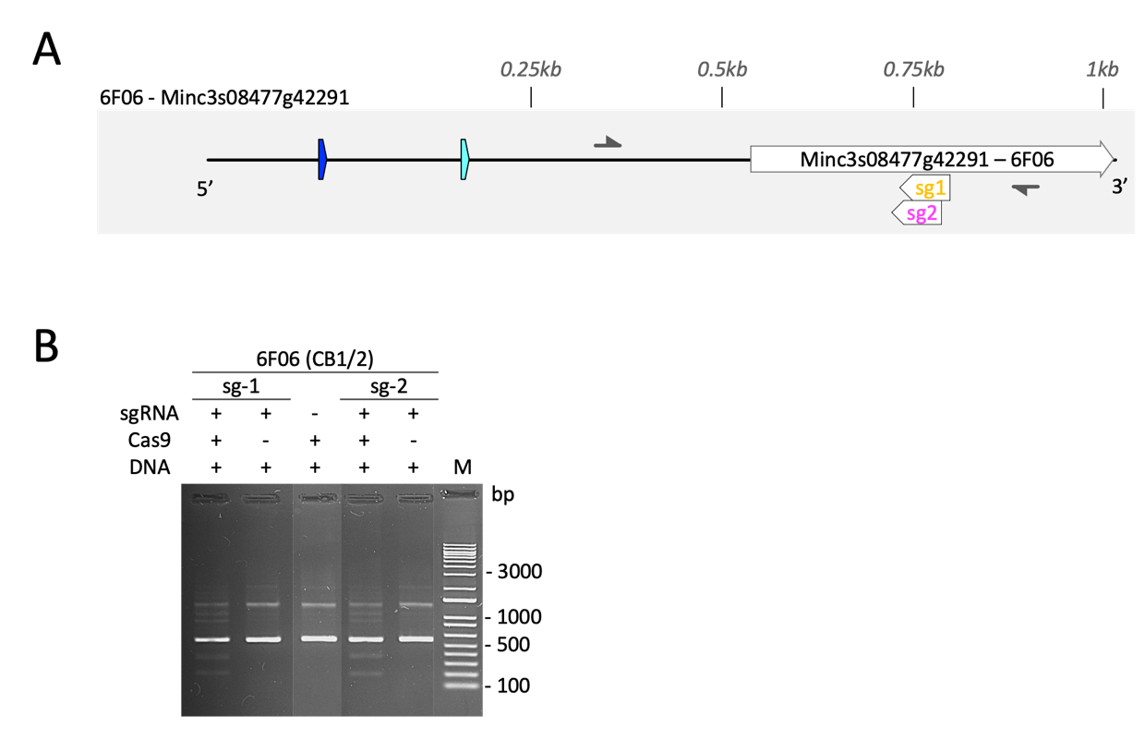
Supplementary Figure S3. in vitro Cas9 assay to assess the cleavage efficiency from chosen sgRNAs targeting PCR-amplified 6F06 locus (A) Map of the 6F06 effector genomic locus (Minc3s08477g42291), showing the regions targeted by the recombinant Cas9/sgRNA complexes. The promoter region contains Mel-DOG boxes, existing in two variants (blue and turquoise arrows). The 6F06 promoter region is targeted with two ribonucleoprotein (RNP) complexes, each composed of the active form of Cas9 and a specific sgRNA (sg1 and sg2), with their positions are indicated. PCR amplification was performed using flanking primers (grey arrows) to generate the DNA template for the assay (B) Representative agarose gel showing results from in vitro digestion assays testing the cleavage efficiency of two sgRNAs targeting the PCR-amplified 6F06 locus. Purified PCR matrices incubated with recombinant Cas9 protein lacking a specific sgRNA (-) showed no cleavage, while the addition of sgRNA/Cas9 complexes led to moderate cleavage of the target PCR product. M = 1 kb DNA ladder.

