Supporting information
Bamboo culm and soil carbon flux synchronous measurement system: A continuous monitoring technique incorporating flow adaptive algorithms

Junjie Jiang ^{a, d}, Junguo Hu ^{b, d, e,} *, Yi Cui ^{b, d}, Jiahao Liu ^{b, d}, Lingxia Feng ^{c, d}, Taolve Chen ^{b}

ª College of Chemistry and Materials Engineering, Zhejiang A&F University, Hangzhou, Zhejiang 311300, China
^{b} College of Mathematics and Computer Science, Zhejiang A&F University, Hangzhou, Zhejiang 311300, China
^{c} College of Forestry and Biotechnology, Zhejiang A&F University, Hangzhou, Zhejiang 311300, China
^{d} Zhejiang Provincial Key Laboratory of Forestry Intelligent Monitoring and Information Technology Research, Zhejiang A&F University, Hangzhou, Zhejiang 311300, China
^{e} State Forestry Administration Key Laboratory of Forestry Sensing Technology and Intelligent Equipment, Zhejiang A&F University, Hangzhou, Zhejiang 311300, China

*Corresponding author. Tel.: +86 13758291023; E-mail address: hujunguo@zafu.edu.cn

1. Figure
(d)
(c)
(b)
(a)

Figure S1. Statistical data on flow rates measured simultaneously at the inlet and outlet of the system. (a) and (b) show data collected by the inlet and outlet flow meters at low flow rates (160 ml min⁻¹) and high flow rates (1000 ml min⁻¹), respectively. (c) and (d) show the results of a test for differences in the readings of the inlet and outlet flow meters at low flow rates (160 ml min⁻¹) and high flow rates (1000 ml min⁻¹), respectively, using a paired t-test.

(l)
(k)
(j)
(i)
(h)
(g)
(f)
(e)
(d)
(c)
(b)
(a)

Figure S2. Test results for the adaptive flow algorithm. (a–c) show the results of the high-flow rate test, where (a) depicts the variation in the designed test flow rate, (b) shows the variation in CO₂ concentration within the chamber, and (c) illustrates the variation in chamber flow rate controlled by the adaptive algorithm. (d–f) show the results of the low-flow rate test, where (d) depicts the variation in the designed test flow rate, (e) shows the variation in CO₂ concentration within the chamber, and (f) illustrates the variation in chamber flow rate controlled by the adaptive algorithm. (g–i) present the results of the periodic variation test, where (g) depicts the variation in the designed test flow rate, (h) shows the variation in CO₂ concentration within the chamber, and (i) illustrates the variation in chamber flow rate controlled by the adaptive algorithm. (j–l) show the results of the step-response test, where (j) is the designed test flow rate variation graph, (k) shows the variation in CO₂ concentration within the chamber, and (l) is the chamber flow rate variation graph controlled by the adaptive algorithm.

Figure S3. CO₂ sensor measurements from the bamboo culm and soil flux monitoring system in an undisturbed, enclosed environment.

(c)
(a)
(b)
Figure S4. Diagram showing the daily variations in CO₂ flux from bamboo culms and soil, illumination, air temperature and relative humidity (3 February 2026). (a) shows illumination, (b) shows air temperature and humidity, and (c) shows CO₂ flux from bamboo culms and soil.

Time (h)
Time (h)
(c)
(b)
(a)
Time (h)
Time (h)
(d)
Figure S5. Wavelet transform plots of continuous data for air temperature and humidity, bamboo culm flux and soil flux. (a) shows air temperature data, (b) shows air humidity data, (c) shows bamboo culm flux data, and (d) shows soil flux data, where the colour bars represent data series at different frequencies.
(c)
(b)
(a)
Figure S6. Data on air temperature, humidity and precipitation during continuous flux measurements. (a) shows bamboo culm flux data. (b) shows soil flux data. (c) shows air temperature, humidity and precipitation during continuous flux measurements.

2. Table
Table S1. Statistical table showing fluctuations in CO₂ concentrations during the one-hour test, comparing CO₂ supplied via the ambient gas stable delivery device with CO₂ introduced directly from the ambient environment.

 | Mean | SD | CV
Direct environment input | 409.44 | 4.41 | 1.07%
Stable gas delivery system | 411.51 | 1.48 | 0.35%

3. Flow Rate Test Experiment
The data presented in this section originate from another study by our team (manuscript under peer review), which used computational fluid dynamics (CFD) to analyse the issues associated with open-flow chambers in measuring tree stem CO₂ flux. Part of that work includes the simulation of measurement errors under different flow rate conditions. The detailed simulation steps and results are as follows.
3.1 Simulation Procedures
To complement the experimental comparison, a supplementary CFD simulation was conducted to investigate how inlet flow rate affects the internal CO₂ concentration distribution and the resulting flux underestimation due to diffusive inhibition. The simulation setup followed the geometry and boundary conditions described in the main text (chamber dimensions, stem porous medium, species transport with SST k-ω turbulence model). Five flow rates (100–500 mL min⁻¹) were tested. The results (Fig. S7) show that at low flow rates (≤200 mL min⁻¹), pronounced vertical concentration stratification occurs, leading to an over-accumulation of CO₂ near the stem surface and a consequent reduction in the diffusive release flux, which underestimates the true flux by up to ~8%. As flow rate increases to ≥400 mL min⁻¹, the concentration field becomes nearly homogeneous and the measured flux approaches the true value (≈0.74 μmol m⁻² s⁻¹). To avoid lengthening this paper, the full procedural details and additional sensitivity analyses will be presented in a separate forthcoming publication (Liu et al., 2026, in preparation).

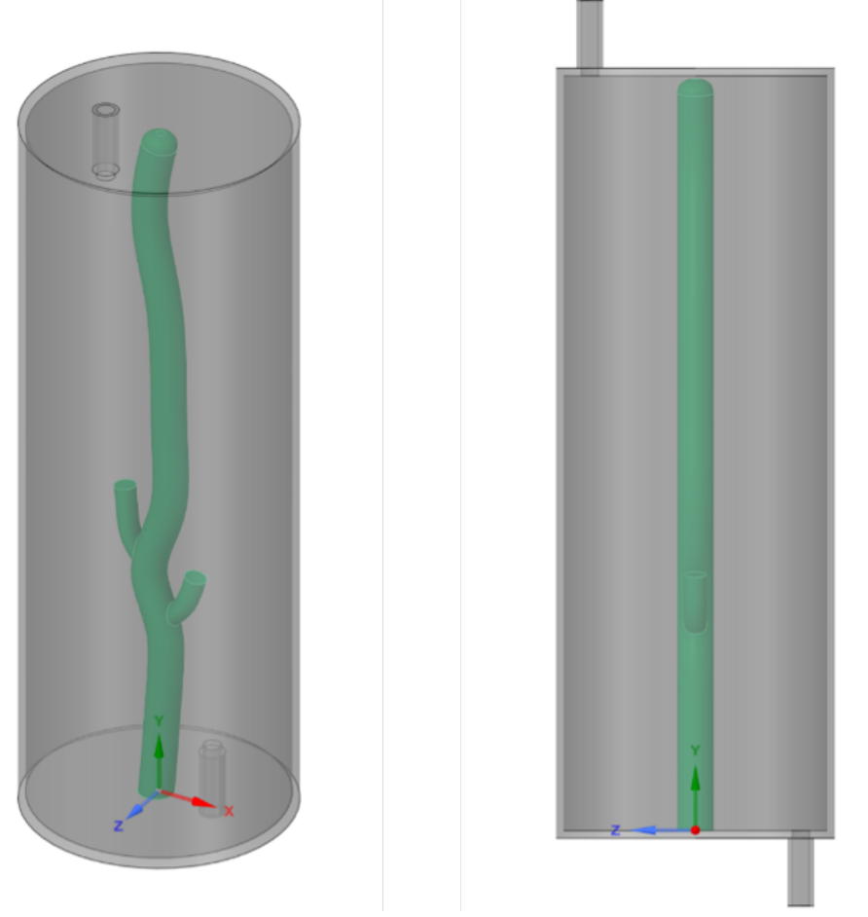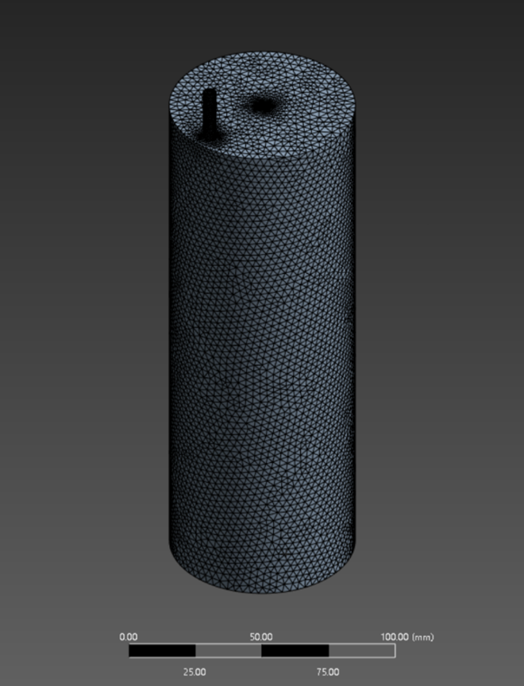
(b)
(a)
(c)
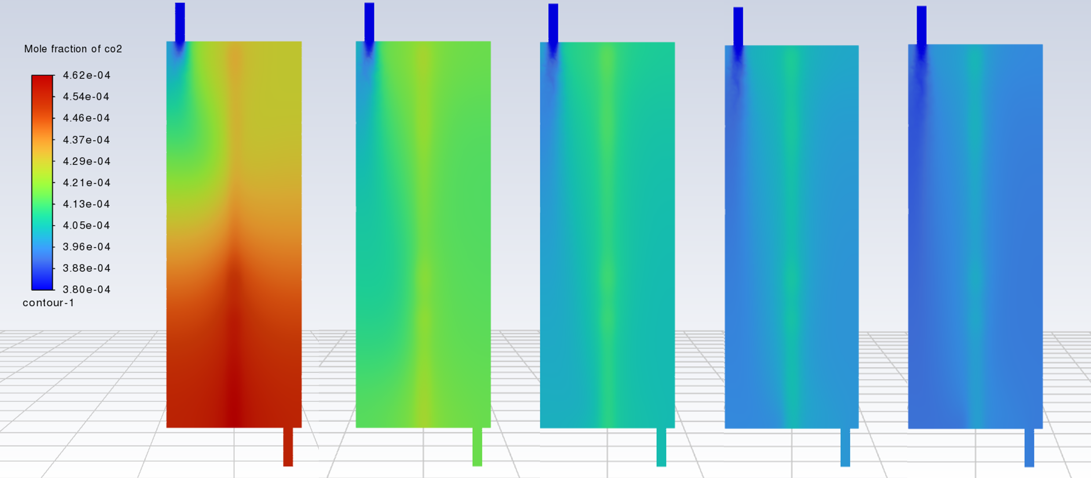
(d)
Figure S7. CFD simulation of the open-flow chamber method for measuring CO₂ flux from plant stems under different flow rate conditions, showing CO₂ concentration distribution inside the chamber and flux measurement results. (a) Three-dimensional geometric model of the stem–chamber system. (b) Mesh generation results. (c) Contours of CO₂ mole fraction distribution in the chamber at steady state under different flow rates, from left to right: 100, 200, 300, 400, and 500 mL/min. (d) Calculated CO₂ flux under different flow rates.

3.2 Validation Experiment
In this study, the effect of flow rate on CO₂ flux measurement was further validated through field experiments. The tests were conducted in a temperature-controlled experimental scenario with ambient temperature set to 22°C and relative humidity at 75%, located in the temperature-controlled greenhouse of Zhejiang A&F University. The measurement object was a Phyllostachys violascens (Lei bamboo) clum with a diameter of 3.6 cm. The open-flow chamber method (NCM) was employed for measurement, using a cylindrical transparent acrylic chamber with an inner diameter of 100 mm, a height of 150 mm, and a wall thickness of 5 mm. The specific testing procedures and analytical instruments were consistent with those used in the NCM system described in this study. For each flow rate condition, 7–8 replicate measurements were performed, and flux calculations were made after the CO₂ concentration inside the chamber reached steady state.
The results (Fig. S7) showed that when the flow rate was below 0.25 L min⁻¹, the measured flux values were lower than those obtained at flow rates above 0.25 L min⁻¹, with a maximum difference of 0.05 μmol m⁻² s⁻¹, corresponding to an 11.9% underestimation relative to the maximum flux value (0.42 μmol m⁻² s⁻¹). This result is mainly attributable to the fact that at low flow rates, the CO₂ concentration inside the chamber (510 ppm) was significantly higher than that under high flow rates (441 ppm). The elevated CO₂ concentration suppressed further CO₂ release from the clum.
Figure S8. CO₂ flux values from bamboo clums and the inlet–outlet CO₂ concentration difference measured using the open-flow chamber method under different flow rates.

References
Yang, X., Pang, X., Liu, X. et al. Determining the pore structure and radial variability of moso bamboo (Phyllostachys edulis). Wood Sci Technol 57, 345–357 (2023). https://doi.org/10.1007/s00226-022-01451-5
Liu, J.H., Zhang S.Q., Hu, J.G., et al., 2026. Derivation Method for Inverting Critical Flow of Tree Stem Respiration Integrating Closed-Circuit Transient Response. (in preparation)

4 Flow‑Adaptive Test Experiment
4.1 Simulated stem setup
To validate the concentration control performance and data reliability of the adaptive continuous monitoring system (ACM) under controllable conditions, a 30‑cm‑long polyvinyl chloride (PVC) pipe with an outer diameter of 6 cm was used as a simulated stem, mimicking the hollow structure of bamboo culms. A 15‑cm segment on the surface of the PVC pipe was designated as the measurement area covered by the open‑chamber system. To simulate the uniform CO₂ release from the bamboo culm surface (i.e., a “surface source”), four diffusion holes of 1.0 mm diameter were drilled along the same generatrix within the 15‑cm measurement area, positioned at 2, 5.7, 9.3 and 13 cm from the edge of the covered region, respectively. These holes allowed the injected CO₂ standard gas to diffuse evenly from the pipe cavity into the chamber. A separate gas supply hole of 1.6 mm diameter was drilled on the pipe wall outside the chamber coverage (approximately 2 cm from the edge) to connect the mass flow controller (MFC) for delivering the CO₂ standard gas. Both ends of the PVC pipe were sealed with end caps fitted with 1.5‑mm orifices to serve as pressure‑relief vents, preventing internal pressure build‑up that could affect MFC output accuracy.

4.2 CO₂ injection setup
The CO₂ source was a certified standard gas mixture containing 5000 ppm (0.5%) CO₂ in synthetic air. Two independent high‑precision thermal mass flow controllers (MFCs) with different flow ranges were used to accommodate the high‑flux and low‑flux test ranges, respectively. Based on the chamber‑covered area (A = π × 0.06 × 0.15 = 0.0283 m²) and the target flux, the required MFC flow rate (for 5000 ppm CO₂) was calculated from the mass balance relation,
(S2)
where Q is the MFC volume flow rate (mL min⁻¹), F is the target flux (μmol m⁻² s⁻¹), A is the covered area (0.0283 m²), 22.4 is the molar volume of an ideal gas at standard conditions (L mol⁻¹), 1000 converts litres to millilitres, 0.005 is the CO₂ fraction (5000 ppm = 0.5%), and 60 converts seconds to minutes. Based on this calculation, the high-flux MFC was selected with a range of 0–100 mL min⁻¹ (the maximum required flow, 60.77 mL min⁻¹, is ≈61% of full scale, well within the optimum operating range), while the low-flux MFC had a range of 0–5 mL min⁻¹ (maximum 2.28 mL min⁻¹, ≈46% of full scale). Both MFCs had an accuracy of ±1% of full scale. Before each experiment, the MFCs were warmed up for at least 30 minutes to achieve thermal stability, and their set-points were verified at multiple points using a soap-film flow meter.

4.3 Step‑flux sequence design
To comprehensively evaluate the response performance of the ACM over a wide dynamic range, two separate step‑flux sequences—a high‑flux sequence and a low‑flux sequence—were designed. Each sequence was tested in both ACM and fixed‑flow (NCM) modes.
High‑flux step sequence (total duration 6000 s): the chamber flux stepped successively through 1.0 μmol m⁻² s⁻¹ (1800 s), 8.0 μmol m⁻² s⁻¹ (1800 s), 3.0 μmol m⁻² s⁻¹ (1200 s), and back to 1.0 μmol m⁻² s⁻¹ (1200 s). This sequence includes a severe upward jump (1→8, an eight‑fold increase) and sustained high‑flux plateaus, designed to test the system’s ability to suppress concentration build‑up under extreme high‑flux conditions.
Low‑flux step sequence (total duration 6000 s): the chamber flux stepped through 0.3 μmol m⁻² s⁻¹ (1800 s), 0.1 μmol m⁻² s⁻¹ (1800 s), 0.2 μmol m⁻² s⁻¹ (1200 s), and back to 0.3 μmol m⁻² s⁻¹ (1200 s). This sequence covers the critical region near the sensor signal‑to‑noise ratio limit (at 0.1, the corresponding ΔC ≈ 7.6 ppm, below the set lower bound of 12 ppm), and is intended to evaluate the system’s capability to maintain detectable signals under very low flux conditions.
Each step transition was executed by sending a new set‑point command to the MFC via the host computer, with the transition completed within 1 second.

4.4 Experimental procedure and data acquisition
ACM mode: The log‑PI adaptive control algorithm running on the Raspberry Pi embedded controller was enabled. The target concentration window was set to ΔC_{min} = 15 ppm (lower signal‑to‑noise bound) and ΔC_{max} = 35 ppm (upper bound to avoid inhibition effects), with a target chamber CO₂ concentration C_{ref} = 430 ppm. The algorithm dynamically adjusted the main air flow rate based on the deviation between the measured chamber outlet CO₂ concentration and the target, maintaining ΔC within the window.
NCM mode: The adaptive algorithm was disabled, and the main air flow was fixed at 0.5 L min⁻¹ (representing the conservative setting of a traditional fixed‑flow system). All other hardware conditions remained identical to the ACM mode.
All experiments were conducted in a temperature-controlled laboratory (25 ± 1 °C). All sensors and MFCs were warmed up for at least 30 minutes before data acquisition. The data logging system recorded timestamps, chamber outlet CO₂ concentration (C_{out}), actual main air flow rate, and the MFC set-point and feedback values at a sampling frequency of 1 Hz. Each experiment lasted 6000 s, and each sequence was run once in ACM mode and once in NCM mode, giving a total of four independent test runs.

