Supplementary Material – Marchetti et al.

In vivo monitoring of dynamic drought responses in tomato using Bioristor to support varietal selection

Edoardo Marchetti¹, Nadia Palermo¹, Filippo Vurro^{*1,2}, Guido Cotti¹, Juan Manuel Acién³, Miguel Gonzalez-Guzman³, Vicent Arbona³, Massimiliano Beretta4, Manuele Bettelli^{1,2}, Nelson Marmiroli⁵, Andrea Zappettini¹, Michela Janni^{*1}

¹IMEM-CNR, CNR, Parma, Parco Area delle Scienze, 37/A, IT;
² PlantBit SrL. Parma, IT
³Dept. Biologia, Bioquimica, y Ciencias Naturales, Universitat Jaume I, Castelló de la Plana, Av. de Vicent Sos Baynat, ES;
⁴ISI Sementi SpA, Fidenza, Località Ponte Ghiara, 8/A, IT;
⁵ Dipartimento SCVSA, Università degli Studi di Parma, Parma, Parco Area delle Scienze 23/A, IT

*Corresponding authors

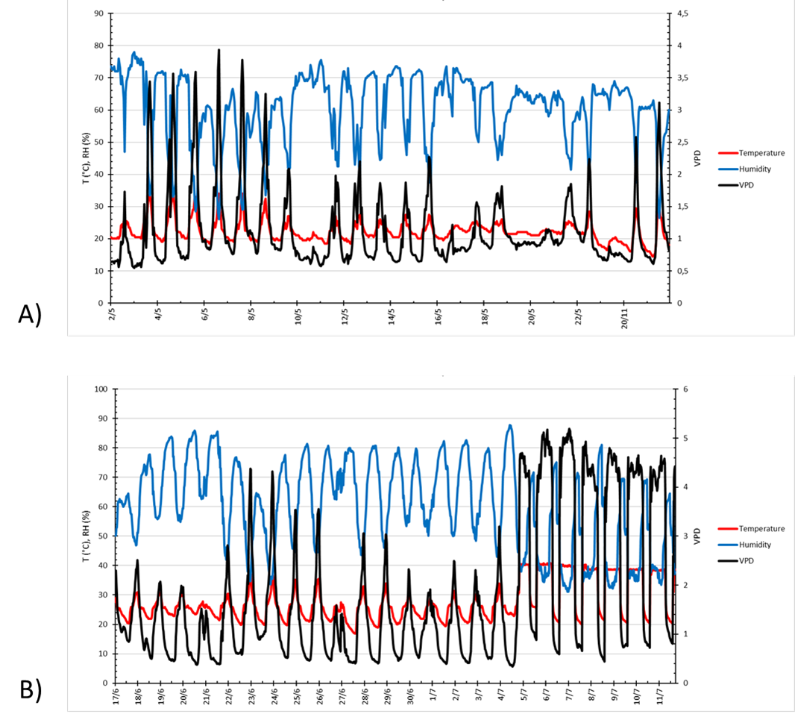

Supplementary Figure 1 - Environmental parameters. A) commercial varieties experiment, B) ILs experiment
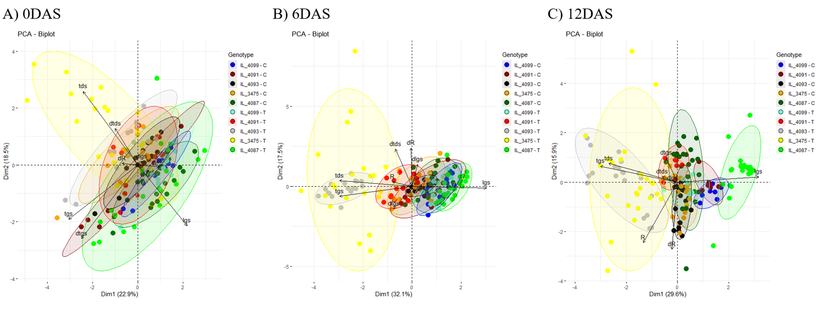
Genotype
IL_4099 - C
IL_4091 - C
IL_4093 - C
IL_3475 - C
IL_4087 - C
IL_4099 - T
IL_4091 - T
IL_4093 - T
IL_3475 - T
IL_4087 - T

Suppl. Fig. 2- PCA plot of Bioristor traits. A) 0 DAS, no stress imposed, B) 6 DAS maximum drought, C) 12 DAS, end of the combined stress. Stressed and Control plants for all the 5 genotypes are shown.

Supplementary Table 1 – Relative Soil water content variation of commercial varieties trial: only Treated has been reported since Control has been maintained at fully hydration level (irrigations are always realized after sampling).
Variety | 2DS | 4DS | 5DS | 6DS | 7DS | 8DS | 11DS | 12DS | 13DS | 14DAS | 15DAS
Faber - T | 58.8 | 49.7 | 53.3 | 49.7 | 50.4 | 50.1 | 82.7 | 106.7 | 105.7 | 107.7 | 95
Mariner - T | 56.8 | 47.7 | 51.6 | 48.9 | 49.7 | 48.9 | 80.6 | 102.4 | 102.7 | 104.4 | 93.4
Red Setter - T | 58.9 | 47.4 | 52.5 | 49.8 | 50.5 | 48 | 80.5 | 100.6 | 100.8 | 102 | 93.9

Supplementary Table 2 - Stomatal conductance (mmol m⁻² s⁻¹) evolution during the whole experiment.

DAS | Faber_T | Mariner_T | Red Setter_T | Faber_C | Mariner_C | Red Setter_C
0 DAS | 407.00±61.34 | 359.67±64.01 | 406.67±52.39 | 289.00±49.80 | 390.00±40.45 | 435.00±13.23
2 DAS | 36.92±3.06 | 63.57±5.33 | 60.40±3.64 | 201.29±18.96 | 207.11±15.26 | 158.33±13.86
4 DAS | 10.63±2.13 | 6.00±0.29 | 7.13±1.63 | 329.57±8.89 | 223.00±9.67 | 211.44±7.61
5 DAS | 23.54±1.50 | 30.74±1.59 | 34.07±3.76 | 288.89±17.60 | 253.82±19.54 | 241.36±8.58
6 DAS | 10.09±0.56 | 9.12±0.75 | 12.33±0.95 | 281.17±14.37 | 215.75±10.69 | 232.87±14.27
7 DAS | 12.53±1.04 | 12.57±1.47 | 12.39±1.84 | 293.54±11.49 | 210.08±10.75 | 236.91±8.58
8 DAS | 24.33±3.39 | 10.14±1.58 | 19.00±2.01 | 221.33±12.84 | 264.12±22.81 | 157.08±12.30
11 DAS | 162.33±12.00 | 172.73±12.00 | 116.75±10.42 | 186.20±22.67 | 187.50±10.91 | 115.07±9.58
12 DAS | 216.68±10.63 | 203.78±12.10 | 194.23±11.26 | 233.78±9.39 | 254.30±11.66 | 183.15±10.98
13 DAS | 244.86±6.84 | 228±9.32 | 214.41±8.26 | 282.14±8.48 | 261.42±12.55 | 246.25±10.50
14 DAS | 259.91±10.95 | 246.60±11.32 | 211.55±12.06 | 287.40±12.76 | 266.80±12.65 | 244.52±13.52
15 DAS | 230.52±9.25 | 199.03±13.05 | 149.46±10.08 | 213.47±8.75 | 214.58±16.68 | 197.97±11.81

Suppl. Table 3. Plant height. Pairwise significance among varieties.
DAS | Red Setter vs Mariner | Red Setter vs Faber | Mariner vs Faber
0 DAS | *** | *** | ***
1 DAS | ns | *** | ***
2 DAS | * | *** | ***
3 DAS | *** | *** | ***
4 DAS | *** | *** | ***
5 DAS | ** | *** | ***
6 DAS | ns | ns | ns
7 DAS | *** | ns | **
8 DAS | *** | *** | ***
9 DAS | *** | *** | ***
10 DAS | *** | *** | ***
11 DAS | *** | *** | ***
12 DAS | ns | *** | ***
13 DAS | ** | *** | ***
14 DAS | ** | *** | ***
15 DAS | *** | *** | ***
ns = p≥0.05, * p≤ 0.05, ** = p < 0.01, *** = p < 0.001; DAS, Days after Stress

Supplementary Table 4. Plant Height. One-way ANOVA testing temporal changes in plant height within each genotype and treatment
Variety | Treatment | F-value | df1 | df2 | p-value | Significant post-hoc comparisons (Holm–Bonferroni corrected)
Faber | Control | 60.96 | 2 | 6 | 0.0001 | T0 vs T4 (p = 0.0478); T0 vs T15 (p = 9.6×10⁻⁵); T4 vs T15 (p = 0.00065)
Faber | Stress | 8.82 | 2 | 6 | 0.01634 | T0 vs T15 (p = 0.0463); T4 vs T15 (p = 0.0169)
Mariner | Control | 14.79 | 2 | 6 | 0.00479 | T0 vs T15 (p = 0.00433); T4 vs T15 (p = 0.02486)
Mariner | Stress | 5.31 | 2 | 6 | 0.04704 | T0 vs T15 (p = 0.0491)
Red Setter | Control | 2.73 | 2 | 6 | 0.1435 | None
Red Setter | Stress | 1.3 | 2 | 6 | 0.3391 | None
Supplementary Table 5. Plant Height. Pairwise comparison of control and drought-treated plants at each sampling time
Variety | Time | Mean Control ± SD | Mean Stress ± SD | Test | p-value | Significance
Faber | 0 DAS | 31.67 ± 2.52 | 32.33 ± 2.89 | Welch t-test | 0.78 | ns
Faber | 4 DAS | 36.63 ± 2.29 | 30.00 ± 3.97 | Welch t-test | 0.089 | ns
Faber | 15 DAS | 48.83 ± 0.29 | 40.83 ± 2.93 | Welch t-test | 0.021 | *
Mariner | 0 DAS | 37.00 ± 1.00 | 35.50 ± 2.60 | Welch t-test | 0.43 | ns
Mariner | 4 DAS | 42.17 ± 5.27 | 37.33 ± 4.04 | Welch t-test | 0.28 | ns
Mariner | 15 DAS | 53.50 ± 3.78 | 44.50 ± 3.79 | Welch t-test | 0.044 | *
Red Setter | 0 DAS | 32.00 ± 1.00 | 28.17 ± 3.18 | Welch t-test | 0.17 | ns
Red Setter | 4 DAS | 31.33 ± 6.03 | 29.67 ± 2.31 | Welch t-test | 0.7 | ns
Red Setter | 15 DAS | 39.83 ± 6.03 | 33.17 ± 5.56 | Welch t-test | 0.23 | ns
Supplementary Table 6. Plant Height. Internal validation metrics for k-means clustering
Number of clusters (k) | Silhouette score | Calinski–Harabasz index
2 | 0.4 | 16.5
3 | 0.32 | 15.6
4 | 0.28 | 14.4

Supplementary Table 7. Stomatal Conductance. Comparison between control and drought-stressed plants within each genotype at each sampling time (Welch's t-test)

Genotype | DAS | n Control | n Stress | Mean Control | Mean Stress | p-value
Mariner | T0 | 3 | 3 | 390 | 359.7 | 0.729
Mariner | 2 DAS | 9 | 7 | 207.1 | 63.6 | 5.11 × 10⁻⁶
Mariner | 4 DAS | 6 | 3 | 223 | 6 | 3.22 × 10⁻⁶
Mariner | 5 DAS | 11 | 7 | 253.8 | 30.7 | 4.27 × 10⁻⁷
Mariner | 6 DAS | 8 | 9 | 215.8 | 9.1 | 2.25 × 10⁻⁷
Mariner | 7 DAS | 13 | 6 | 210.1 | 12.6 | 2.44 × 10⁻¹⁰
Mariner | 8 DAS | 9 | 6 | 221.3 | 24.3 | 1.12 × 10⁻⁷
Mariner | 11 DAS | 14 | 11 | 187.5 | 172.7 | 0.463
Mariner | 12 DAS | 23 | 18 | 254.3 | 203.8 | 0.00467
Mariner | 13 DAS | 25 | 23 | 264.1 | 229.6 | 0.0362
Mariner | 14 DAS | 25 | 25 | 266.8 | 246.6 | 0.24
Mariner | 15 DAS | 26 | 29 | 214.6 | 199 | 0.467
Faber | T0 | 3 | 3 | 255.7 | 407 | 0.122
Faber | 2 DAS | 7 | 5 | 201.3 | 36.9 | 1.06 × 10⁻⁴
Faber | 4 DAS | 7 | 4 | 329.6 | 10.6 | 8.54 × 10⁻⁹
Faber | 5 DAS | 9 | 10 | 288.9 | 23.5 | 3.29 × 10⁻⁷
Faber | 6 DAS | 6 | 9 | 281.2 | 10.1 | 7.54 × 10⁻⁶
Faber | 7 DAS | 13 | 10 | 293.5 | 12.5 | 1.03 × 10⁻¹¹
Faber | 8 DAS | 8 | 7 | 264.1 | 10.1 | 9.95 × 10⁻⁶
Faber | 11 DAS | 10 | 18 | 186.2 | 162.3 | 0.368
Faber | 12 DAS | 26 | 26 | 223 | 216.9 | 0.682
Faber | 13 DAS | 29 | 22 | 282.1 | 244.9 | 0.00127
Faber | 14 DAS | 28 | 32 | 295.3 | 259.9 | 0.0196
Faber | 15 DAS | 34 | 34 | 213.5 | 226.7 | 0.315
Red Setter | T0 | 3 | 3 | 401.7 | 406.7 | 0.945
Red Setter | 2 DAS | 6 | 5 | 158.3 | 60.4 | 6.07 × 10⁻⁴
Red Setter | 4 DAS | 9 | 3 | 211.4 | 7.1 | 1.43 × 10⁻⁹
Red Setter | 5 DAS | 11 | 11 | 241.4 | 34.1 | 4.07 × 10⁻¹²
Red Setter | 6 DAS | 8 | 9 | 232.9 | 12.3 | 1.07 × 10⁻⁶
Red Setter | 7 DAS | 11 | 14 | 236.9 | 12.4 | 9.66 × 10⁻¹¹
Red Setter | 8 DAS | 12 | 10 | 157.1 | 19 | 1.62 × 10⁻⁷
Red Setter | 11 DAS | 15 | 16 | 115.1 | 116.8 | 0.906
Red Setter | 12 DAS | 26 | 27 | 183.2 | 190 | 0.672
Red Setter | 13 DAS | 24 | 27 | 246.3 | 214.4 | 0.0214
Red Setter | 14 DAS | 23 | 22 | 244.5 | 211.5 | 0.0758
Red Setter | 15 DAS | 31 | 24 | 198 | 149.5 | 0.00289

Supplementary Table 8. Stomatal Conductance. Temporal ANOVA
Genotype | Treatment | F-value | df1 | df2 | p-value
Mariner | Control | 4.84 | 11 | 160 | 1.96 × 10⁻⁶
Mariner | Stress | 40.15 | 11 | 135 | 3.27 × 10⁻³⁷
Faber | Control | 10.38 | 11 | 168 | 2.24 × 10⁻¹⁴
Faber | Stress | 69.7 | 11 | 168 | 1.02 × 10⁻⁵⁶
Red Setter | Control | 13.48 | 11 | 167 | 3.20 × 10⁻¹⁸
Red Setter | Stress | 59.51 | 11 | 159 | 1.30 × 10⁻⁵⁰

Suppl. Table 9. Normalized sensor response (NR) statistical analysis

DAS | F-value | p-value | Overall | RS vs Mariner | RS vs Faber | Mariner vs Faber
0DAS | 11.668 | 0.000024 | **** | * | **** | ****
1DAS | 9.068 | 0.000218 | *** | ns | **** | ***
2DAS | 17.643 | 2.01E-07 | **** | ** | **** | ****
3DAS | 27.755 | 1.37E-10 | **** | *** | **** | ****
4DAS | 29.547 | 4.1E-11 | **** | *** | **** | ****
5DAS | 21.076 | 1.52E-08 | **** | *** | **** | ns
6DAS | 7.525 | 0.000843 | *** | * | **** | ns
7DAS | 5.711 | 0.0043 | ** | ns | *** | **
8DAS | 10.605 | 5.85E-05 | **** | * | **** | ***
9DAS | 9.463 | 0.000155 | *** | * | **** | ***
10DAS | 8.393 | 0.000392 | *** | ns | **** | ***
11DAS | 10.252 | 0.000079 | **** | * | **** | ****
12DAS | 7.741 | 0.000696 | *** | ns | *** | ***
13DAS | 8.18 | 0.000473 | *** | ns | *** | ***
14DAS | 9.549 | 0.000144 | *** | ns | **** | ***
15DAS | 11.314 | 3.22E-05 | **** | ** | **** | ****
p < 0.05 (*), p < 0.01 (**), p < 0.001 (***), and p < 0.0001 (****), whereas differences with p ≥ 0.05 were considered not significant (ns).

