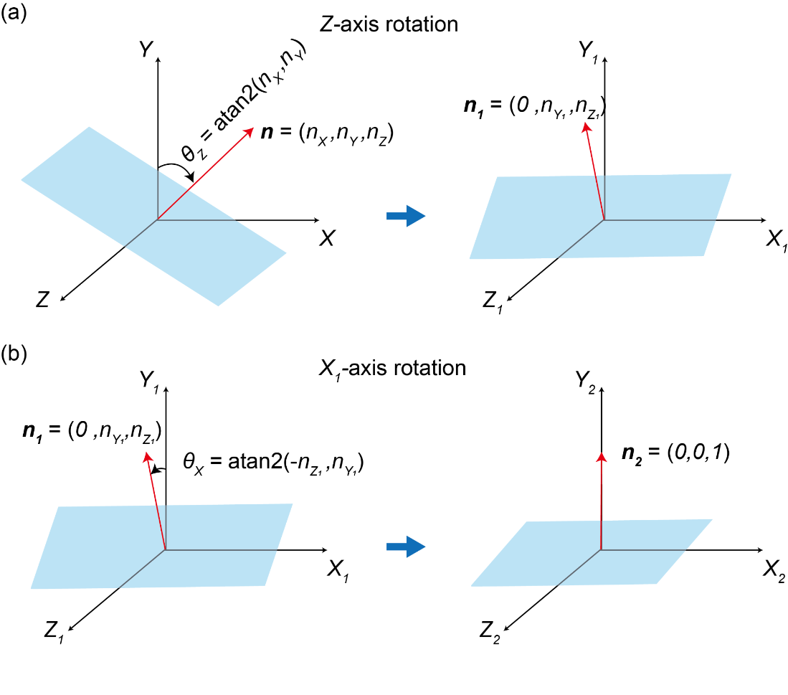
Fig. S1. Schematic illustrations of two types of rotations of the original coordinate system. (a) $Z$-axis rotation is performed by the rotation angle $θ_{Z}$ around the $Z$-axis and the resulting coordinate system becomes $(X_{1}, Y_{1}, Z_{1})$. (b) $X_{1}$-axis rotation is performed by the rotation angle $θ_{X}$ around the $X_{1}$-axis and the resulting coordinate system becomes $(X_{2}=x, Y_{2}=y, Z_{2}=z)$ where the $y$-axis coincides with the vertical axis perpendicular to the bottom plane.
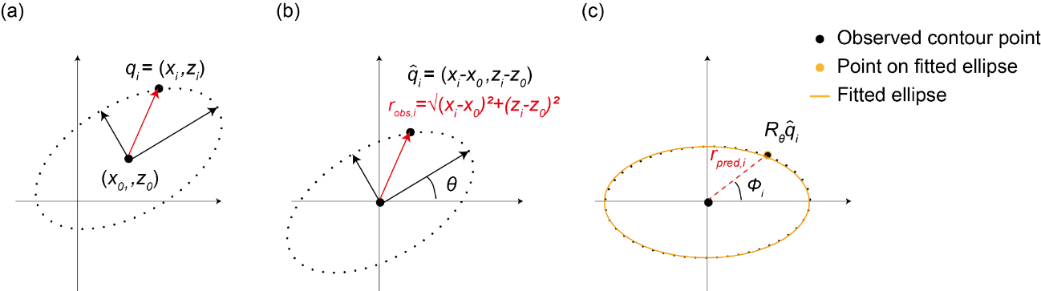
Fig. S2. Schematic illustrations of elliptic fitting processes. (a) Data points $q_{i} = (x_{i}, z_{i})$ are fitted by the ellipse with the center $(x_{0}, z_{0})$. (b) Translation is performed to locate the ellipse center at the center of the coordinate system, and rotation is performed to align the major and minor axes of the ellipse coincide with the axes of the coordinate system. (c) Calculation of the fitting error. The $RMSE$ is calculated between the aligned observed contour point and the point on the fitted ellipse.

