Supporting Information
UXT enhances melanoma proliferation, migration, and invasion through modulation of the P53 signaling pathway
Kaifen Xiong^{1,2}, Chong Wang^{2,3,4}, Binqian Hu^{2,3,4}, Jianglin Zhang ^{2,3,4,*}, Min Qi^{5*}
¹ Department of Dermatology, Shenzhen People’s Hospital (The Second Clinical Medical College, Jinan University; The First Affiliated Hospital, Southern University of Science and Technology), Shenzhen, 518020, Guangdong, China
² Department of Dermatology, Xiangya Hospital, Central South University, Changsha, 410000, China
³ Candidate Branch of National Clinical Research Center for Skin Diseases, China
⁴ Department of Geriatrics, Shenzhen People’s Hospital (The Second Clinical Medical College, Jinan University; The First Affiliated Hospital, Southern University of Science and Technology), Shenzhen, 518020, Guangdong, China
⁵ Department of Plastic Surgery, Shenzhen Hospital, Southern Medical University, Shenzhen 518000, China

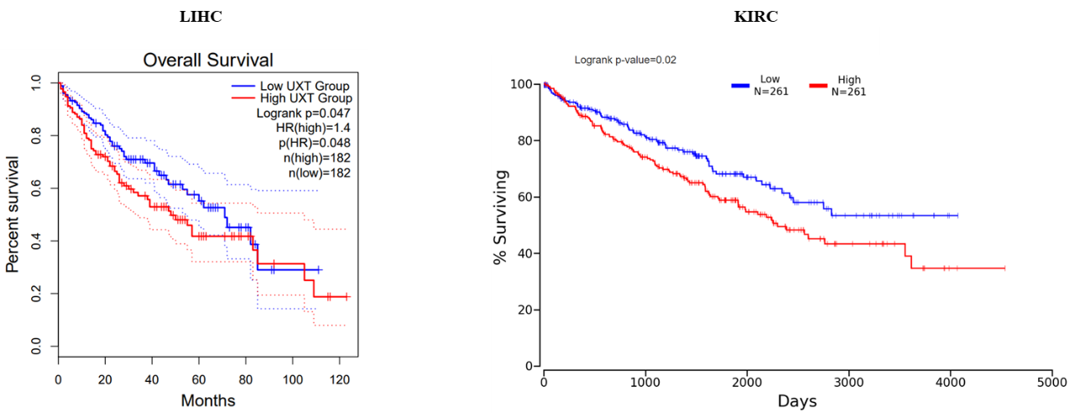
Figure S 1. Higher UXT expression levels are associated with poorer survival in cancer patients. The result was derived from public cancer database, in which UXT expression relevant Kaplan-Meier survival curve was generated for indicated cancers. (http://gepia2.cancer-pku.cn/#survival; http://www.oncolnc.org/ )

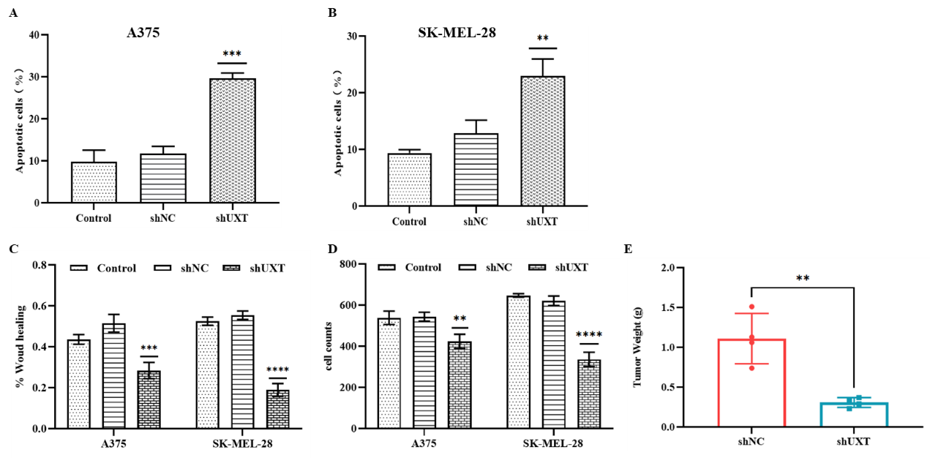
Figure S 2. Quantification of apoptosis in A375 (A) and SK-MEL-28 (B) cells. Migration rate (C) and invasion rate (D) of A375 and SK-MEL-28 melanoma cells after knockdown of UXT (quantification of migration and invasion). (E) The weight of tumors of two different targeting sequences groups.
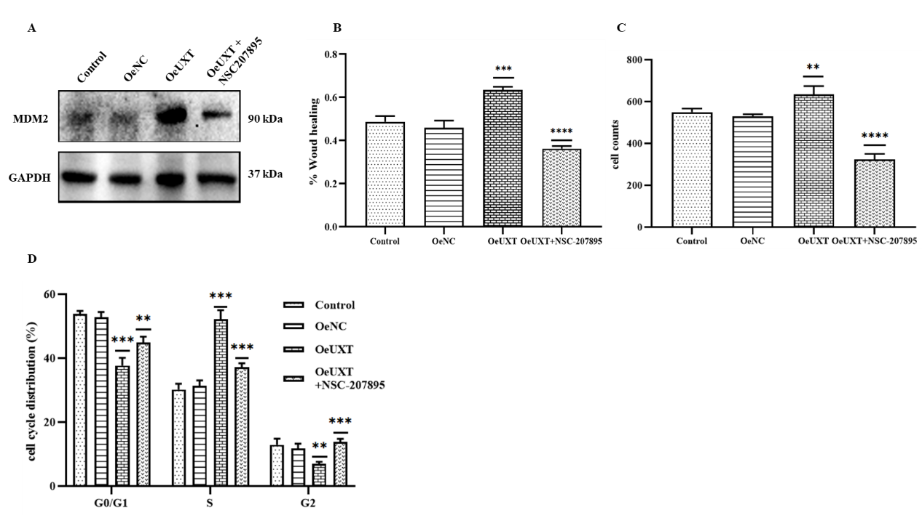
Figure S 3. (A) MDM2 protein expression in A375 cells under various treatment conditions. Migration rate (B), invasion rate (C) and cell cycle distribution (D) of A375 melanoma cells after overexpression of UXT (quantification of migration, invasion and proportion of different cell cycle stages).

Table S 1. UXT-shRNA sequences
Target | Species | Sequence (5′-3′) | GC content (%)
UXT-shRNA1 | Human | CCAGATACTTCACGCATCTAT | 36.84%
UXT-shRNA1 | Human | GCTAAGCACTCGGAGTTATAT | 36.84%
UXT-shRNA1 | Mouse | CCGTATATCTTCAACTAAGAA | 26.32%
UXT-shRNA1 | Mouse | GGGCTGTAACTTCTTCGTTGA | 47.62%
NC-shRNA (scramble sequence) |  | TTCTCCGAACGTGTCACGT

Table S 2. The primers sequences used in this study
Gene/Primers
 | Forward primer | Reverse primer
UXT | CTGGAGTTGACACTGGCAGAAGC | CCTTGGTGAGGCTGTTGCTGAG
GAPDH | GTCTCCTCTGACTTCAACAGCG | ACCACCCTGTTGCTGTAGCCAA

