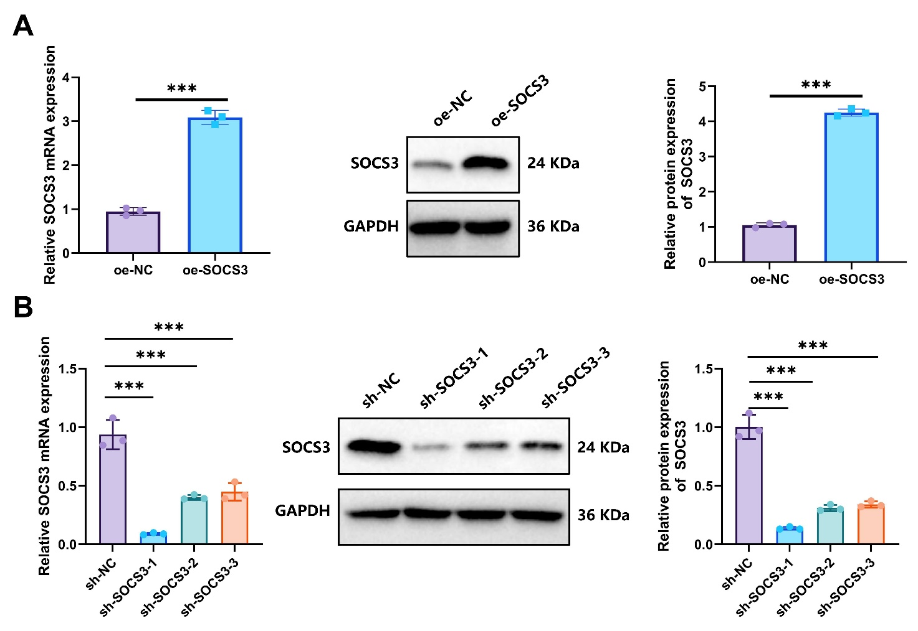
Figure S1. Detection of SOCS3 Overexpression and Knockdown Efficiency.
Note: (A) RT-qPCR and WB analysis of SOCS3 overexpression in A172 cells; (B) RT-qPCR and WB analysis of SOCS3 knockdown in A172 cells; *** indicates a significant difference between the two groups, p < 0.001. The cell experiments were performed in triplicate.

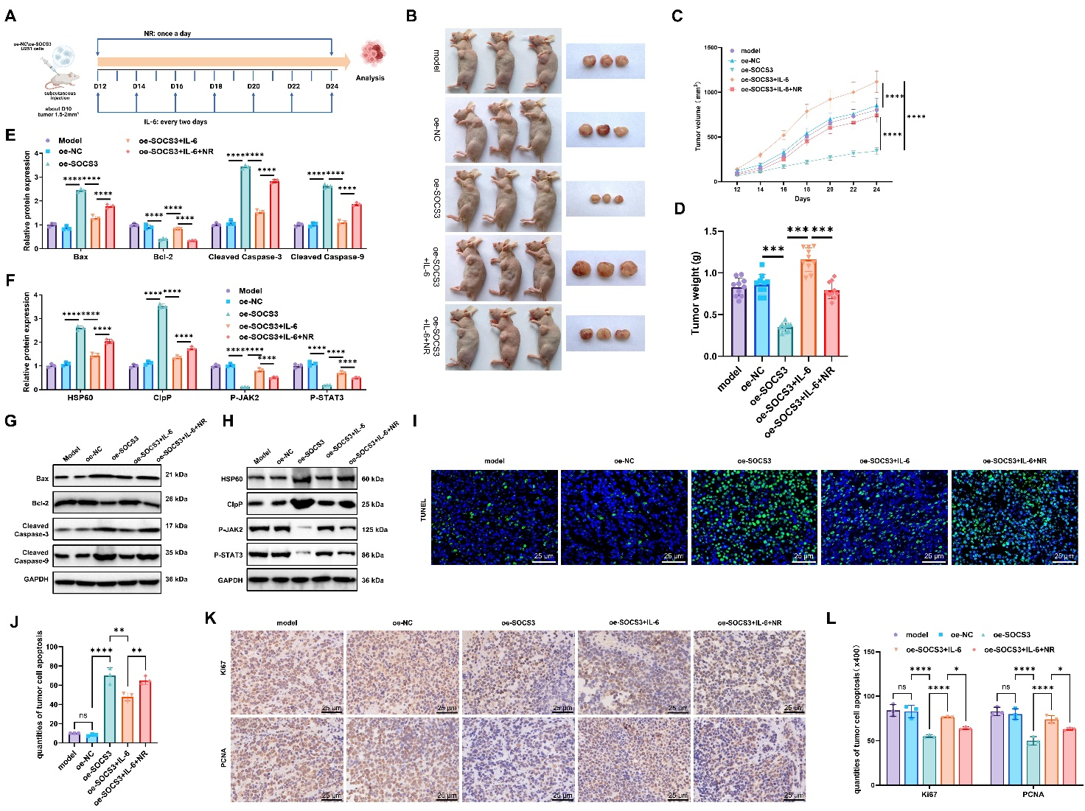
Figure S2. Mechanistic investigation of SOCS3 in U251 glioblastoma xenograft models
Note: (A) Experimental workflow of U251 cell xenograft model in nude mice; (B) Representative images of tumor-bearing nude mice and tumors, with caliper measurements of tumor volume across groups; (C) Tumor growth curves showing tumor volume trends in each experimental group (n=10); (D) Body weight changes of nude mice (n=10); (E) Expression levels of Cleaved Caspase-3, Bax, and Bcl-2 proteins (n=3); (F) Expression levels of HSP60, ClpP, p-JAK, and p-STAT3 proteins (n=3); (G) Western blot analysis of Cleaved Caspase-3, Cleaved Caspase-9, Bax, and Bcl-2 expression in tumor tissues; (H) Western blot analysis of HSP60, ClpP, p-JAK2, and p-STAT3 expression in tumor tissues; (I–J) TUNEL staining of apoptotic cells in tumor tissues (n=3); (K–L) Immunohistochemistry of Ki67 and PCNA expression in tumor tissues (n=3). *p < 0.05, **p < 0.01, ***p < 0.001 compared between groups.

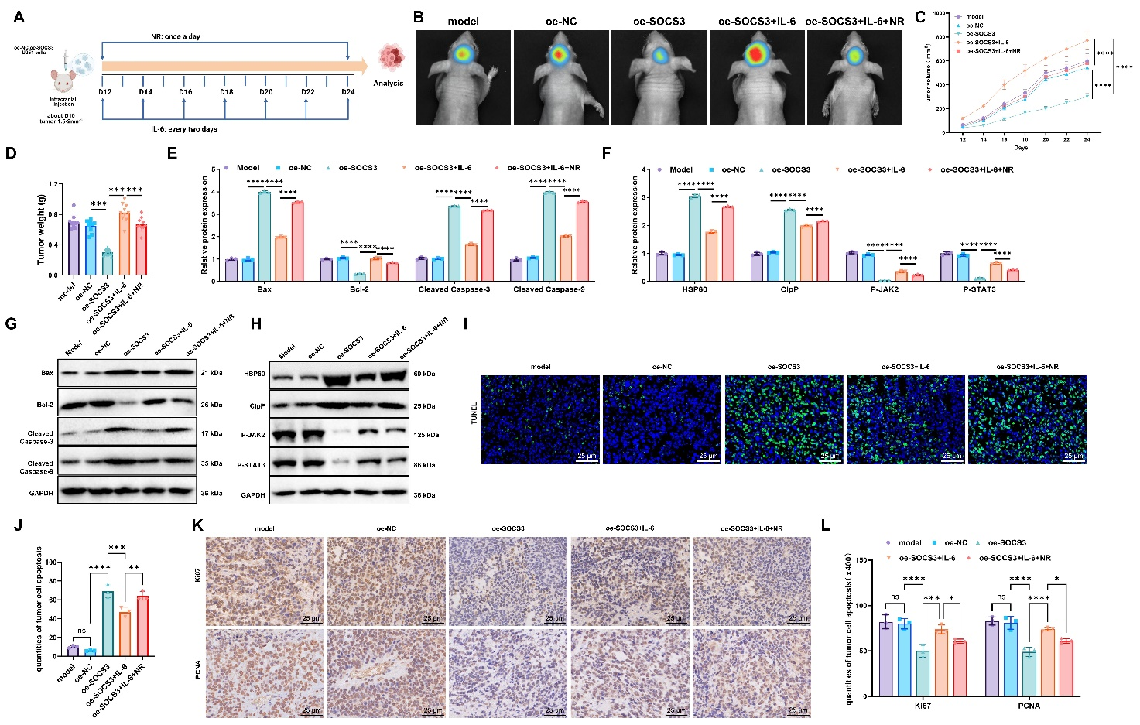
Figure S3. Mechanistic investigation of SOCS3 in U251 intracranial glioblastoma nude mouse models
Note: (A) Experimental workflow of U251 intracranial glioblastoma model; (B) Representative images of tumor-bearing nude mice and MRI measurements of tumor volume across groups; (C) Tumor growth curves showing tumor volume trends in each experimental group (n=10); (D) Body weight changes of nude mice (n=10); (E) Expression levels of Cleaved Caspase-3, Bax, and Bcl-2 proteins (n=3); (F) Expression levels of HSP60, ClpP, p-JAK, and p-STAT3 proteins (n=3); (G) Western blot analysis of Cleaved Caspase-3, Cleaved Caspase-9, Bax, and Bcl-2 expression in tumor tissues; (H) Western blot analysis of HSP60, ClpP, p-JAK2, and p-STAT3 expression in tumor tissues; (I-J) TUNEL staining of apoptotic cells in tumor tissues (n=3); (K-L) Immunohistochemistry of Ki67 and PCNA expression in tumor tissues (n=3). *p < 0.05, **p < 0.01, ***p < 0.001 compared between groups.

Table S1. SOCS3 Target Sequences of shRNA.
shRNA | Sequences (5’-3’)
sh-SOCS3-1 | TGACGGTCTTCCGACAGAGAT
sh-SOCS3-2 | TTTCTCATAGGAGTCCAGGTG
sh-SOCS3-3 | GCACCTTTCT TATCCGCGACA
sh-NC | GCAAGAAACAGCCTTGAGAGT

Table S2. RT-qPCR Primer Sequence (Human).
Gene | Forward Primer (5’-3’)
SOCS3 | F: 5ʹ- CAAGGACGGAGACTTCGATT-3ʹ
SOCS3 | R: 5ʹGGAGCCAGCGTGGATCTG-3ʹ
HSP60 | F: 5ʹ- TGCTTCGGTTACCCACAGTC -3ʹ
HSP60 | R: 5ʹ- GGACTTCCCCAACTCTGCTC -3ʹ
ClpP | F: 5ʹ- GTGGAGCAGACGGGTCG -3ʹ
ClpP | R: 5ʹ- CGATAACAAGGCTGGCAACG -3ʹ
Caspase-3 | F: 5′-TGGCGAAATTCAAAGGATG-3′
Caspase-3 | R: 5′-TAACCCGGGTAAGAATGTGC-3′
Caspase-9 | F: 5′-GCAGTAACCCCGAGCCAGATG-3′
Caspase-9 | R: 5′-CCGGAGGAAATTAAAGCAACCAG-3′
Bax | F: 5′- GCCCTTTTGCTTCAGGGTTT -3′
Bax | R: 5′- CATCCTCTGCAGCTCCATGT -3′
Bcl-2 | F: 5′- GAACTGGGGGAGGATTGTGG -3′
Bcl-2 | R: 5′- CCGTACAGTTCCACAAAGGC -3′
GAPDH | F:5′-GGAGCGAGATCCCTCCAAAAT-3′
GAPDH | R:5′-GGCTGTTGTCATACTTCTCATGG-3′
mtHSP70 | F:5′-AGCTGGAGCAGGTGTGTAAC-3′
mtHSP70 | R:5′-CAGCAATCTTGGAAAGGCCC-3′
LONP1 | F:5′-CATGACGATCCCCGATGTGT-3′
LONP1 | R:5′-CCTTCTCAGCAGCTCAACCA-3′
CHOP | F:5′-TTCTCTGGCTTGGCTGACTG-3′
CHOP | R:5′-TCCTCCTCTTCCTCCTGAGC-3′
F: Forward; R: Reverse

Table S3. Summary of Primary Reactor Information.
Primary antibody | Catalog Number | Concentration | Manufacturer
SOCS3 | ab280884 | 1:1000 | Abcam
Ki67 | ab16667 | 1:1000 | Abcam
PCNA | ab18197 | 1:1000 | Abcam
Bax | ab32503 | 1:1000 | Abcam
Bcl-2 | ab182858 | 1:2000 | Abcam
Cleaved Caspase-3  (Cl-Casp3) | ab32042 | 1:500 | Abcam
Cleaved Caspase-9  (Cl-Casp9) | 9505 | 1:1000 | Cell Signaling Technology
Fas | ab271016 | 1:1000 | Abcam
FasL | ab303666 | 1:1000 | Abcam
TNFa | ab92324 | 1:5000 | Abcam
Cleaved Caspase-8  (Cl-Casp8) | HY-P80624 | 1:10000 | MedChemExpress
p-PERK | 3179 | 1:1000 | Cell Signaling Technology
GRP78 | ab212054 | 1:1000 | Abcam
Cleaved Caspase-7  (Cl-Casp7) | ab256469 | 1:1000 | Abcam
Cleaved Caspase-12  (Cl-Casp12) | PA5-85716 | 1:3000 | Thermo Fisher Scientific
p-JAK2 | 3776S | 1:500 | Cell Signaling Technology
JAK2 | 3230S | 1:500 | Cell Signaling Technology
p-STAT3 | 9145S | 1:1000 | Cell Signaling Technology
STAT3 | 9139S | 1:1000 | Cell Signaling Technology
HSP60 | 12165 | 1:1000 | Cell Signaling Technology
ClpP | 14181 | 1:1000 | Cell Signaling Technology
mtHSP70 | ab194360 | 1:1000 | Abcam
LONP1 | ab103809 | 1:1000 | Abcam
CHOP | ab317378 | 1:1000 | Abcam
GAPDH | ab9485 | 1:2500 | Abcam

