Additional File 2

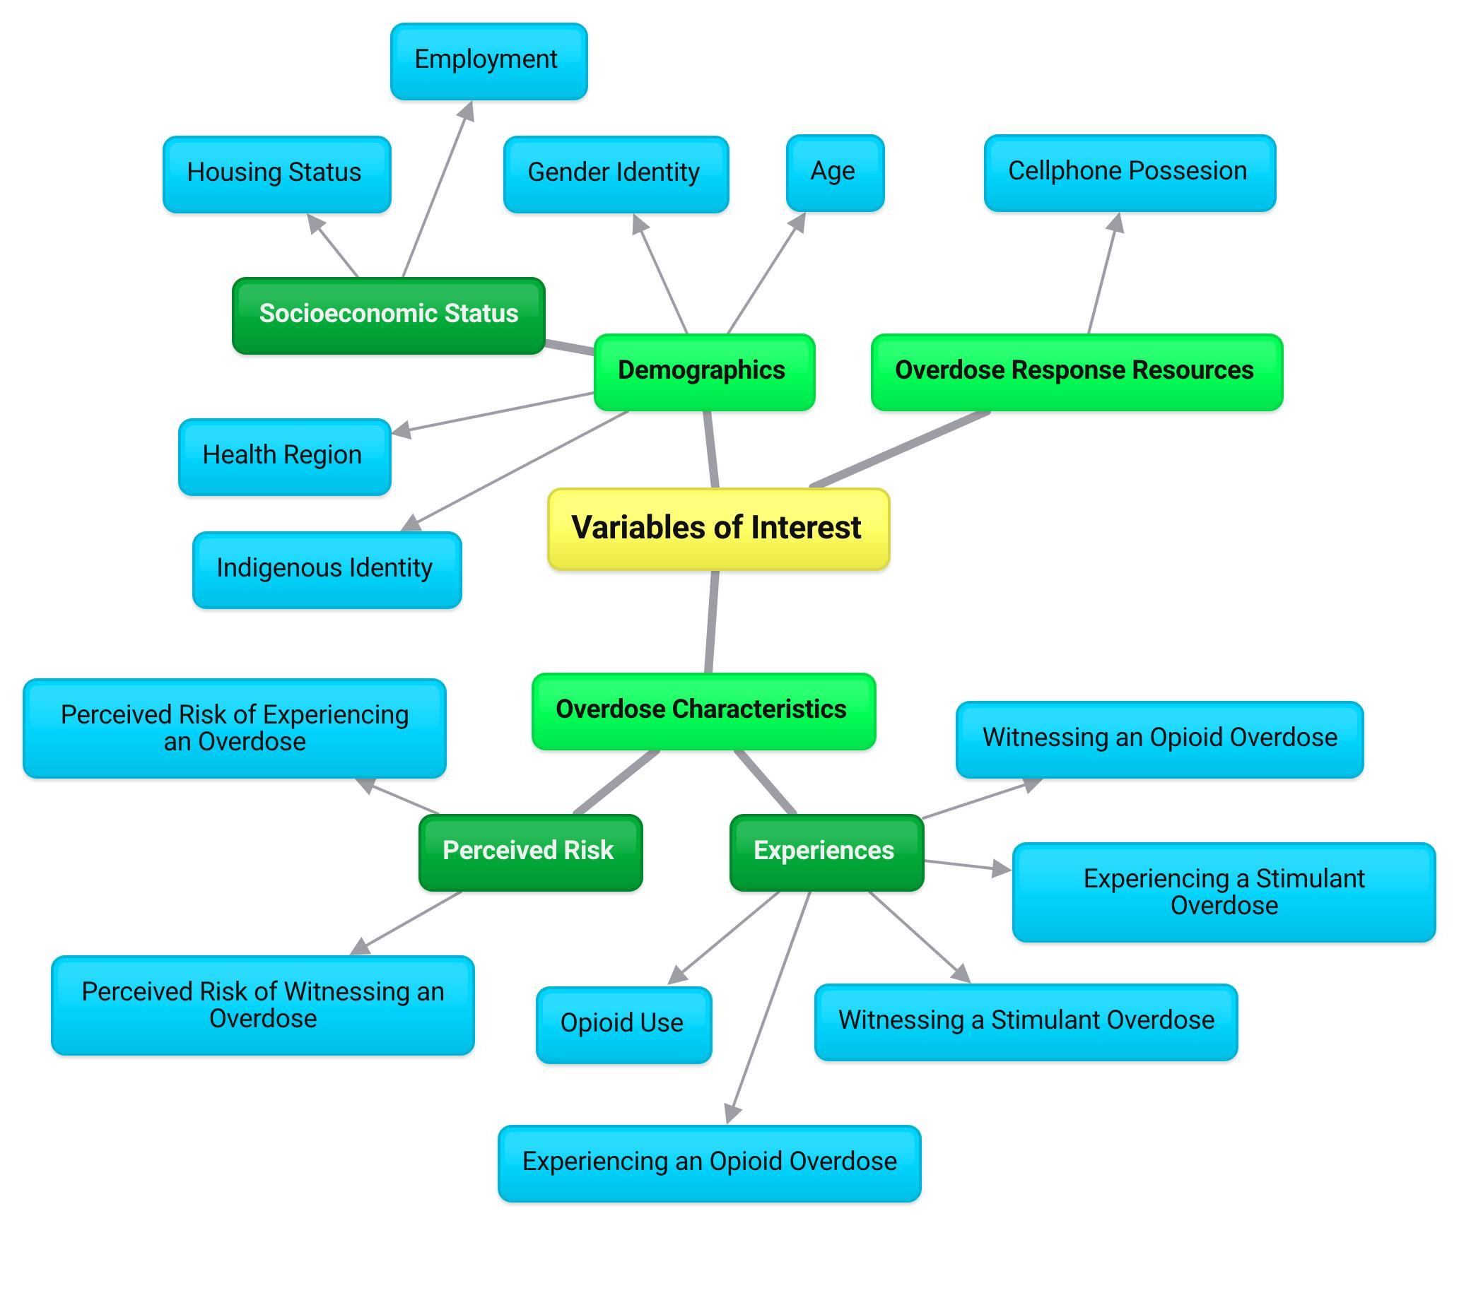
Supplementary Figure 1. Concept map of study variables of interest used to inform the development of a hierarchical regression model. Variables (blue) were assembled into categories (green) and subcategories (dark green) with categories ultimately becoming the “blocks” upon which the regression was built.

Supplementary Table 1. Factors associated with GSDOA awareness among survey respondents with “unknown” observations imputed by multiple imputation by chained equations (MICE).
 | GSDOA Awareness
 | Aware  (N = 259)  n (row %) | Unaware  (N = 234)  n (row %) | Total  (N = 493)  n (column %) | P-value
Age (years) |  |  |  | 0.138
16 – 24 years | 50 (43.9) | 64 (56.1) | 114 (23.1)
25 – 34 years | 59 (61.5) | 37 (38.5) | 96 (19.5)
35 – 44 years | 61 (55.5) | 49 (44.5) | 110 (22.3)
45 – 54 years | 52 (51.5) | 49 (48.5) | 101 (22.3)
55 years and over | 37 (51.4) | 35 (48.6) | 72 (14.6)
Gender Identity |  |  |  | 0.333
Cis man | 141 (51.9) | 137 (48.1) | 285 (57.8)
Cis woman | 102 (55.1) | 83 (44.9) | 185 (37.5)
Trans and gender expansive | 9 (39.1) | 14 (60.9) | 23 (4.7)
Indigenous Self-Identification |  |  |  | 0.024
Indigenous | 98 (46.4) | 113 (53.6) | 211 (42.8)
Non-Indigenous | 161 (57.1) | 121 (42.9) | 282 (57.2)
Health Region |  |  |  | 0.394
Fraser | 54 (51.9) | 50 (48.1) | 104 (21.1)
Interior | 75 (58.6) | 53 (41.4) | 128 (26.0)
Island | 47 (47.0) | 53 (53.0) | 100 (20.3)
Northern | 21 (45.7) | 25 (54.3) | 46 (9.3)
Vancouver Coastal | 62 (53.9) | 53 (46.1) | 115 (23.3)
Housing Status |  |  |  | 0.924
Private | 103 (52.3) | 94 (47.7) | 197 (40.0)
Supportive or Unstable Housing | 120 (53.3) | 105 (46.7) | 225 (45.6)
Homeless | 36 (50.7) | 35 (49.3) | 71 (14.4)
Employment |  |  |  | 0.751
Yes | 84 (51.2) | 80 (48.8) | 164 (33.3)
No | 175 (53.2) | 154 (46.8) | 329 (66.7)
Cellphone Possession |  |  |  | 0.020
Yes | 188 (56.3) | 146 (43.7) | 334 (67.7)
No | 71 (44.7) | 88 (55.3) | 159 (32.3)
Perceived Risk of Experiencing an Overdose (last 6 months)ª |  |  |  | <0.01
Never | 107 (44.8) | 132 (55.2) | 239 (48.5)
Ever | 152 (59.8) | 102 (40.2) | 254 (51.5)
Perceived Risk of Witnessing an Overdose (last 6 months)ª |  |  |  | <0.01
Never | 12 (20.7) | 46 (79.3) | 58 (11.8)
Ever | 247 (56.8) | 188 (43.2) | 435 (88.2)
Opioid Use (last 6 months) |  |  |  | <0.01
Yes | 175 (57.4) | 130 (42.6) | 305 (61.9)
No | 84 (44.7) | 104 (55.3) | 188 (38.1)
Opioid Overdose (last 6 months)^{b} |  |  |  | 0.153
Yes | 60 (63.8) | 34 (36.2) | 94 (19.1)
No | 115 (54.5) | 96 (45.5) | 211 (42.8)
Didn’t use opioids | 84 (44.7) | 104 (55.3) | 188 (38.1)
Stimulant Overdose (last 6 months) |  |  |  | 0.189
Yes | 49 (59.8) | 33 (40.2) | 82 (16.6)
No | 210 (51.1) | 201 (48.9) | 411 (83.4)
Opioid Overdose Witnessed (last 6 months) |  |  |  | <0.01
Yes | 190 (61.7) | 118 (38.3) | 308 (62.5)
No | 69 (37.3) | 116 (62.7) | 185 (37.5)
Stimulant Overdose Witnessed (last 6 months) |  |  |  | <0.01
Yes | 128 (61.2) | 81 (38.8) | 209 (42.4)
No | 131 (46.1)) | 153 (53.9) | 284 (57.6)
ª “Never” = “Never”; “Ever” = “Rarely/sometimes/often/all the time”
^{b} “Didn’t use opioids” is shown but is not included in the chi square test

Supplementary Table 2. Adjusted odds ratios (AOR) for predictors of GSDOA awareness with multiple imputations by chained equation (MICE).
 | GSDOA Awareness
 | Block 3 (OD Characteristics)ª  AOR (95% CI) | Imputed Block 3 (OD Characteristics)^{b}  AOR (95% CI)
Demographic Characteristics
Age (years)
16 – 24 | — | —
25 – 34 | 2.18 (1.09, 4.35) * | 1.92 (1.02, 3.64) *
35 – 44 | 1.59 (0.81, 3.14) | 1.41 (0.77, 2.56)
45 – 54 | 1.21 (0.62, 2.34) | 1.14 (0.62, 2.09)
55 + | 1.37 (0.63, 2.95) | 1.41 (0.71, 2.81)
Gender
Cis man | — | —
Cis woman | 1.01 (0.63, 1.60) | 1.14 (0.75, 1.75)
Trans and gender expansive | 0.54 (0.17, 1.72) | 0.74 (0.28, 1.97)
Overdose Response Resources
Cellphone possession
Yes | 2.36 (1.44, 3.86) *** | 2.04 (1.29, 3.23) **
No | — | —
Overdose Characteristics
Perceived risk of overdose^{c}
Ever | 1.47 (0.93, 2.31) | 1.48 (0.99, 2.21)
Never | — | —
Opioid overdose witness
Yes | 2.29 (1.42, 3.70) *** | 2.25 (1.46, 3.47) ***
No | — | —
ªFinal unimputed model is based on N = 340 observations after exclusion of “unknown” responses for each variable.
^{b}Final imputed model is based on N = 493 observations after “unknown” responses were imputed via MICE (Azur et al., 2011).
^{c}“Never” = “Never”; “Ever” = “Rarely/sometimes/often/all the time”

