Additional file 2
Concept key terms and search strategy

Concept key terms
Concept 1  Frameworks/Models/Theories | Concept 2  Sustainability | Concept 3  Research use or evidence-based
Framework(s) | Sustain* (*includes variable endings) | Research
Model(s) | Routinization / Routinisation | Research utilization(s)
Theory(ies) | Institutionalization / Institutionalisation | Evidence-based practice(s) or guideline(s)
 |  | Practice Guideline(s)
 |  | Diffusion of innovation(s)
 |  | Organizational innovation(s)
 |  | Clinical protocol(s)
 |  | Program(s) / Programme(s)
 |  | Intervention(s)

Search strategies
Embase Classic + Embase 1947 to 2017 October 25
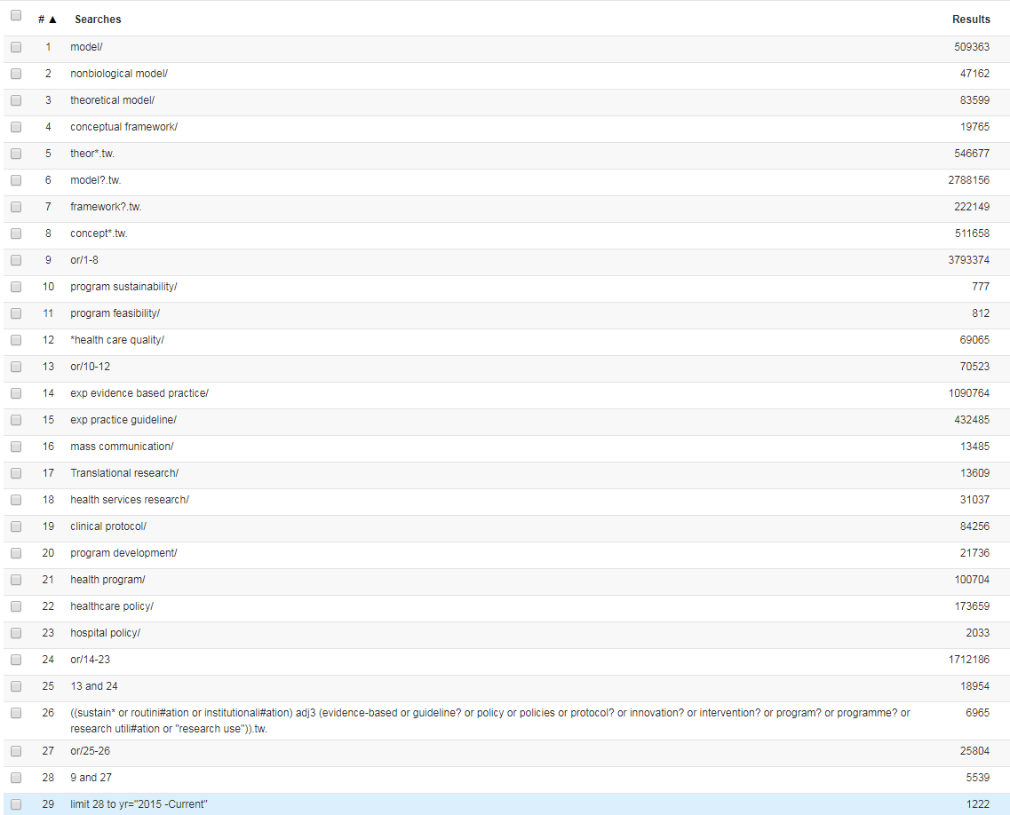

Ovid MEDLINE(R) Epub Ahead of Print, In-Process & Other Non-Indexed Citations, Ovid MEDLINE(R) Daily and Ovid MEDLINE(R) 1946 to Present
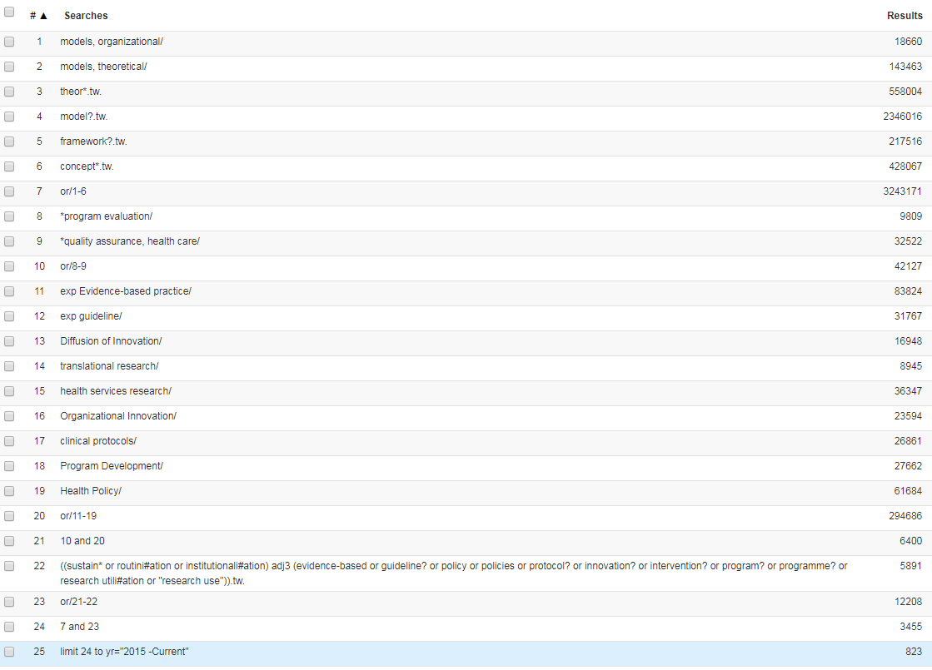

CINAHL (Ebsco)
S1 | (MH "Models, Theoretical") | 26,273
S2 | (MH "Organizational Theory") | 513
S3 | (MH "Theory-Practice Relationship") | 2,478
S4 | (MH "Conceptual Framework") | 29,374
S5 | TI model# OR AB model# | 191,696
S6 | TI theor* OR AB theor* | 71,718
S7 | TI framework# OR AB framework# | 42,142
S8 | TI concept# OR AB concept# | 47,307
S9 | S1 OR S2 OR S3 OR S4 OR S5 OR S6 OR S7 OR S8 | 324,912
S10 | (MM "Program Evaluation") | 6,159
S11 | (MM "Quality of Health Care") | 23,071
S12 | S10 OR S11 | 29,137
S13 | (MH "Professional Practice, Evidence-Based+") | 48,564
S14 | (MH "Professional Practice, Research-Based+") | 4,345
S15 | (MH "Health Services Research+") | 14,737
S16 | (MH "Program Implementation") | 15,396
S17 | (MH "Program Development") | 15,943
S18 | (MH "practice guidelines") | 40,880
S19 | (MH "Guideline Adherence") | 5,612
S20 | (MH "Health Policy") | 31,714
S21 | (MH "Diffusion of Innovation") | 7,274
S22 | (MH "Protocols") | 11,218
S23 | S13 OR S14 OR S15 OR S16 OR S17 OR S18 OR S19 OR S20 OR S21 OR S22 | 172,135
S24 | S12 AND S23 | 4,348
S25 | TI ( ((sustain* OR routini?ation OR institutionali?ation) N3 ("evidence-based" OR guideline? OR policy OR policies OR protocol? OR innovation? OR intervention? OR program? OR programme? OR "research utili?ation" OR "research use")) ) OR AB ( ((sustain* OR routini?ation OR institutionali?ation) N3 ("evidence-based" OR guideline? OR policy OR policies OR protocol? OR innovation? OR intervention? OR program? OR programme? OR "research utili?ation" OR "research use")) ) | 1,244
S26 | S24 OR S25 | 5,570
S27 | S9 AND S26 | 1,283
S28 | S9 AND S26 | 262

ProQuest Dissertations & Theses Global
Search Strategy:
TI,AB(model OR theory OR framework OR concept) AND TI,AB((sustain* OR institutionalization OR routinization) NEAR/3 ("evidence-based" OR guideline OR policy OR protocol OR innovation OR intervention OR program OR "research utilization" OR "research utilisation" OR “research use”)) AND TI,AB(health)
Results= 36
Other sources
Rogers (2005). Diffusion of Innovations
Buchanan, Fitzgerald & Ketley (2006). The Sustainability and Spread of Organizational Change

Follow up search from Oct 1 2017 to July 3, 2018

Databases | Platform | Date | # records
CINAHL | Ebsco | July 2018 | 91
Medline | Ovid | July 2018 | 197
Embase | Ovid | July 2018 | 260
ProQuest Dissertation & Thesis Global‎ | ProQuest | July 2018 | 4
Total of records |  | July 2018 | 552
Total of records after duplicates removed | N=53 | July 2018 | 499

