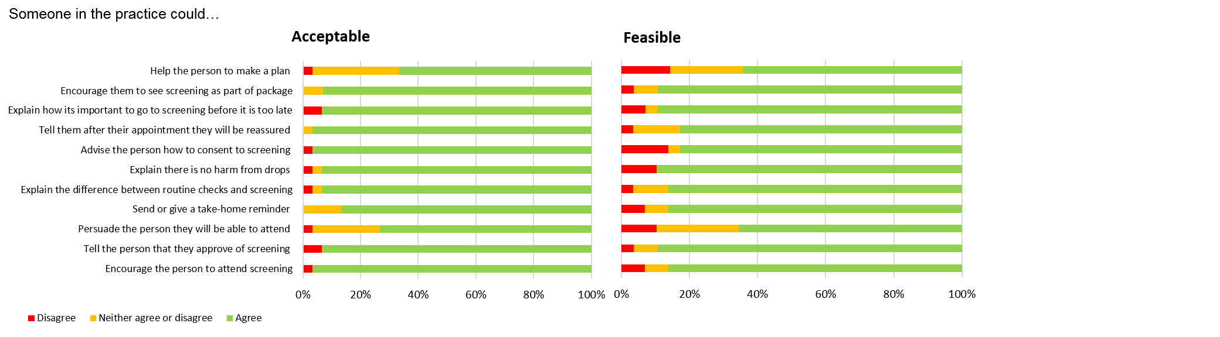

Suppl. Figure 1 (a) Ways to encourage patients to attend (practice led)
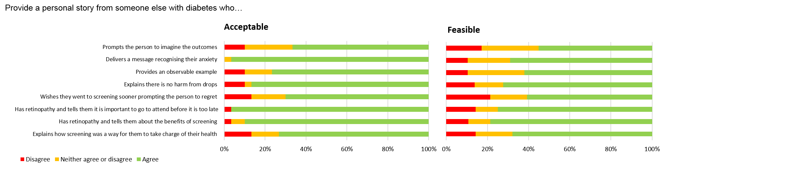

Suppl. Figure 1 (b) Ways to encourage patients to attend (narrative led)

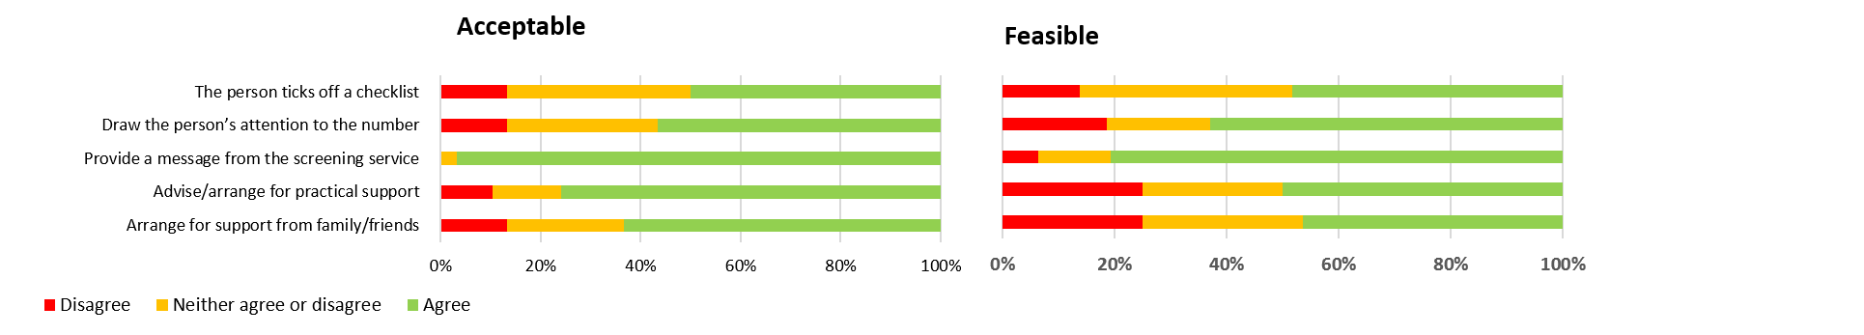

Suppl. Figure 1 (c) Ways to encourage patients to attend (other ideas)

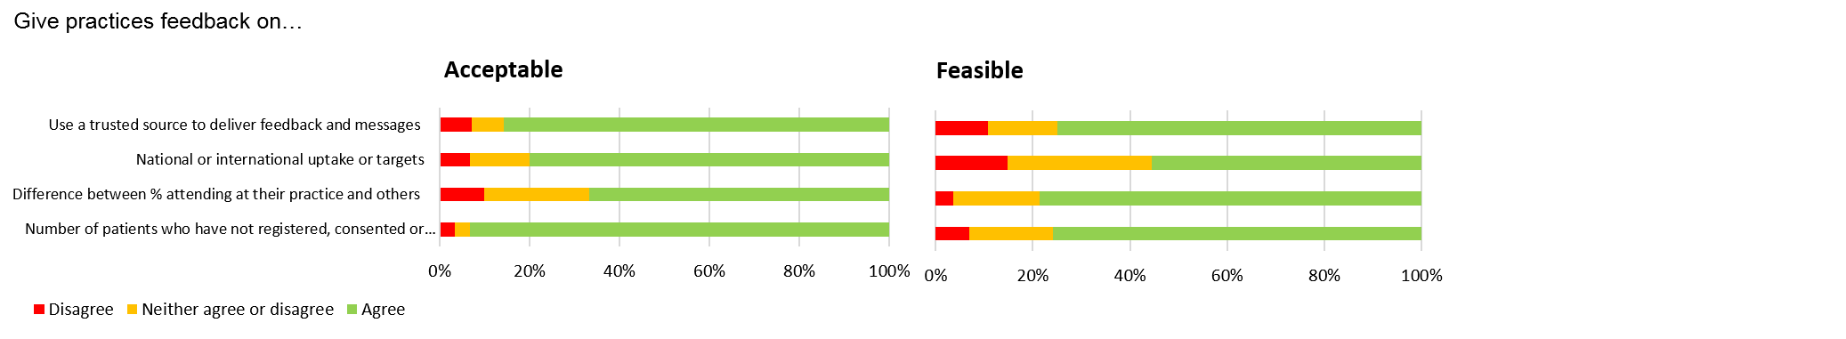
Suppl. Figure 1 (d) Ways to encourage professionals to prompt patients about screening (feedback)

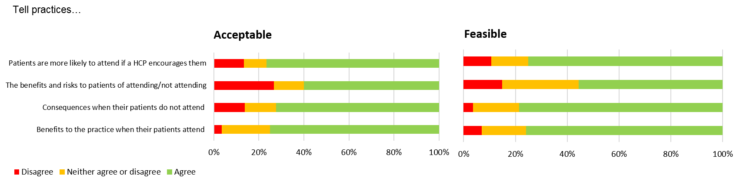
Suppl. Figure 1 (e) Ways to encourage professionals to prompt patients about screening (feedback)

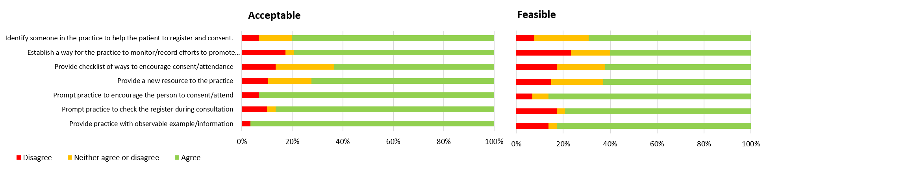

Suppl. Figure 1 (f) Ways to encourage professionals to prompt patients about screening (other ideas)

