Stroke Feedback Report

The current guideline recommends that healthcare professionals treat eligible stroke patients with tPA within 60 minutes of arrival to the hospital.

- Tissue plasminogen activator (tPA) is the only approved acute stroke treatment. tPA greatly increases the chance that a stroke patient will have a good outcome.

- tPA works better the earlier it is given.

- Major medical organizations including the American Heart Association and American College of Emergency Physicians support treating eligible stroke patients with tPA.

- If you have any questions please contact the Stroke Program Coordinator.

Figures shown are not actual hospital data and were created for this sample report.

GRAPH 1: PERCENTAGE OF ISCHEMIC STROKE PATIENTS TREATED WITH TPA

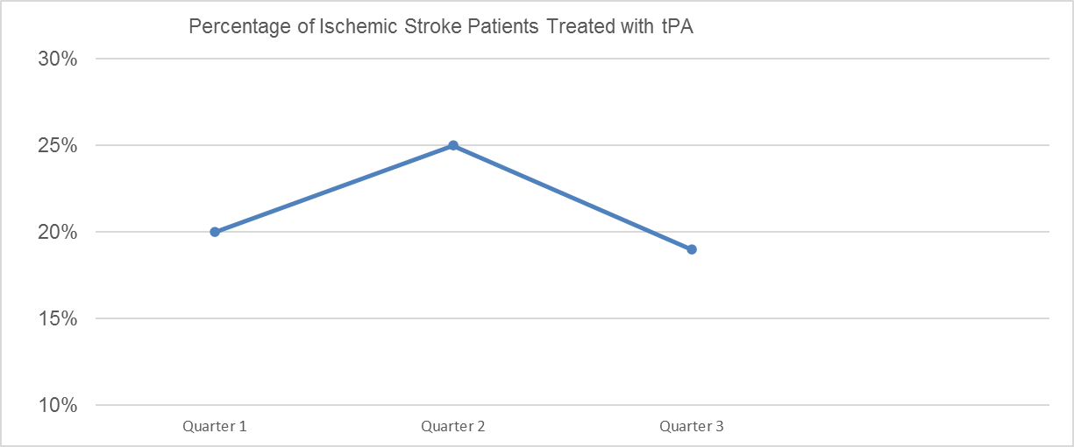
- Time is measured in quarters on the horizontal line
Figures shown are not actual hospital data and were created for this sample report.

GRAPH 2: ACUTE STROKE TREATMENT TIMES: SHORTER TIMES ARE BETTER
Figure 1

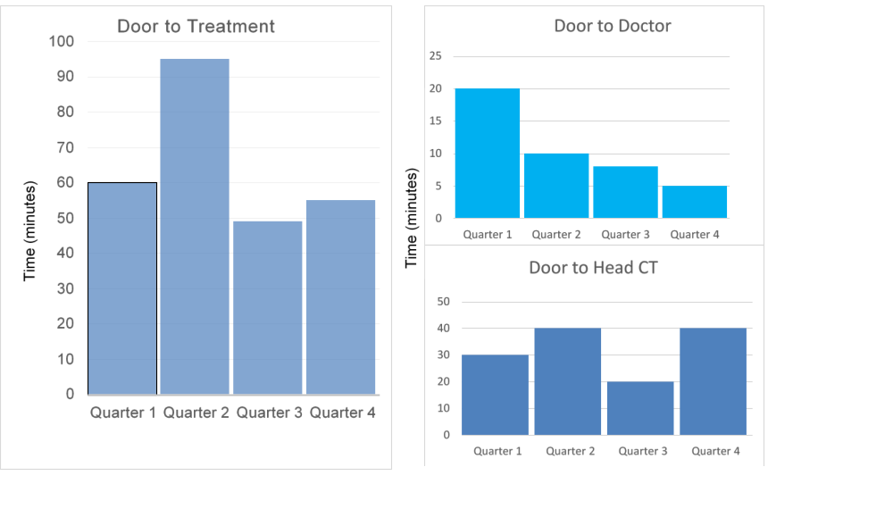
Figure 3
Figure 2
Figure 1: Door to Treatment shows the overall time from when the patient arrived to the hospital (Door) to when the patient received tPA treatment.

Figure 2: Door to Doctor shows the time from when the patient arrived to the hospital (Door) to when the patient first saw a doctor.

Figure 3: Door to Head CT shows the time from when the patient arrived to the hospital (Door) to when the patient received a head CT scan.

Figures shown are not actual hospital data and were created for this sample report.

