Additional File 4. Examples of the tasks conducted at the synthesis phase
- Categorising the evidence based on Capability, Opportunity, and Motivation (COM-B Model) to improve delivery by professionals of psychological interventions over the telephone
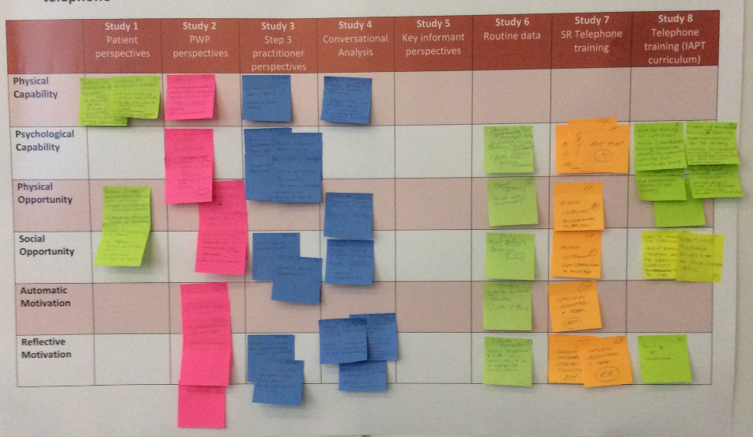

b) Categorising the evidence based on Capability, Opportunity, and Motivation (COM-B Model) to improve engagement by patients with anxiety and/or depression to psychological interventions over the telephone
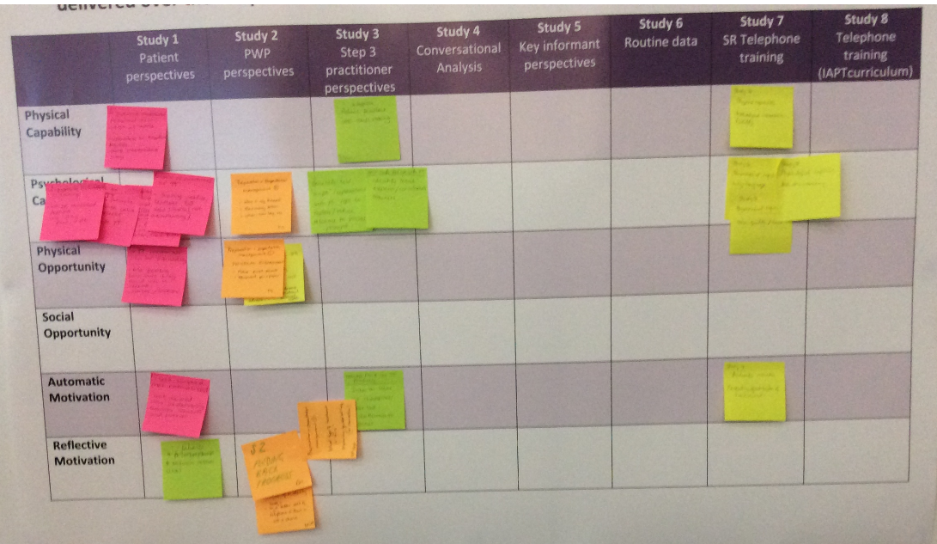

Note that findings from “study 6” were not included in the synthesis day because access to routine data were not granted in sufficient time

