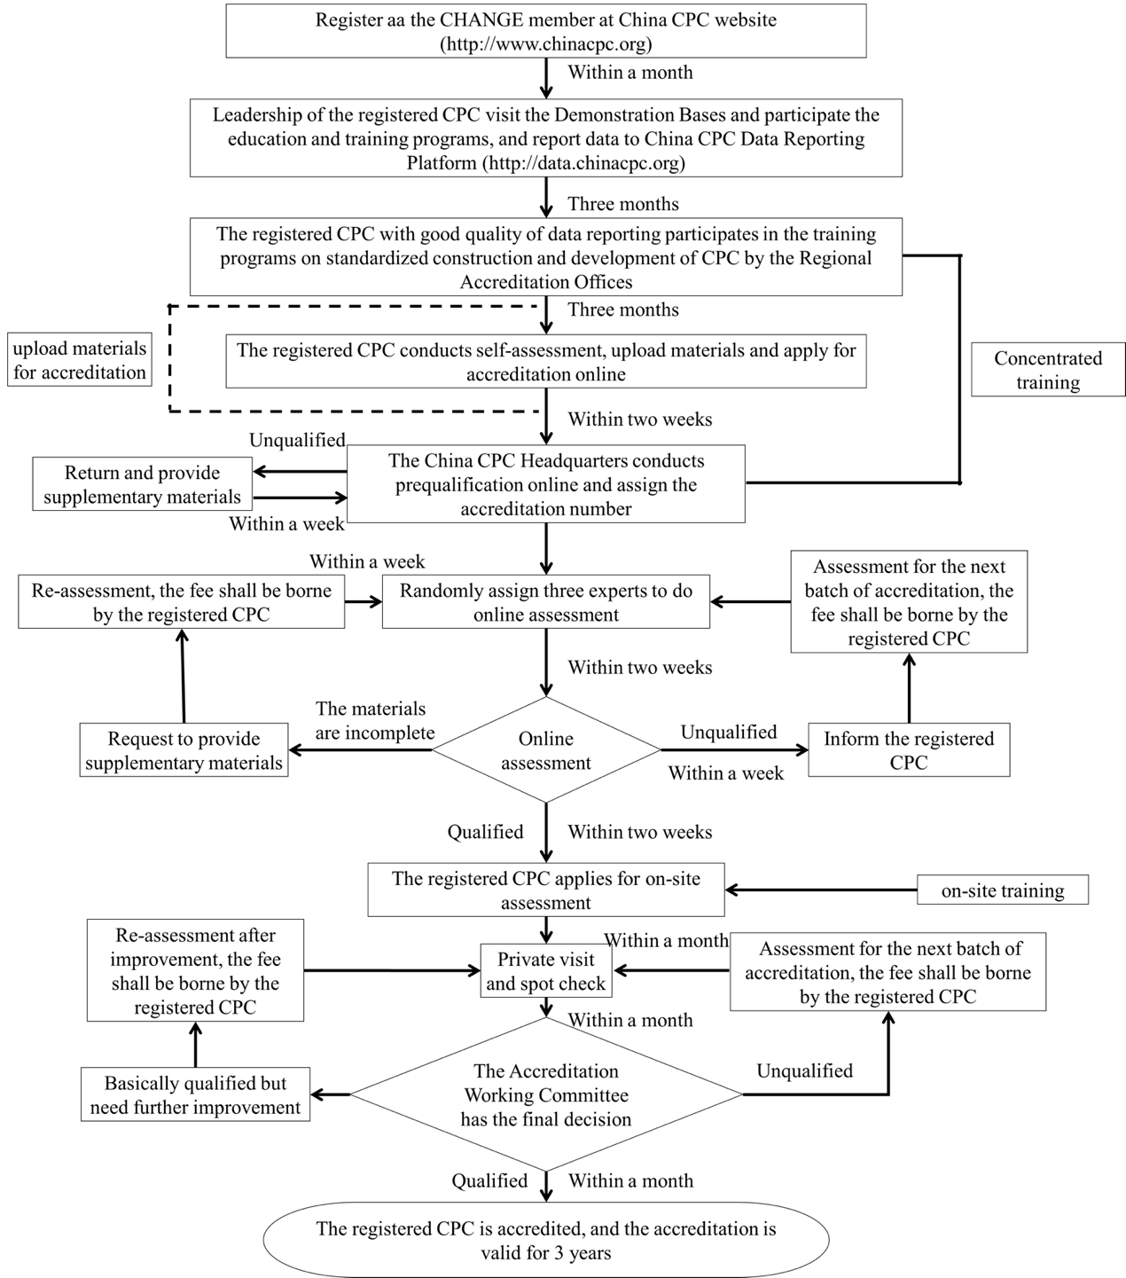
Supplemental Fig 1. The Chest Pain Center Accreditation Workflow in the NCPCP

