Additional file 1: illustration of individual contours of investigated patients
Figure S1. Patient #1
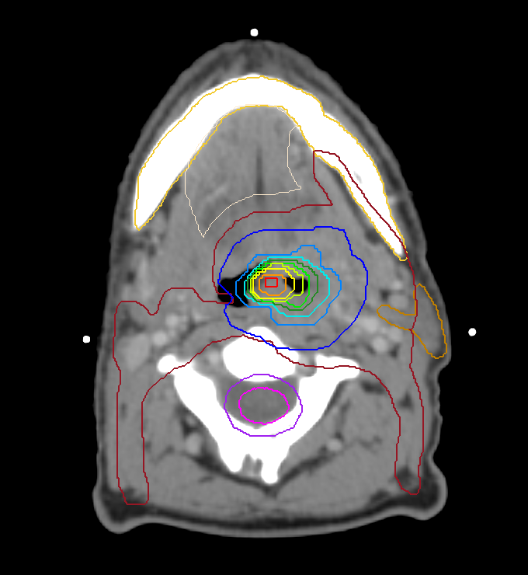
PAR
PRV SC
PTV PET
Level 7
Level 6
Level 5
Level 4
Level 3
Level 2
Level 1
PTV 70
PTV 56
Mandible
Oral cavity
SC

Figure S2. Patient #2
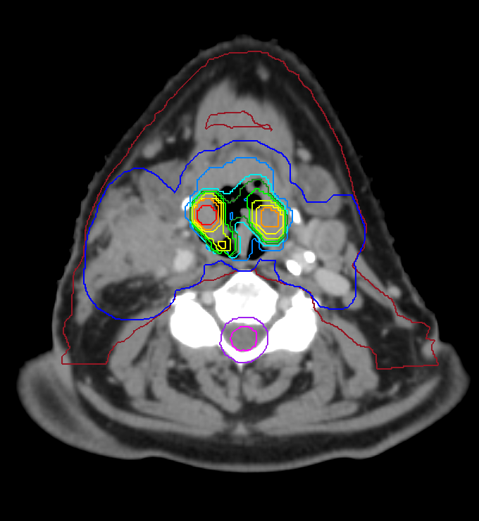
PTV 56
PRV SC
SC
Level 7
Level 6
Level 5
Level 4
Level 3
Level 2
Level 1
PTV PET
PTV 70

Figure S3. Patient #3
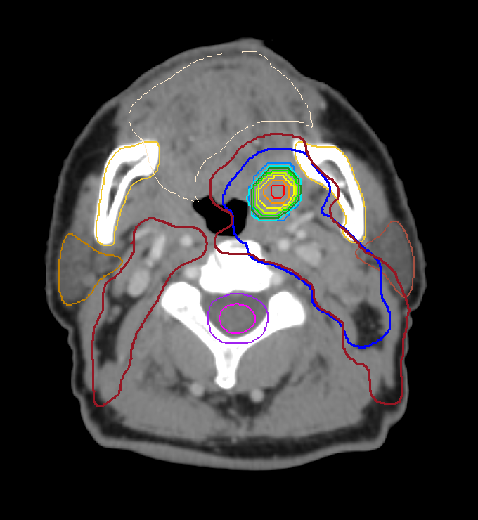
PAR
Level 7
Level 6
Level 5
Level 4
Level 3
Level 2
Level 1
PTV PET
PAR
PRV SC
SC
PTV 70
PTV 56
Oral cavity
Mandible

Figure S4. Patient #4
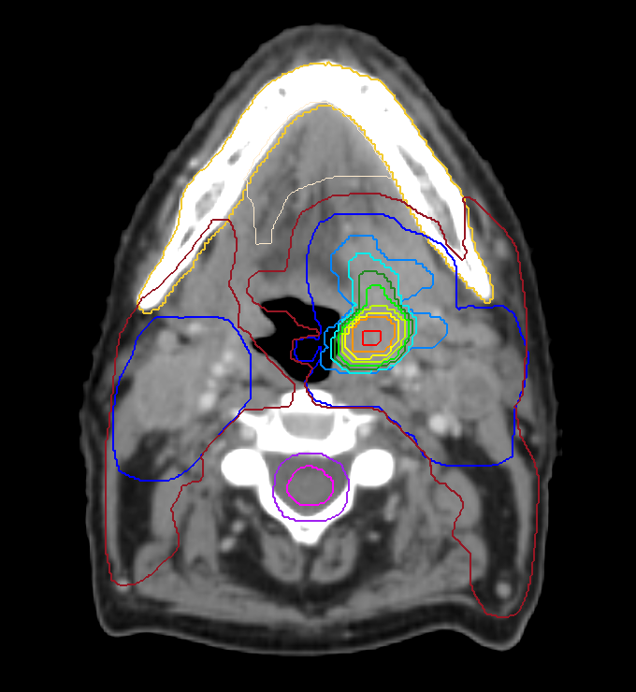
PTV 56
Level 7
Level 6
Level 5
Level 4
Level 3
Level 2
Level 1
PTV PET
Mandible
Oral cavity
PRV SC
SC
PTV 70

Figure S5. Patient #5
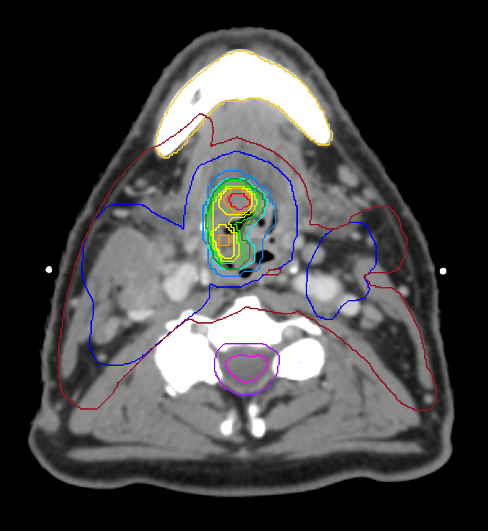
Level 7
Level 6
Level 5
Level 4
Level 3
Level 2
Level 1
PTV PET
PRV SC
SC
PTV 70
PTV 56
Mandible
Legend
PTV 70 = therapeutic planning target volume; PTV 56 = prophylactic planning target volume;
PTV PET = dose painting target volume
SC = spinal cord; PRV SC = planning risk volume of the spinal cord; PAR = parotid gland

Pt | Location | TNM stage | Volumes (cm³)
Pt | Location | TNM stage | PTV_{PET} | Level |  |  |  |  |  |  | PTV₇₀ | PTV_{total}
 |  |  |  | 1 | 2 | 3 | 4 | 5 | 6 | 7 | PTV₇₀ | PTV_{total}
1 | Lateral pharygeal wall L | T4N0M0 | 36.8 | 19.3 | 14.2 | 9.9 | 6.4 | 3.5 | 1.6 | 0.4 | 98.7 | 482.1
2 | Vallecula R | T4N2cM0 | 26.4 | 14.2 | 10.4 | 7.2 | 4.6 | 2.6 | 1.1 | 0.3 | 273.6 | 707.6
3 | Tonsil L | T2N2bM0 | 10.6 | 6.5 | 4.8 | 3.3 | 2.2 | 1.2 | 0.5 | 0.1 | 132.7 | 467.5
4 | Tonsil L | T4N2cM0 | 38.8 | 20.4 | 14.9 | 10.4 | 6.7 | 3.7 | 1.7 | 0.4 | 216.8 | 702.8
5 | Base of tongue | T3N2cM0 | 21.7 | 11.8 | 8.7 | 6.0 | 3.9 | 2.1 | 0.9 | 0.2 | 209.2 | 888.5
Table S1 Patients characteristics (Pt: patient)

