Additional file 1
Supplementary data 1: Dose values for MRI based RT for the different rats. D_{x} stands for the dose that x % of the tissue volume received.

 | Rat 1 | Rat 2 | Rat 3 | Rat 4 | Rat 5 | Rat 6 | Rat 7 | Rat 8 | Rat 9 | Average | SD
Volume (ccm) | 0.10 | 0.10 | 0.11 | 0.10 | 0.07 | 0.07 | 0.08 | 0.12 | 0.06 | 0.09 | 0.02
Average dose (cGy) | 1828 | 1855 | 1833 | 1803 | 1860 | 1920 | 1857 | 1795 | 1851 | 1845 | 36
Maximum dose (cGy) | 2171 | 2475 | 2098 | 2413 | 2866 | 2525 | 2514 | 2116 | 2470 | 2405 | 245
Minimum dose (cGy) | 451 | 753 | 796 | 333 | 606 | 656 | 650 | 676 | 706 | 625 | 146
D90 (cGy) | 1475 | 1600 | 1500 | 1400 | 1500 | 1600 | 1550 | 1375 | 1525 | 1502 | 78
D50 (cGy) | 1900 | 1900 | 1925 | 1900 | 1950 | 2000 | 1900 | 1900 | 1925 | 1922 | 34
D2 (cGy) | 2100 | 2100 | 2175 | 2125 | 2150 | 2200 | 2100 | 2075 | 2075 | 2122 | 44

Supplementary data 2: Dose values for PET/MRI-based RT with PET based sub-volume boosting. D_{x} stands for the dose that x % of the tissue volume received.
 | Rat 1 | Rat 2 | Rat 3 | Rat 4 | Rat 5 | Rat 6 | Rat 7 | Rat 8 | Rat 9 | Average | SD
Volume (ccm) | 0.10 | 0.10 | 0.11 | 0.10 | 0.07 | 0.07 | 0.08 | 0.12 | 0.06 | 0.09 | 0.02
Average dose (cGy) | 1896 | 1875 | 1856 | 1826 | 1885 | 1936 | 1883 | 1816 | 1880 | 1872 | 36
Maximum dose (cGy) | 2645 | 2512 | 2538 | 2506 | 2867 | 2529 | 2515 | 2436 | 2490 | 2560 | 127
Minimum dose (cGy) | 683 | 761 | 797 | 334 | 607 | 672 | 651 | 676 | 709 | 654 | 133
D90 (cGy) | 1625 | 1550 | 1500 | 1350 | 1500 | 1600 | 1550 | 1400 | 1550 | 1513 | 89
D50 (cGy) | 1950 | 1900 | 1025 | 1900 | 1950 | 2025 | 1950 | 1900 | 1900 | 1933 | 41
D2 (cGy) | 2125 | 2200 | 2250 | 2250 | 2300 | 2200 | 2200 | 2150 | 2250 | 2213 | 54

Supplementary data 3: representative DVH of 5 Gy boost using a 1 x 1 mm² collimator. The DVH shows that over 50% of the tissue volume received a dose of 5 Gy.
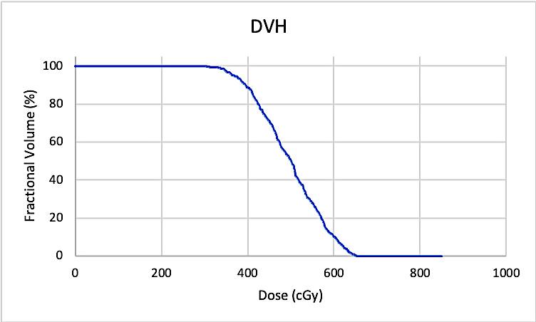

Supplementary data 4: Overview of data obtained. ✓ means the scan was performed, ✕ means the scan was not obtained.

Supplementary data 5: Overview tumor volumes (ccm) for all groups. The tumor volumes were based on the volumes of interest manually drawn based on the T1 weighted MRI. For the PET based volumes, a threshold of 60% maximum standardized uptake value was applied within the rat brain. Animals were euthanized when human endpoints were reached (>20% weight loss, tumor volume >40% of total brain volume based on MRI or signs of ataxia).

