1. Supplement A

Table S1. Patient characteristics.
Site | NPC | Rectum
Age | 57±15 | 56±13
Gender
Male | 6 | 3
Female | 4 | 7
T-stage
T1-T2 | 3 | 2
T3-T4 | 7 | 8
N-stage
N0-N1 | 5 | 3
N2-N3 | 5 | 7

2. Supplement B

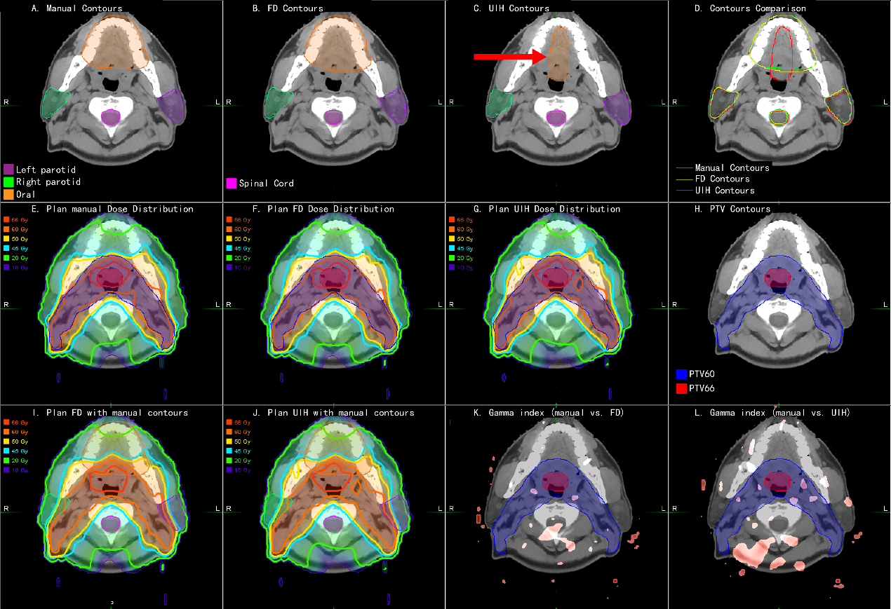
Fig. S1 An example of nasopharyngeal carcinoma (NPC) patient. A. Manual OARs; B. FD OARs; C. UIH OARs; D. Contour comparison; E. Plan_Manual dose distribution; F. Plan_FD dose distribution; G. Plan_UIH dose distribution; H. PTV contour; I. Plan_FD with manual OARs; J. Plan_UIH with manual OARs; K. 3D gamma analysis of Plan_FD; red color represents gamma index > 1; L. 3D gamma analysis of Plan_UIH, red color represents gamma index > 1.

Table S2. Summary of the OARs dosimetry parameters of the original treatment plans (Plan_Manual) on orginal OARs (OAR_Manual) and two deep learning-based segmentations (OAR_FD and OAR_UIH). All the values are reported as the mean ± standard deviation.
Site | Structure | Dosimetric metrics | OARs sets | Value | Comparison (paired t test)
Rectal | Bladder | V₄₀ (%) | Manual | 43.45 ± 26.96 | /
Rectal | Bladder | V₄₀ (%) | FD | 42.85 ± 24.93 | p = 0.83
Rectal | Bladder | V₄₀ (%) | UIH | 42.55 ± 25.74 | p = 0.54
Rectal | Bladder | D_{mean} (cGy) | Manual | 3476 ± 1281 | /
Rectal | Bladder | D_{mean} (cGy) | FD | 3451 ± 1216 | p = 0.70
Rectal | Bladder | D_{mean} (cGy) | UIH | 3401 ± 1250 | p = 0.11
Rectal | Femoral head_L | D_{mean} (cGy) | Manual | 2199 ± 773 | /
Rectal | Femoral head_L | D_{mean} (cGy) | FD | 2198 ± 714 | p = 0.99
Rectal | Femoral head_L | D_{mean} (cGy) | UIH | 2134 ± 859 | p = 0.59
Rectal | Femoral head_R | D_{mean} (cGy) | Manual | 2130 ± 755 | /
Rectal | Femoral head_R | D_{mean} (cGy) | FD | 2084 ± 751 | p = 0.53
Rectal | Femoral head_R | D_{mean} (cGy) | UIH | 2125 ± 820 | p = 0.95
NPC | Eye_L | D_{max} (cGy) | Manual | 2199 ± 1175 | /
NPC | Eye_L | D_{max} (cGy) | FD | 2147 ± 1244 | p = 0.62
NPC | Eye_L | D_{max} (cGy) | UIH | 2151 ± 1163 | p = 0.71
NPC | Eye_R | D_{max} (cGy) | Manual | 2441 ± 1892 | /
NPC | Eye_R | D_{max} (cGy) | FD | 2461 ± 1845 | p = 0.89
NPC | Eye_R | D_{max} (cGy) | UIH | 2379 ± 1873 | p = 0.74
NPC | Spinal cord | D_{max} (cGy) | Manual | 4261 ± 161 | /
NPC | Spinal cord | D_{max} (cGy) | FD | 4225 ± 206 | p = 0.25
NPC | Spinal cord | D_{max} (cGy) | UIH | 4246 ± 321 | p = 0.81
NPC | Brainstem | D_{max} (cGy) | Manual | 5578 ± 803 | /
NPC | Brainstem | D_{max} (cGy) | FD | 5530 ± 667 | p = 0.51
NPC | Brainstem | D_{max} (cGy) | UIH | 5523 ± 669 | p = 0.57
NPC | Parotid_L | V₃₀ (%) | Manual | 57.78 ± 25.86 | /
NPC | Parotid_L | V₃₀ (%) | FD | 56.89 ± 32.01 | p = 0.20
NPC | Parotid_L | V₃₀ (%) | UIH | 56.99 ± 27.01 | p = 0.33
NPC | Parotid_L | D_{mean} (cGy) | Manual | 4365 ± 926 | /
NPC | Parotid_L | D_{mean} (cGy) | FD | 4241 ± 1027 | p = 0.18
NPC | Parotid_L | D_{mean} (cGy) | UIH | 4308 ± 1024 | p = 0.59
NPC | Parotid_R | V₃₀ (%) | Manual | 55.53 ± 23.68 | /
NPC | Parotid_R | V₃₀ (%) | FD | 55.38 ± 33.21 | p = 0.11
NPC | Parotid_R | V₃₀ (%) | UIH | 54.67 ± 25.61 | p = 0.25
NPC | Parotid_R | D_{mean} (cGy) | Manual | 4060 ± 508 | /
NPC | Parotid_R | D_{mean} (cGy) | FD | 4015 ± 513 | p = 0.70
NPC | Parotid_R | D_{mean} (cGy) | UIH | 3848 ± 633 | p = 0.17
NPC | Len_L | D_{max} (cGy) | Manual | 592 ± 390 | /
NPC | Len_L | D_{max} (cGy) | FD | 604 ± 388 | p = 0.20
NPC | Len_L | D_{max} (cGy) | UIH | 554 ± 371 | p = 0.08
NPC | Len_R | D_{max} (cGy) | Manual | 568 ± 385 | /
NPC | Len_R | D_{max} (cGy) | FD | 525 ± 256 | p = 0.39
NPC | Len_R | D_{max} (cGy) | UIH | 510 ± 295 | p = 0.18
NPC | Optic nerve_L | D_{max} (cGy) | Manual | 3551 ± 2224 | /
NPC | Optic nerve_L | D_{max} (cGy) | FD | 3460 ± 2253 | p = 0.44
NPC | Optic nerve_L | D_{max} (cGy) | UIH | 3622 ± 2337 | p = 0.46
NPC | Optic nerve_R | D_{max} (cGy) | Manual | 3612 ± 2115 | /
NPC | Optic nerve_R | D_{max} (cGy) | FD | 3600 ± 2154 | p = 0.95
NPC | Optic nerve_R | D_{max} (cGy) | UIH | 3877 ± 1960 | p = 0.22
NPC | Temporal lobe_L | D_{max} (cGy) | Manual | 6376 ± 2126 | /
NPC | Temporal lobe_L | D_{max} (cGy) | FD | 6579 ± 2178 | p = 0.10
NPC | Temporal lobe_L | D_{max} (cGy) | UIH | 6356 ± 2289 | p = 0.86
NPC | Temporal lobe_R | D_{max} (cGy) | Manual | 6430 ± 2143 | /
NPC | Temporal lobe_R | D_{max} (cGy) | FD | 6320 ± 2070 | p = 0.37
NPC | Temporal lobe_R | D_{max} (cGy) | UIH | 6454 ± 2193 | p = 0.86
NPC | Oral cavity | D_{mean} (cGy) | Manual | 3933 ± 551 | /
NPC | Oral cavity | D_{mean} (cGy) | FD | 3922 ± 552 | p = 0.83
NPC | Oral cavity | D_{mean} (cGy) | UIH | 3799 ± 561 | p = 0.06
NPC | Larynx | D_{mean} (cGy) | Manual | 3829 ± 153 | /
NPC | Larynx | D_{mean} (cGy) | FD | 3884 ± 215 | p = 0.43
NPC | Larynx | D_{mean} (cGy) | UIH | 3801 ± 254 | p = 0.66

3. Supplement C

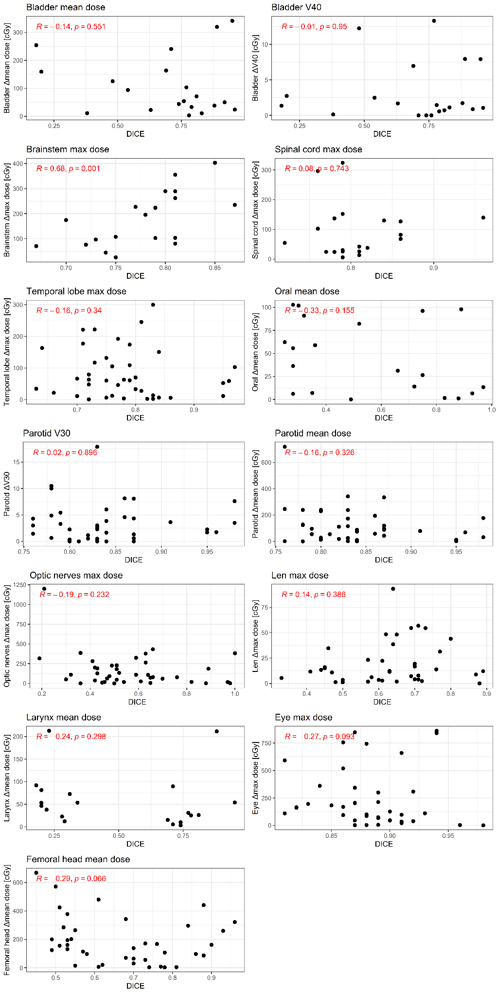
Fig. S2 The correlation between DICE and dose metric deviation
Fig. S3 The correlation between Hausdorff distance and dose metric deviation
Fig. S4 The correlation between JACCARD and dose metric deviation
Fig. S5 The correlation between mean distance to agreement and dose metric deviation
4. Supplement D

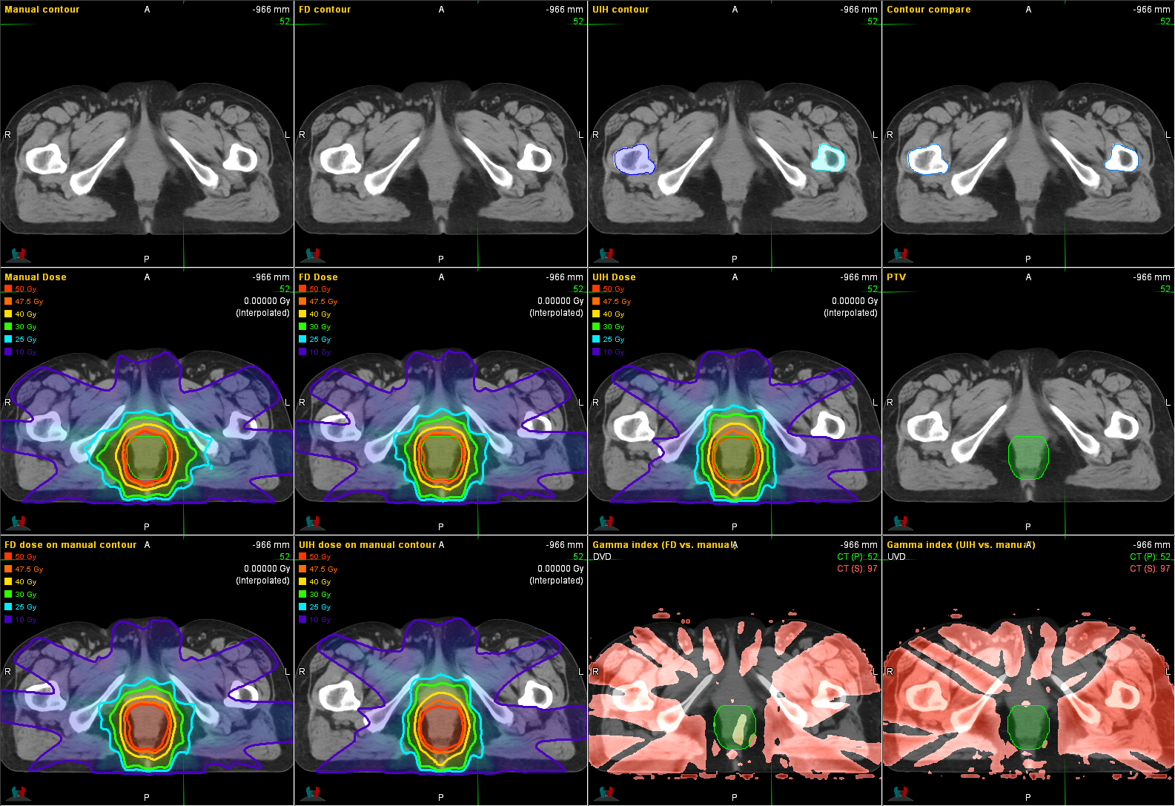
Fig. S6 Rectal cancer patient example

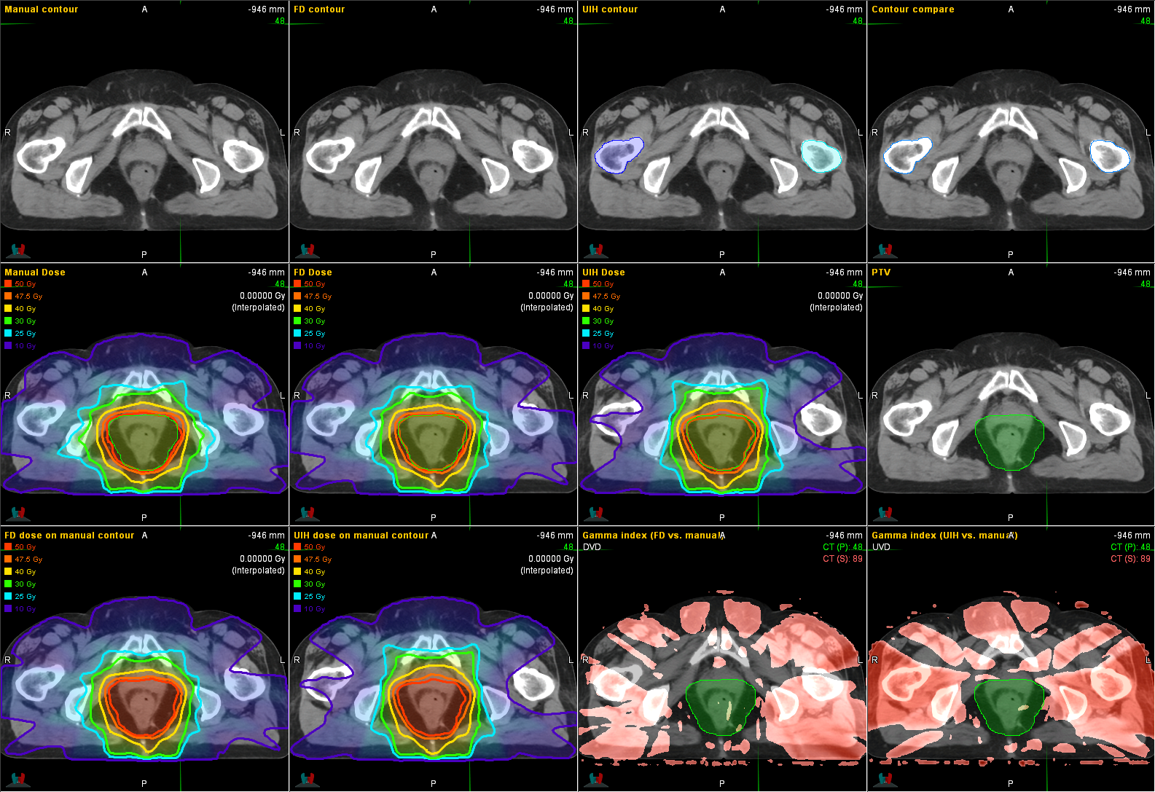
Fig. S7 Rectal cancer patient example
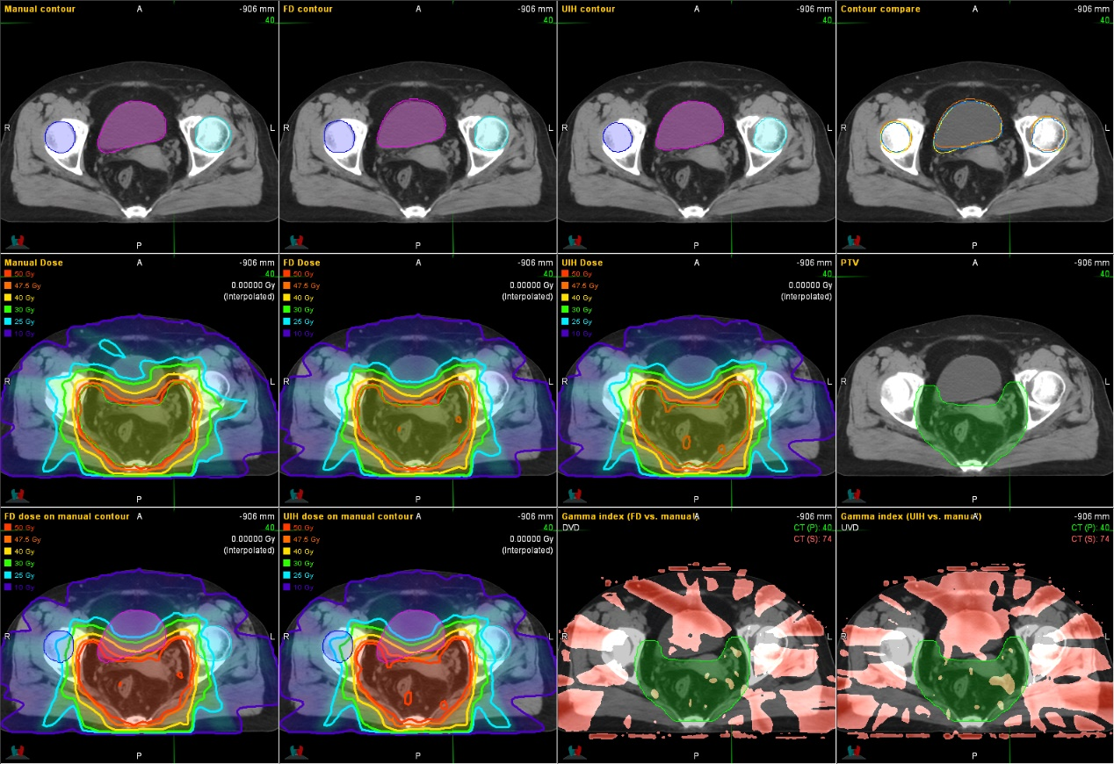
Fig. S8 Rectal cancer patient example

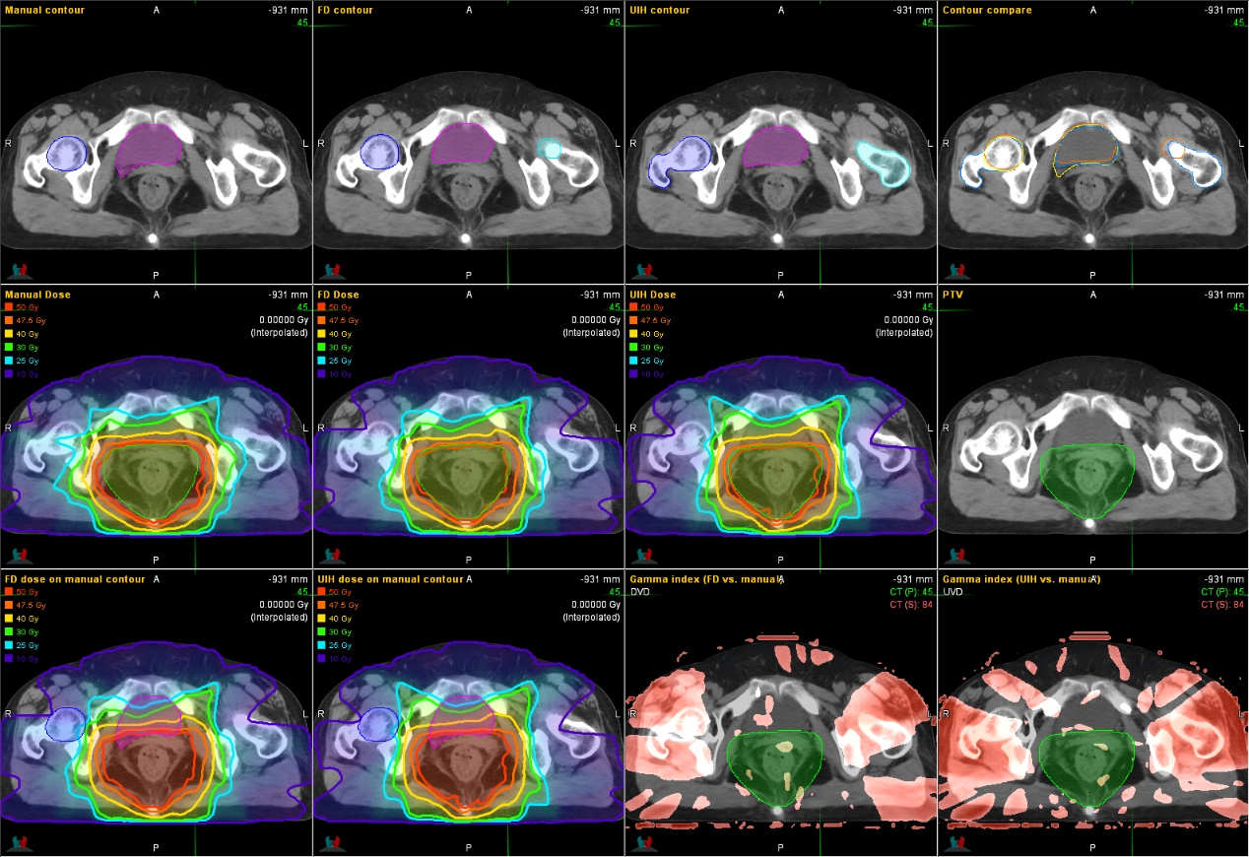
Fig. S9 Rectal cancer patient example

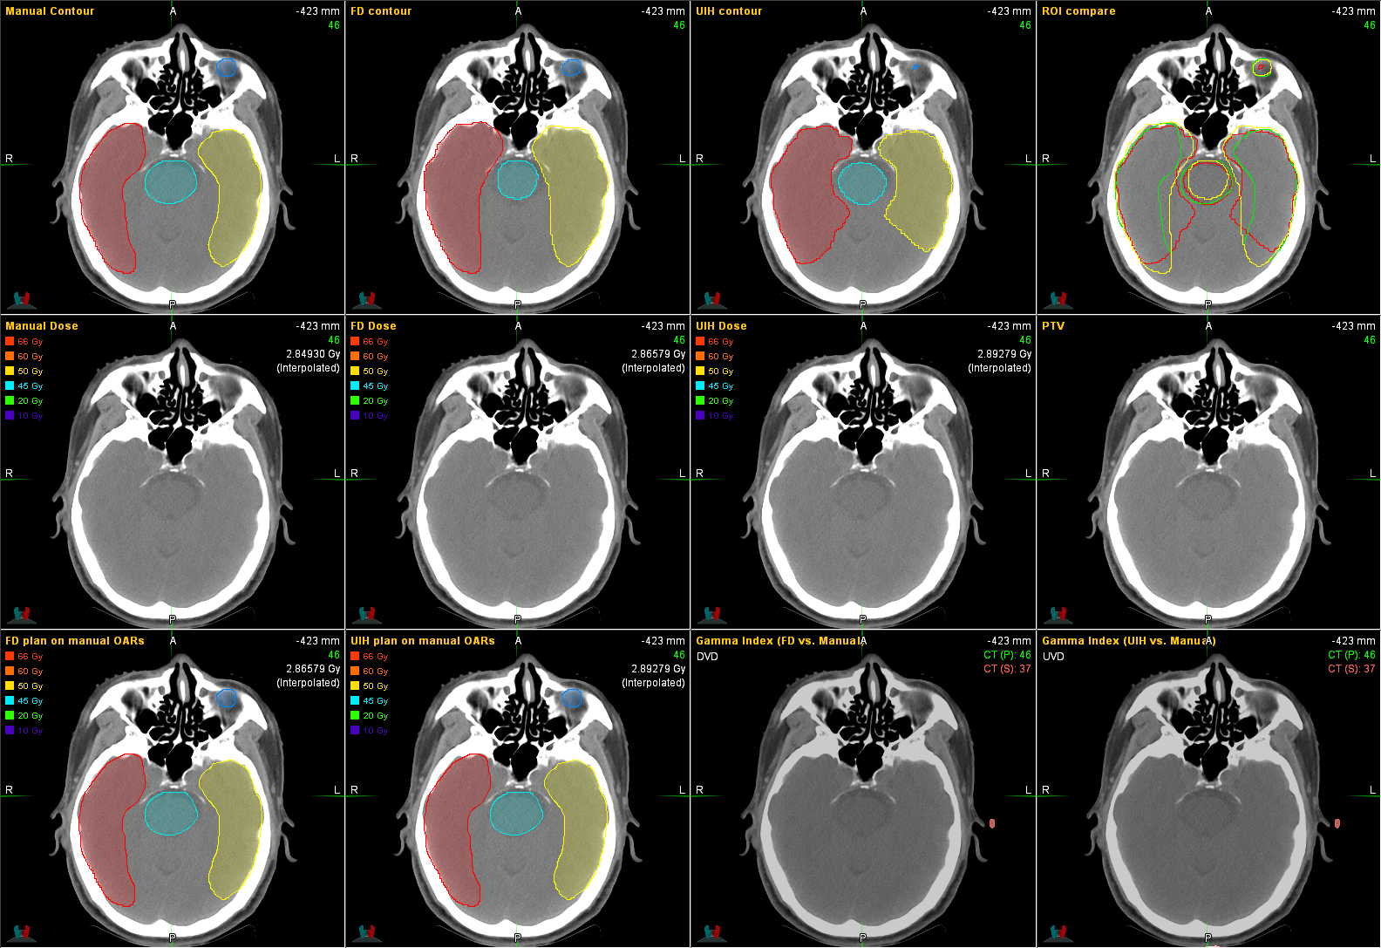
Fig. S10 NPC patient example

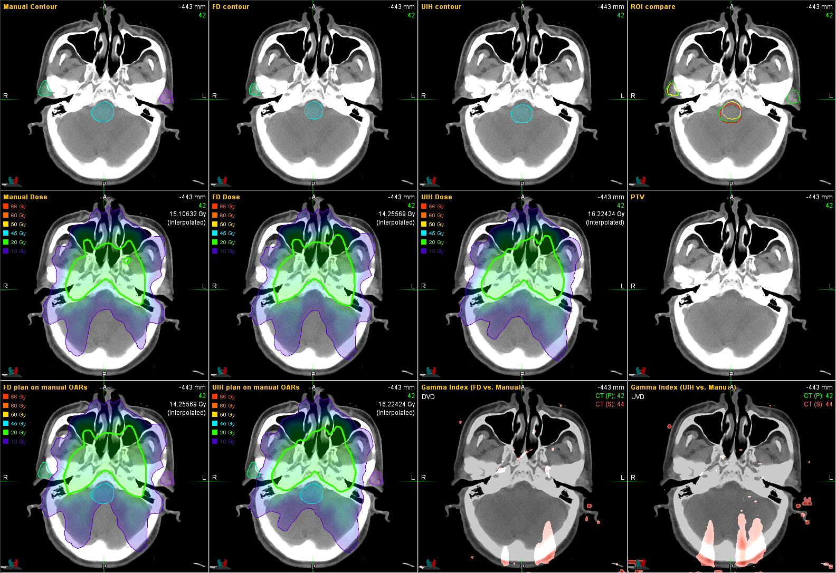
Fig. S11 NPC patient example
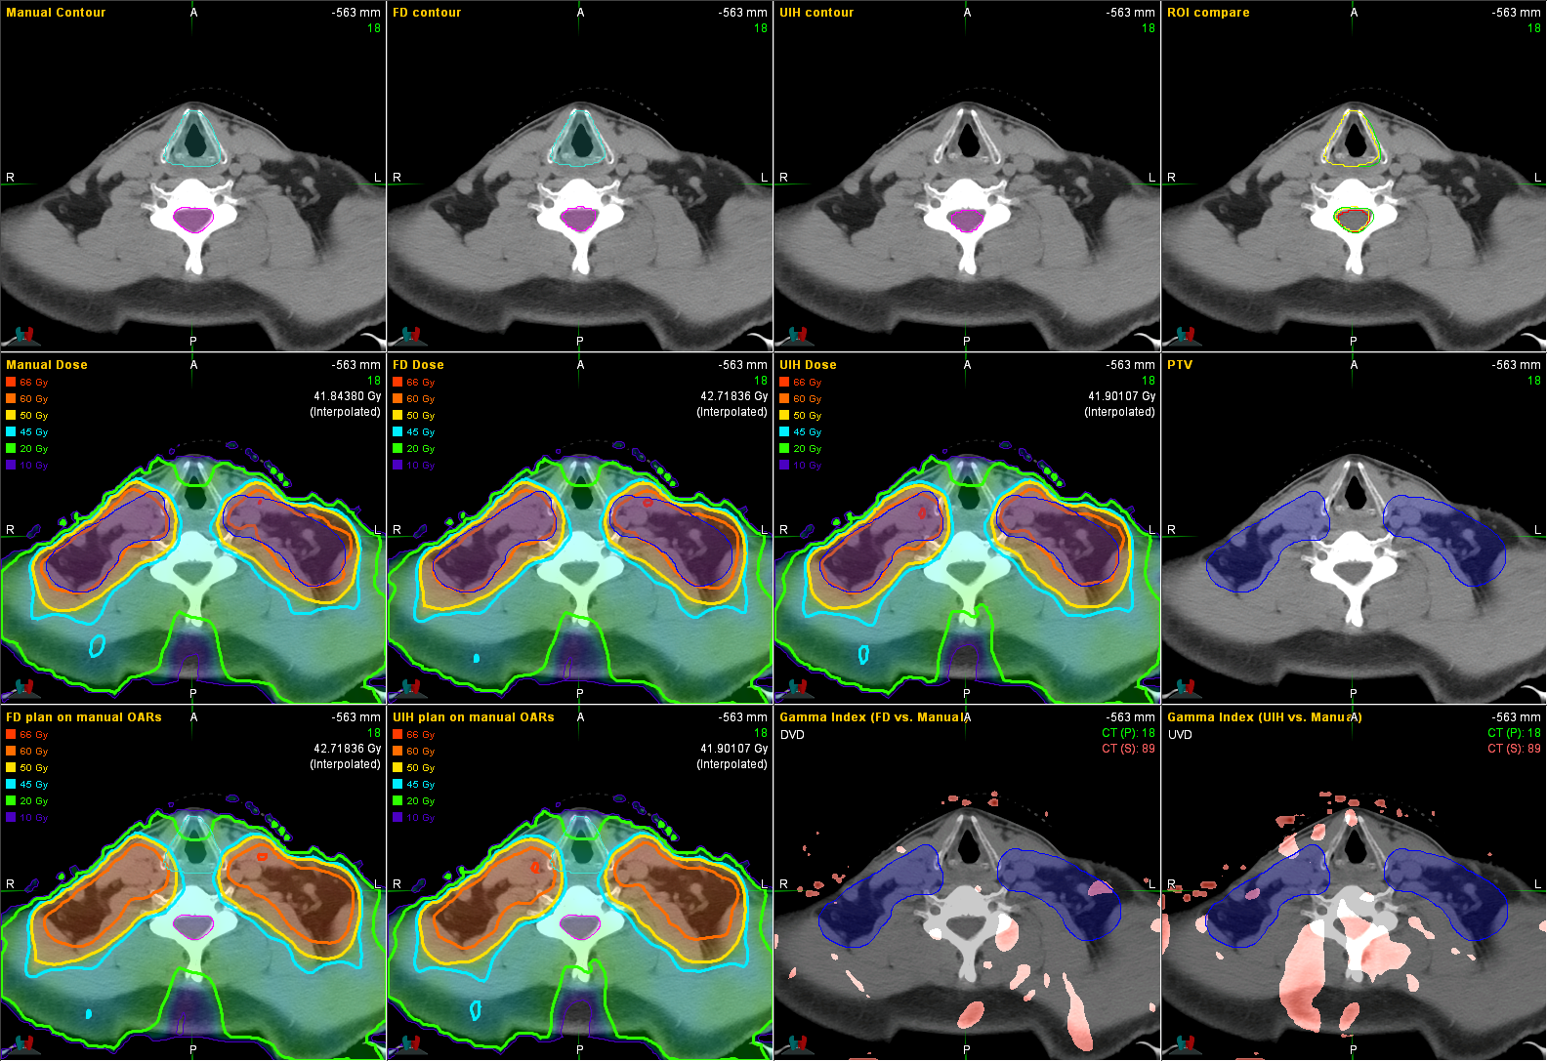
Fig. S12 NPC patient example

