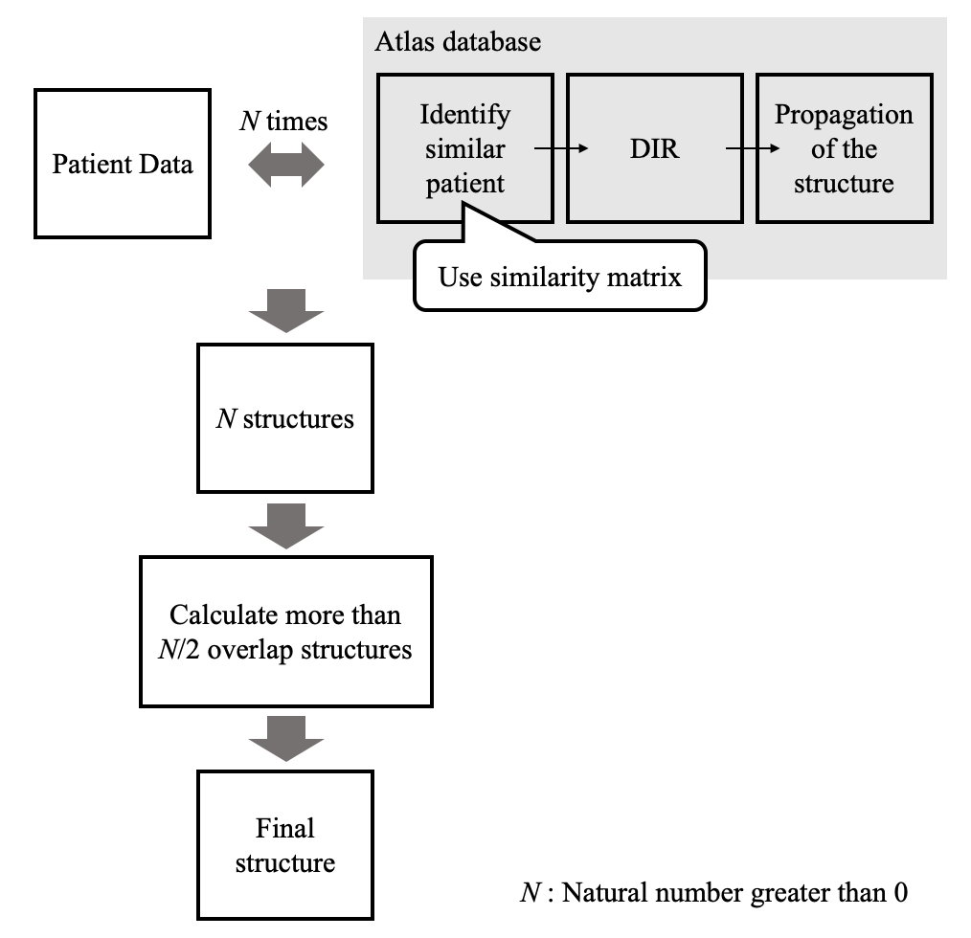
Supplementary Figure 1. The workflow of the SEG_{atlas} (atlas-based segmentation)

